

**TIG AC/DC 421 PULSE**

**Owner’s Manual**

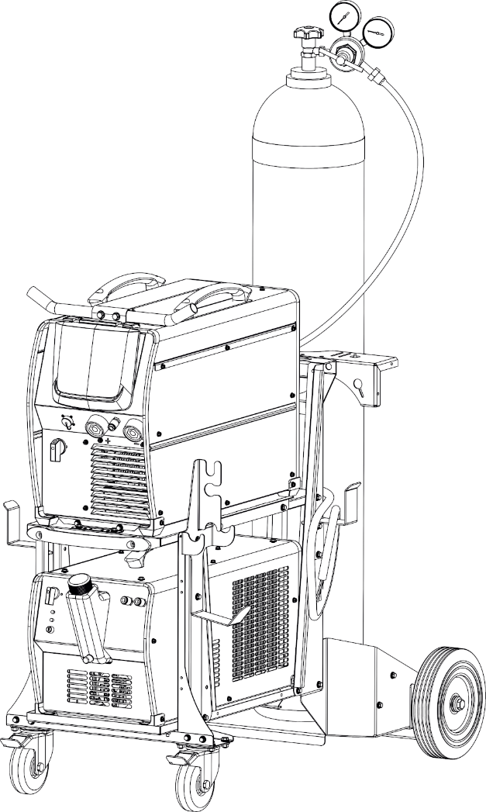



Thank You

From

Canaweld

Thank you for choosing a Canaweld machine, with 40+ years of welding equipment manufacturing experience overseas, you can feel confident that you have made the right choice.

**Since the 1980s**, the founders of Canaweld have been actively involved in research & development, production and sales within the welding and cutting industries. They have filed countless patents and set new standards in the welding industry.

For over a decade the founders of Canaweld, have been members of the Technical Committee (TC 26) of the **International Electro-Technical Commission (IEC). IEC** is the world’s leading organization on international standards for all electrical, electronic, and related technologies.

The company has also been an **expert member of the Canadian Standards Association (CSA), within the Technical Committee, responsible for Canadian standards of welding and cutting machines.**

Canaweld was created with the aim of providing our customers with advanced technologies. Our products, from design to assembly, are created with years of experience in research & development, materials engineering, quality control and testing.

Canaweld machines are among the best in the world in terms of quality.

The materials used in our designs are some of the best available on the market.

We believe in the high performance of our equipment and, therefore, offer a 3-year warranty.

We use strict test procedures, and our expectations exceed the required standards. For example, according to International Standards, machines must be tested at 40°C (104°F), but Canaweld tests the machines at both 40°C and 50°C (122°F). In doing so, we ensure that our machines will continue to operate even in hot climates.

Finally, all machines are only packaged and shipped when they pass strict mandatory tests.

**This user manual should be read carefully to fully understand the machine you have purchased and how to maintain it in the best operating condition.**

For more information on our full line of products please visit our website or contact a dealer in your local area, our dealer list can be found on our website: [www.canaweld.com](http://www.canaweld.com/)

**❑Table of contents**

❑Safety Precautions & Symbols (English) 2

❑ Précautions de sécurité et les symboles (French) 7

❑Introduction 12

❑Description 12

❑Technical Data 13

❑Usage Limits (IEC 60974-1) 13

❑How to Lift Up the Machine 13

❑Open the Packaging 14

❑Installation and Connections 14

❑Connecting the Welding Machine to the Utility Line 14

❑ Connection to Generator 15

❑ Command and Control Units 15

❑SMAW (Stick) Display Introduction 17

❑HF/LIFT TIG Display Introduction 18

❑TIG Pulse Display Introduction 18

❑TIG Spot Display Introduction 18

❑JOB Program Introduction 18

❑Optional Accessories 19

❑TIG Welding Procedure 19

❑TIG Welding Setup Installation 25

❑ Stick Welding Procedure 26

❑ Stick (SMAW) Welding Setup Installation 27

❑Welding Circuit: Cables, and Connections 29

❑ Maintenance 29

❑ Troubleshooting Table 30

❑Stick Welding Troubleshooting 31

❑ DC TIG Welding Troubleshooting 31

❑ Error Codes 32

❑ Meaning of Graphic Symbols on Machine 32

❑ Wiring Diagram 33

❑Safety Precautions & Symbols (English)

* 1. **General Safety Precautions**

Users of Canaweld welding and plasma cutting equipment are ultimately responsible for ensuring that everyone working on or around the equipment follow all safety measures. Safety precautions must fulfill the criteria for welding or plasma cutting equipment of this sort. In addition to the usual workplace laws, the following guidelines should be followed. To keep yourself and others safe, read, obey, and save these critical safety warnings and operating instructions. You are entirely responsible for the Product's safe operation. Canaweld does not and cannot give any assurances or warranties about the product's safety in your environment. This device is not designed for use in residential areas where the electrical power comes from a public low-voltage supply source. Due to both conducted and radiated disturbances, it may be challenging to ensure electromagnetic compatibility of the equipment in certain regions. This product is only for removing metal. Any other usage might result in bodily harm and/or damage to the equipment. In the event of a malfunction, contact a professional for assistance.

All work must be done by skilled employees who are familiar with how the welding or plasma cutting equipment works. Incorrect equipment operation can lead to dangerous circumstances, resulting in harm to the operator and equipment damage. Anyone who works with welding or plasma cutting equipment should understand how it works, where the emergency stops are situated, what safety measures should be followed, and how to utilize plasma cutting and/or welding.

Use approved personal safety equipment, such as safety glasses, flame-resistant clothes, and safety gloves. Avoid wearing scarves, bracelets, rings, and other loose-fitting items that may become stuck or cause burns. The operator must guarantee that no unauthorized personnel are present in the equipment's working area when it is turned on and no one is exposed to the arc when it is struck. The work environment must be free from drafts and appropriate for the job. The return cable must be securely connected and working on high voltage equipment must be done by a qualified electrician only. A proper and clearly marked fire extinguishing equipment must be close at hand. While the equipment is in operation, do not lubricate or maintain it.

* 1. **Safety Precautions & Symbol**

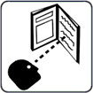**Before working on the machine, read the owner's manual.**

Read the safety information at the beginning of the requirements manual. To fully understand the machine's capabilities and safety measures, read this manual thoroughly. Follow the Owner's Manuals, industry standards, and national, province, state, and local.

**DANGER!**

The symbol indicates a dangerous action that will result in death or serious injury if not prevented. The potential dangers or hazards are depicted in the symbols next to them or discussed in the text.

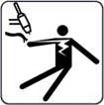**ELECTRIC SHOCK**

Touching electrical components can cause fatal electric shock and severe burns. By using a dry insulating mat or cover, insulate yourself from the workpiece and ground. While the machine is powered on, do not remove the machine cover, or touch any electrical components or circuits without a pair of proper and dry insulating gloves. Equipment that has been incorrectly placed or grounded is a hazard. ELECTRIC SHOCK can cause death or severe injuries. Do not touch any active electrical components. Wear dry insulating gloves and body protection with no holes in them. Use dry insulating mats or blankets large enough to avoid any direct touch with the work or ground to isolate oneself from the work and ground. If the torch pieces touch the work or the ground, do not touch them. Inspect the input power cable and ground conductor on a regular basis for aging or bare wiring; repair promptly if damaged; bare wiring can kill. When not in use, turn off all equipment. Do not utilize cables that are worn, broken, undersized, or repaired. Avoid wrapping the torch cable around your body. If codes demand it, connect the workpiece to a good electrical (earth) ground. Only use well-maintained equipment. Repair or replace broken pieces at the same time. When operating above floor level, use a safety harness. Maintain the integrity of all panels and coverings. Do not try to bypass or overcome the safety mechanisms. Only use the torch types which indicated in the owner's manual. When the trigger is pressed, keep your hands away from the electrode/tungsten tip and the arc. Clamp the work cable to the workpiece (not a component that will fall away) or the worktable as close to the welding area as possible. When not attached to the workpiece, insulate the work clamp to avoid contact with any metal objects. Before inspecting, cleaning, or replacing torch parts, and before installing or repairing this machine, turn off the power. Install, ground, and operate this equipment in accordance with its owner's manual and any national, province, state, and local laws. Always ensure that the input power cord ground wire is correctly connected to the ground terminal and the cord connector is attached to a properly grounded receptacle outlet. Attach the correct grounding conductor first while establishing input connections. Maintain cables by keeping them dry, clear of oil and grease, and away from hot metal and sparks.

**High DC VOLTAGE exists inside the machine even after turning off.**

Even after disconnecting the input power, there

is dangerous DC voltage in inverter welding power sources. Before touching any parts, turn off the inverter, disconnect the input power, and wait for the input capacitors to discharge.

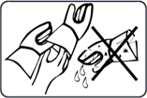**BURNS AND ELECTRIC SHOCK RISK WEAR DRY INSULATED GLOVES.**

When replacing the consumables, always use dry insulated gloves. During welding, the consumables get extremely hot, and serious burns are possible. If the power supply is turned on, touching the consumables might cause an electric shock. Never touch the exposed parts of the welding torch/electrode holder of the machine, change or clean consumables while the machine is on, because the shocking voltage between the parts will be extremely dangerous and even fatal.

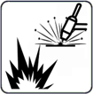**WELDING can result in a fire or explosion.**

From the welding arc, hot metal and sparks are ejected that can cause fire or explosion. Before performing any welding, double-check that the location is safe. Welding has the potential to start a fire or explosion. Remove all combustible materials around the work area. If this isn't feasible, use certified covers to firmly cover them. Avoid welding in areas where flying sparks might ignite combustible materials. Make sure you and others are safe from flying sparks and hot metal. Be aware that welding sparks and hot materials can easily pass-through minor gaps and holes and onto surrounding places. Keep an eye out for flames and a fire extinguisher nearby. Welding on a ceiling, floor, bulkhead, or wall might result in a fire on the concealed side. Do not weld on combustible-filled containers or closed containers like tanks, drums, or pipelines unless they have been adequately prepared according to relevant safety standards. Check the area for sparks, glowing embers, and flames when the task is completed. Only use the proper fuses or circuit breakers. Do not oversize or bypass them. All work should be done in accordance with applicable safety regulations, and a fire watcher and extinguisher should be available. To avoid welding currents from traveling too long, perhaps unknown courses and generating electric shock, sparks, and fire dangers, connect the work cable to the work as near to the welding area as possible. Never weld on containers containing potentially combustible products; they must first be emptied and thoroughly cleaned. Never perform welding where combustible dust, gas, or liquid vapors (such as gasoline) are present in the atmosphere. Welding pressurized cylinders, pipelines, or containers is prohibited. Wear flame-resistant, long-lasting body protection (leather, heavy cotton, wool). Oil-free clothes, such as leather gloves, a thick shirt, cuffless pants, work boots with electrical insulated sole, and a hat, are all recommended for body protection. Avoid placing the device near or on flammable materials. Before performing any welding, make sure you don't have any combustibles on you, such as butane lighter or matches.

**EXCESSIVE NOISE HAZARD**

Be cautious if there is excessive noise in the workplace. Wear hearing protection if the noise level is too high. Workers nearby are also impacted by noise and may require hearing protection.

**Hot PARTS HAZARD**

All welded pieces become extremely hot immediately after welding or cutting, causing burns to anybody in touch with exposed skin. After welding or cutting, do not contact the workpiece, ground clamp, or electrode holder/torch instantly, and wait for a cooling interval before picking them up. To avoid burns, use proper equipment while working with hot parts, and use thick insulating welding/cutting gloves and clothes as well.

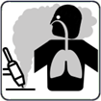**WELDING/CUTTING FUMES HAZARD**

Welding and cutting generate gases and fumes. The inhalation of these gases and vapors might be hazardous. These gases and fumes can replace oxygen in the body, causing harm or death. Keep your head away from the welding or cutting area and avoid inhaling the fumes and gases. If the weld/cut is indoors, ventilate the environment or utilize local forced ventilation at the weld site to eliminate smoke and gas. Wear an authorized air supply respirator if ventilation is insufficient. Only work inside if you are properly ventilated or using an air-supplied respirator. For any materials being used, read the Material Safety Data Sheet (MSDS) and the manufacturer's instructions.

**DANGEROUS GASES AND FUMES HAZARD**

Welding and cutting coated metal, such as stainless steel, are not permitted, unless the coating has been removed from the weld or cut area, and the area is thoroughly ventilated, and an air-supplied respirator is used as well. During welding or cutting, the coating and all metals containing these elements can produce harmful fumes. Do not cut containers that contain poisonous or reactive products or containers that have previously held toxic or reactive materials; they must first be emptied and thoroughly cleaned. Cut away from degreasing, cleaning, or spraying processes. The arc's heat and light can combine with vapors to produce very poisonous and unpleasant fumes.

**DANGEROUS GAS HAZARD FROM THE SHIELDING / CUTTING GAS CYLINDERS**

Turn off the shielding/cutting gas, when not in use. These gases can displace air, lowering oxygen levels and resulting in harm or death.

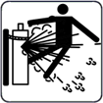**CYLINDERS can explode if they are damaged.**

Excessive heat, mechanical shocks, physical damage, slag, open flame, sparks, and arcs should all be avoided while using compressed gas cylinders. Keep cylinders away from any electrical or cutting/welding circuits. Never allow a welding torch/electrode holder or plasma arc torch to make electrical contact with a cylinder. An explosion will occur if you cut a pressurized cylinder. When the cylinder is not in use or attached for use, keep the protective cap on the valve. To avoid falling or tipping, install and secure cylinders in an upright position by chaining them to a fixed support or equipment cylinder rack. Lift and move cylinders with the proper equipment, procedures, and a sufficient number of people. Read and obey the directions on compressed gas cylinders, associated equipment, and Compressed Gas Association (CGA). Use just the right compressed gas cylinders, regulators, hoses, and fittings for the job, and keep them and their parts in excellent working order. When opening the cylinder valve, face away from the valve outlet. When opening the valve, make sure you're not standing in front of or behind the regulator.

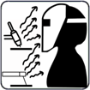**WELDING/CUTTING RAYS HAZARD**

The visible and invisible light (ultraviolet and infrared rays) produced by the welding or cutting process can burn the eyes and skin. Wear an appropriate welding helmet with suitably shaded filter lenses to protect your face and eyes from welding rays. Cover any exposed skin, arms, or neck. Wear protective clothing made of flame-resistant material (leather, thick cotton, or wool). Protect people from flashes, glare, and sparks by using a safety screen or barriers.

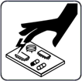**ESD- ELECTROSTATIC DISCHARGE**

During welding/cutting, an electric static charge can be produced and released into any items contacted by the welder/cutter after welding/cutting. Before touching any boards or electronic components, put on a grounded wrist strap. When storing, moving, or shipping PC boards, use proper static-proof bags and boxes.

**MOVING PARTS HAZARD**

Typical welding/cutting machines may include several moving elements, such as rollers and fans. Hands should be kept away from moving elements like fans. Keep a safe distance from moving parts. Keep your distance from pinch spots like drive rolls. Keep loose garments and hair out of the path of moving parts. All doors, panels, covers, and guards should be closed and secured. Only allow qualified individuals to remove doors, panels, coverings, or guards as needed for maintenance and troubleshooting. When the maintenance is performed, reinstall the doors, panels, covers, or guards before reconnecting the input power.

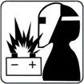**BATTERY EXPLOSION can cause injury.**

Do not use welding machine to charge batteries or jump start vehicles that can cause explosion.

**FALLING EQUIPMENT can cause injury.**

Lift just the unit, not the gas cylinders, or other attachments together. Make sure you have equipment with adequate capacity to raise the unit. If you're going to relocate the unit using lift forks, be sure they're long enough to reach the other side. When working from an aerial location, keep equipment (cables and cords) out of the way of moving vehicles.

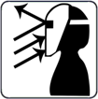**Sparks and hot metal blow out from the cutting arc can cause injury.**

Flying hot metal generated by chopping and grinding can cause injury. Wear a face shield or safety goggles with side shields that are approved. Protect your skin by wearing suitable body protection. To prevent sparks from entering your ears, use flame-resistant ear plugs or earmuffs. Wear safety glasses with side shields or wear face shields.

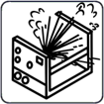**EXPLODING INVERTER PARTS can cause injury.**

When electricity is connected to inverter power sources, faulty parts can explode or cause other parts to explode. Turn off the power source and then start to service the inverters, and always wear a face shield and long sleeves to protect your body and skin.

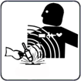**EMF- ELECTRIC MAGNETIC FIELDS can cause fault in electrical devices such as pacemakers.**

Electric magnetic fields are formed during welding or cutting, which might cause faults in electrical components or Implanted Medical Devices in the surrounding area. Those who wear pacemakers or other implanted medical devices should stay away from EMF emitted by welders/cutters. Before arc welding, spot welding, gouging, plasma arc cutting, or induction heating operations, wearers of implanted medical devices should consult their doctor and the device manufacturer.

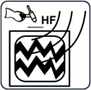**H.F. RADIATION can cause interference in electronic equipment.**

Radio navigation, Cellular phones, safety services, computers, and communication equipment can be affected by high frequency (H.F.) igniter. This welding machine should only be installed by qualified people who are knowledgeable about electronic equipment. The user is responsible for having any interference issues caused by the installation of the welding machine and the issue must be quickly resolved by having a certified electrician. Stop using the equipment immediately if the interference issue has not been solved. Have the machine installation tested and maintained regularly. To reduce the chance of interference, maintain high-frequency source doors and panels completely sealed, keep spark gaps at the proper setting, and employ proper and sufficient grounding and shielding.

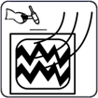**Welding can cause interference in electronic equipment.**

Electronic equipment, such as computers and computer-driven equipment, such as robots, can be harmed by electromagnetic energy. Keep cables short, close together, and low as possible, to prevent any interference. Welding should be done far away from any sensitive electrical equipment. Ensure that this welding power source is installed and grounded in accordance with the instructions in this manual. If interference still occurs, the user should consider relocating the equipment, employing shielded cables, utilizing line filters, or shielding the workspace.

**1.3 Important Safety Precautions**

* Put on dry insulating gloves. Avoid touching the electrode with your bare hand. Wearing damp or damaged gloves is not permitted.
* Injuries can be caused by flying components. When servicing a unit, always wear a face shield. Put on a cap and safety glasses. Wear a welding helmet with the appropriate filter shade. Wear full bodily protection.
* The most unstable position of the equipment must not be inclined up more than 10°. Auxiliary components such as gas cylinders, wire feed units, or cooling devices may impact stability depending on the kind of equipment, and they must be considered.
* Before changing torch consumables, working on the machine, turn off the power and unplug the input plug.
* After the power is switched off, dangerous voltage remains on the input capacitors. Do not touch fully charged capacitors. Always wait 60 seconds after turning off the power before working on the machine and check the input capacitor voltage to ensure it is near zero before touching any parts.

**1.4 Minimizing EMF (Electrical and Magnetic Fields) Exposure from the Welding / Cutting Circuit.**

Arc welding and related processes such as gouge, plasma arc cutting, and spot welding generate an EMF field surrounding the welding circuits. Some medical devices, such as pacemakers, can be affected by EMF. Protective precautions for those who have medical implants must be implemented. For example, limit passing by or do individual risk assessments for welders. By following the relevant procedures, EMF exposure can be reduced. Twist or tape cables together, or use a cable cover, to keep them close together.

Precautions about Implanted Medical Devices

Before performing or going near arc welding, spot welding, gouging, plasma arc cutting, or induction heating procedures, implanted medical device wearers should consult their doctor and the device manufacturer. Follow the above procedures only if your doctor has approved you.

Avoid putting your body between welding or cutting cables. Arrange the wires so that they are to one side and away from the operator. Work away from the welding power source and do not sit or lean on it. Keep your head and body as far away from the welding circuit's equipment as possible.

Work clamp should be connected to the workpiece as near to the weld or cut area as possible. Welding should not be done while carrying the welding or cutting power source or wire feeder. If you have an Implanted Medical Device in your body, you should consult your doctor before doing or going near arc welding, spot welding, gouging, or plasma arc cutting activities. Do not wrap cables around your body or coil them. It is the user's responsibility to install and operate the equipment in accordance with the manufacturer's instructions. If electromagnetic disturbances are detected, it is the user's obligation to fix the problem with the manufacturer's technical help. In other circumstances, resolving the problem may be easy by connecting the machine to the earth and the workpiece. In other circumstances, it might include building an electromagnetic screen that encloses the power source and the work area, along with applying some input filters. Cutting/welding equipment must be connected to the power source in accordance with the manufacturer's instructions. If interference occurs, further precautions, such as mains supply filtering, may be required. Shielding the supply cable of permanently installed equipment in metallic conduit or equivalent should be considered. The shielding should be electrically continuous over its whole length. The shielding should be attached to the power supply to preserve excellent electrical contact between the conduit and the power source enclosure. The user must analyze any electromagnetic concerns in the surrounding region before installing the device. The user must confirm that all other devices in the area are compatible. This may necessitate extra precautions. Where the workpiece is not tied to earth for electrical safety or because of its size and location, such as a ship's hull or constructing steel work, a connection linking the workpiece to earth may minimize emissions in some cases. The workpiece without earth increases the danger of harm to users or damage to other electrical equipment. The workpiece should be connected to earth by a direct connection to the workpiece. If direct connection is not permitted, bonding should be accomplished via adequate capacitances determined in accordance with national rules. Changing the earth circuit arrangements should be authorized only by someone who is qualified to assess whether the alterations would raise the danger of injury, such as by enabling parallel cutting/welding current return pathways, which may damage the earth circuits of other equipment. IEC 60974-9 provides additional advice, Arc Welding Equipment, Part 9: Installation and Use.

Interference concerns may be alleviated by selective screening and shielding of other cables and equipment in the direct vicinity. For some particular applications, screening of the complete cutting/welding system may be considered.

**1.5 Grounding of Welding/Cutting Machines:**

In an electric circuit, there is an active wire that supplies power, a neutral wire that returns the current, and a 'grounding wire' that provides an additional path for electrical current to safely return to the ground in the event of a short circuit. A copper conductor is connected from the wiring system's metal rod to a set of ground connection terminals in the service panel.

Because electricity always seeks the shortest path to the earth, if the neutral wire is broken or interrupted, it is the grounding wire that provides a direct path to the ground. Because of this direct physical connection, the earth can act as the path of least resistance, preventing an appliance or person from becoming the shortest path.

**Importance of Electrical Grounding**

**Protects Against Electrical Overloads**

You may occasionally experience power surges or be struck by lightning during severe weather conditions. These occurrences may generate dangerously high levels of electricity, which can destroy your electrical appliances. By grounding the electrical system, all excess electricity is directed to the earth rather than frying the system's connected appliances. The appliances will be secure and safe from large electrical surges.

**Stabilizes the Voltage Levels**

Grounding the electrical system makes it easier to distribute the right amount of power to the right places. This ensures that the circuits are never overloaded and, as a result, do not blow. The earth can be regarded as a common reference point for any electrical system's voltage sources. This aids in maintaining stable voltage levels throughout the electrical system.

**Earth Conducts with Least Resistance**

One of the primary reasons for grounding your electrical appliances is that the earth is a great conductor, capable of carrying all excess electricity with minimal resistance. When you ground the electrical system and connect it to the earth, you are allowing excess electricity to flow somewhere without resistance rather than through you or your appliances.

**Prevents Serious Damage and Death**

When you fail to ground the electrical system, you endanger your appliances and even your life. When high voltage is passed through a device, it is fried and irreparably damaged. An excess of electricity can even start a fire, endangering your property and the lives of your loved ones.

**Welding and Cutting Equipment Grounding**

Welding/cutting machines are typically grounded via a third grounding wire connected to their electrical connections. Mobile engine-driven generator welding units should be grounded by connecting a cable from the machine's ground stud to a metal stake driven into the ground. Always follow the manufacturer's instructions for properly grounding the model being used.

Auxiliary receptacles on welding machines may or may not be protected by a ground-fault circuit interrupter (GFCI). In wet or damp areas, GFCI adapters or "pigtails" should be used. Tools, extension cords, and other items plugged into these receptacles must be grounded or double insulated.

When connecting the work piece to the welding table, make sure the table is grounded as well (typically a cable from the table leg to the building structure). Avoid grounding to a structure that is a long distance away from the weld. Never use flammable liquid pipelines as a ground, and never use electrical conduit as a ground.

**Precautions to prevent an electrical shock.**

To reduce the extent of live parts, ensure that all cables are in good condition, with no bare insulation or frayed wires.

Keep cables safe from vehicle traffic and other hazards so they don't get damaged, cut, or pinched.

Check that the rod electrode holder is properly insulated.

During a welding/cutting operation, always keep your hands and body dry. Avoid standing in water, on wet surfaces, using wet hands, or wearing sweaty clothing. Never immerse energized (hot) electrode holders or torches in water.

Avoid coming into direct contact with live welding equipment and the workpiece. Connect the work or metal to a good electrical ground. Always shield yourself from the work and the ground. If performing arc welding in wet or high humidity conditions, wear appropriate protective equipment such as rubber boots and rubber pads. Wear rubber gloves beneath your welding gloves. Use an insulating mat under the operator if the welding/cutting operation must be performed on steel or another conductive material. Put the welding or cutting machine in close proximity. In the event of an emergency or an accident, the machine can be quickly turned off to cut off the power source. When not in use or on breaks, turn off the welding or cutting machine. Before leaving the cutting/welding area, disconnect the machine from the power grid. When moving from one working position to another, do not hold or move the torch/electrode holder and the Ground (Earth) return cable at the same time If the power source to the equipment has not been cut.

**What should I do in case of an electric shock?**

Call for medical assistance right away.

DO NOT USE YOUR "BARE HANDS" on the victim until he or she is away from the live electrical source. If an appliance or electrical equipment is the electrical source, turn off the power at the fuse box or circuit breaker panel, or, if possible, turn off the appliance or electrical equipment and unplug it. Simply turning off the equipment is insufficient.

If the electricity cannot be turned off and the victim is still in contact with the electrical source, determine whether the victim should be moved, or the wire should be pushed away from the victim (call for emergency help if the wire is a high voltage power line).

Wear dry gloves or cover your hands with cloth if you must move a victim away from a live contact, and stand on dry insulating material such as cardboard, wood, or clothes. When attempting to move the victim, ensure that you have good footing and will not slip or fall.

Move the wire or power source away from the victim or push the victim off the live electrical source with a dry piece of wood, broom, or other dry, insulating object or material.

If there is a risk of neck or spinal injuries (for example, from a fall), do not move the victim unless absolutely necessary.

If the victim is not breathing, provide artificial respiration.

If the victim's heart has stopped, perform CPR (only if you are trained in CPR).

Apply a sterile dressing to burns. There could be burns where the power source touched the victim and where the electricity exited the body (to ground). Electrical burns may appear minor on the surface, but they can be severe deep within the tissue. Maintain the victim's comfort, warmth, and rest, and keep an eye on his or her breathing.

**Information Sources for Grounding**

American Welding Society, ANSI Z49.1:2005 "Safety in Welding, Cutting & Allied Processes."

National Fire Protection Association, NFPA 70, "National Electrical Code", 2005.

American Welding Society, Safety and Health Fact Sheet No. 29, "Grounding of Portable and Vehicle Mounted Welding Generators", July 2004.

American Welding Society, AWS A3.0-2001, "Standard Welding Terms and Definitions"

**Guide for Helmet Shade Number**

When cutting or watching, use face protection (helmet or shield) with appropriate filter glasses to protect your face and eyes from arc rays and sparks (see Safety Standards). The suggested colors in the table below are offered for the convenience of the operator.

|  |  |  |  |
| --- | --- | --- | --- |
| **Process** | **Welding Current (A)** | **Minimum Protective Shade Size** | **Recommended**\* **Shade Size** |
| **Gas Tungsten Arc Welding (GTAW)** | **Less than 50** | **8** | **10** |
| **50 to 150** | **8** | **12** |
| **150 to 500** | **10** | **14** |
| **Shielded Metal Arc Welding (SMAW)** | **Less than 60** | **7** | **10** |
| **60 to 160** | **8** | **10** |
| **160 to 250** | **10** | **12** |
| **250 to 550** | **11** | **14** |
| **Recommendation:** take a shade that is too dark to see the weld zone.  Then try a lighter shade which ensures sufficient view of the weld zone without going below the minimum. | | | |

**Additional Safety Information**

Safety in Welding, Cutting, and Allied Processes, CSA Standard W117.2 from Canadian Standards Association. Website: www.csagroup.org

**OSHA Occupational Safety and Health Standards for General Industry,** Title 29, Code of Federal Regulations (CFR), Part 1910.177 Subpart N, Part 1910 Subpart Q, and Part 1926, Subpart J. Website: www.osha.gov

**OSHA Important Note Regarding the ACGIH TLV, Policy Statement** on the Uses of TLVs and BEIs. Website: www.osha.gov.

**Applications Manual for the Revised NIOSH Lifting Equation** from the National Institute for Occupational Safety and Health (NIOSH). Website: www.cdc.gov/niosh.

**Standard for Fire Prevention During Welding, Cutting, and Other Hot Work,**

NFPA Standard 51B from National Fire Protection Association. Website: www.nfpa.org.

**Safety in Welding, Cutting, and Allied Processes**, American Welding Society standard ANSI Standard Z49.1. Website: www.aws.org.

**Safe Handling of Compressed Gases in Cylinders**, CGA Pamphlet P-1 from Compressed Gas Association. Website: www.cganet.com.

**Safe Practices for Welding and Cutting Containers that have Held Combustibles**, American Welding Society Standard AWS A6.0 from Global Engineering Documents. Website: www.global.ihs.com.

**Safe Practices for the Preparation of Containers and Piping for Welding and Cutting**, American Welding Society Standard AWS F4.1 from Global Engineering Documents.

Website: www.global.ihs.com.

**Safe Practice for Occupational and Educational Eye and Face Protection**, ANSI Standard Z87.1 from American National Standards Institute. Website: www.ansi.org.

❑ Précautions de sécurité et les symboles (French)

**Mesures de sécurité generals**

Les utilisateurs d'équipement de soudage et de coupage au plasma Canaweld sont en fin de compte responsables de s'assurer que toute personne travaillant sur ou autour de l'équipement respecte toutes les mesures de sécurité. Les mesures de sécurité doivent répondre aux critères d'un équipement de soudage ou de découpe au plasma de ce type. En plus des lois habituelles sur le lieu de travail, les directives suivantes doivent être suivies. Pour assurer votre sécurité et celle des autres, lisez, respectez et conservez ces avertissements de sécurité et instructions d'utilisation essentiels. Vous êtes entièrement responsable de l'utilisation sûre du produit. Canaweld ne donne et ne peut donner aucune assurance ou garantie quant à la sécurité du produit dans votre environnement. Cet appareil n'est pas conçu pour être utilisé dans des zones résidentielles où l'alimentation électrique provient d'une source publique de basse tension. En raison des perturbations conduites et rayonnées, il peut être difficile d'assurer la compatibilité électromagnétique de l'appareil dans certaines régions. Ce produit est uniquement destiné à enlever du métal. Toute autre utilisation peut entraîner des blessures corporelles et/ou endommager l'équipement. En cas de dysfonctionnement, contactez un professionnel pour obtenir de l'aide. Tous les travaux doivent être effectués par des employés qualifiés qui connaissent le fonctionnement de l'équipement de soudage ou de découpe au plasma. Une utilisation incorrecte de l'équipement peut conduire à des circonstances dangereuses, entraînant des blessures pour l'opérateur et des dommages pour l'équipement. Toute personne qui travaille avec un équipement de soudage ou de découpe au plasma doit comprendre comment il fonctionne, où se trouvent les arrêts d'urgence, quelles sont les mesures de sécurité à respecter et comment utiliser la découpe au plasma et/ou le soudage. Utilisez des équipements de sécurité personnelle approuvés, tels que des lunettes de sécurité, des vêtements résistant aux flammes et des gants de sécurité. Évitez de porter des écharpes, des bracelets, des bagues et d'autres articles amples qui pourraient se coincer ou causer des brûlures. L'opérateur doit garantir qu'aucune personne non autorisée ne se trouve dans la zone de travail de l'équipement lorsqu'il est allumé et que personne n'est exposé à l'arc lorsqu'il est amorcé. L'environnement de travail doit être exempt de courants d'air et adapté à la tâche. Le câble de retour doit être solidement connecté et les travaux sur les équipements à haute tension ne doivent être effectués que par un électricien qualifié. Un équipement d'extinction d'incendie approprié et clairement identifié doit être à portée de main. Pendant que l'équipement est en fonctionnement, ne le lubrifiez pas et ne l'entretenez pas.

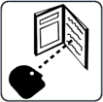**Précautions et symboles de sécurité**

**Avant de travailler sur la machine, lisez le manuel d'utilisation.**

Lisez les informations de sécurité au début du manuel. Trouvez chaque partie à étudier dans le manuel pour bien comprendre les capacités de la machine. Respectez les manuels du propriétaire, les normes industrielles et les exigences nationales, provinciales, étatiques et locales.

**DANGER !**

Le symbole indique une action dangereuse qui entraînera la mort ou des blessures graves si elle n'est pas évitée. Les dangers ou risques potentiels sont représentés par les symboles qui leur sont accolés ou discutés dans le texte.

**CHOC ELECTRIQUE**

Le contact avec des composants électriques peut provoquer un choc électrique mortel et des brûlures graves. En utilisant un tapis isolant sec ou une couverture, isolez-vous de la pièce à travailler et de la terre. Lorsque la machine est sous tension, ne retirez pas le capot de la machine et ne touchez pas les composants ou circuits électriques sans un gant isolant sec et approprié. Un équipement mal placé ou mal mis à la terre présente un risque. Les CHOCS ELECTRIQUES peuvent causer la mort ou des blessures graves. Ne pas entrer en contact avec des composants électriques actifs. Porter des gants isolants secs et des protections corporelles non trouées. Utiliser des tapis ou des couvertures isolants secs suffisamment grands pour éviter tout contact direct avec l'ouvrage ou le sol afin de s'isoler de l'ouvrage et du sol. Si les pièces de la torche entrent en contact avec l'ouvrage ou le sol, ne pas les toucher.

Inspectez régulièrement le câble d'alimentation d'entrée et le conducteur de terre pour vérifier qu'ils ne sont pas vieillissants ou dénudés ; réparez-les rapidement s'ils sont endommagés ; les fils dénudés peuvent tuer. Lorsque vous n'utilisez pas l'appareil, éteindre tous les équipements. N'utilisez pas de câbles usés, cassés, sous-dimensionnés ou réparés. Évitez d'enrouler le câble du chalumeau autour de votre corps. Si les codes l'exigent, connectez la pièce de travail à une bonne mise à la terre électrique (earth). N'utilisez que du matériel bien entretenu. Réparez ou remplacez les pièces cassées en même temps. Lorsque vous travaillez au-dessus du niveau du sol, utilisez un harnais de sécurité. Maintenez l'intégrité de tous les panneaux et revêtements.N'essayez pas de contourner ou de surmonter les mécanismes de sécurité. N'utilisez que les types de torche indiqués dans le manuel d'utilisation. Lorsque vous appuyez sur la gâchette, gardez vos mains de l'électrode/du bout du tungstène et de l'arc. Fixez le câble de travail à la pièce (et non à un élément qui va tomber) ou à la table de travail, aussi près que possible de la zone de soudage. Lorsqu'elle n'est pas fixée à la pièce, isolez la pince de travail pour éviter tout contact avec des objets métalliques.

Avant d'inspecter, de nettoyer ou de remplacer des pièces de la torche, et avant d'installer ou de réparer cette machine, mettez-la hors tension. Installez, mettez à la terre et utilisez cet équipement conformément au manuel d'utilisation et aux lois nationales, provinciales, nationales et locales. Assurez-vous toujours que le fil de terre du cordon d'alimentation d'entrée est correctement connecté à la borne de terre et que le connecteur du cordon est fixé à une prise de courant correctement mise à la terre. Fixez d'abord le bon conducteur de mise à la terre lorsque vous établissez les connexions d'entrée. Entretenez les câbles en les gardant au sec, exempts d'huile et de graisse, et à l'écart du métal chaud et des étincelles.

**Une tension continue élevée existe à l'intérieur de la machine même après l'avoir éteinte.**

Même après avoir déconnecté l'alimentation d'entrée, il existe une tension continue dangereuse dans les sources d'alimentation de soudage de l'onduleur. Avant de toucher une quelconque pièce, éteignez l'onduleur, déconnectez l'alimentation d'entrée et attendez que les condensateurs d'entrée se déchargent.

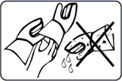**RISQUE DE BRÛLURES ET DE CHOCS ÉLECTRIQUES - PORTER DES GANTS SECS ISOLÉS**

Lors du remplacement des consommables, utilisez toujours des gants secs et isolés. Pendant le soudage, les consommables deviennent extrêmement chauds et des brûlures graves sont possibles. Si l'alimentation électrique est sous tension, le fait de toucher les consommables peut provoquer un choc électrique. Ne touchez jamais les parties exposées de la torche de soudage/du porte-électrode de la machine, ne changez pas ou ne nettoyez pas les consommables lorsque la machine est allumée, car la tension de choc entre les pièces sera extrêmement dangereuse, voire mortelle.

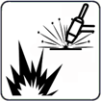**La soudure peut provoquer un incendie ou une explosion.**

L'arc de soudage projette du métal chaud et des étincelles qui peuvent provoquer un incendie ou une explosion. Avant d'effectuer toute soudure, vérifiez que l'endroit est sûr. Le soudage est susceptible de déclencher un incendie ou une explosion. Retirez tous les matériaux combustibles autour de la zone de travail. Si cela n'est pas possible, utilisez des couvertures certifiées pour les recouvrir fermement. Évitez de souder dans des zones où des étincelles pourraient enflammer des matériaux combustibles. Assurez-vous que vous et les autres personnes êtes à l'abri des étincelles et du métal chaud. Sachez que les étincelles de soudage et les matériaux chauds peuvent facilement passer à travers de petits trous et interstices et atteindre les endroits environnants. Gardez un œil sur les flammes et un extincteur à proximité.Le soudage sur un plafond, un plancher, une cloison ou un mur peut provoquer un incendie sur le côté caché. Ne soudez pas sur des récipients remplis de combustible ou des récipients fermés tels que des réservoirs, des fûts ou des canalisations, à moins qu'ils n'aient été préparés de manière adéquate conformément aux normes de sécurité en vigueur.

Une fois la tâche terminée, vérifiez l'absence d'étincelles, de braises incandescentes et de flammes dans la zone. N'utilisez que les fusibles ou les disjoncteurs appropriés. Ne les surdimensionnez pas et ne les contournez pas. Tous les travaux doivent être effectués conformément aux règles de sécurité en vigueur, et un surveillant d'incendie et un extincteur doivent être disponibles. Pour éviter que les courants de soudage ne se déplacent trop longtemps, peut-être sur des parcours inconnus, et ne génèrent des chocs électriques, des étincelles et des risques d'incendie, connectez le câble de travail à l'ouvrage aussi près que possible de la zone de soudage. Ne soudez jamais sur des récipients contenant des produits potentiellement combustibles; ils doivent d'abord être vidés et soigneusement nettoyés. Ne jamais effectuer de soudage lorsque des poussières, des gaz ou des vapeurs liquides combustibles (comme l'essence) sont présents dans l'atmosphère. Il est interdit de souder des bouteilles, des canalisations ou des conteneurs sous pression. Portez des protections corporelles résistantes aux flammes et de longue durée (cuir, coton lourd, laine). Pour la protection corporelle, il est recommandé de porter des vêtements exempts d'huile, tels que des gants en cuir, une chemise épaisse, un pantalon sans revers, des bottes de travail avec une semelle isolée électriquement et un chapeau.

Évitez de placer l'appareil à proximité ou sur des matériaux inflammables. Avant d'effectuer des travaux de soudage, assurez-vous que vous n'avez pas de combustibles sur vous, comme un briquet au butane ou des allumettes.

**RISQUE DE BRUIT EXCESSIF**

Soyez prudent s'il y a un bruit excessif sur le lieu de travail. Portez des protections auditives si le niveau sonore est trop élevé. Les travailleurs à proximité sont également touchés par le bruit et peuvent avoir besoin de protections auditives.

**DANGER LIÉ AUX PIÈCES CHAUDES**

Toutes les pièces soudées deviennent extrêmement chaudes immédiatement après le soudage ou le coupage, provoquant des brûlures à toute personne en contact avec la peau exposée. Après le soudage ou le coupage, ne pas toucher instantanément la pièce, la pince de masse ou le porte-électrode/la torche, et attendre un intervalle de refroidissement avant de les ramasser. Pour éviter les brûlures, utilisez un équipement approprié lorsque vous travaillez avec des pièces chaudes, ainsi que des gants et des chiffons de soudage/coupage épais et isolants.

**RISQUE DE FUMÉES DE SOUDAGE/COUPAGE**

Le soudage et le coupage génèrent des gaz et des fumées. L'inhalation de ces gaz et vapeurs peut être dangereuse. Ces gaz et vapeurs peuvent remplacer l'oxygène dans le corps, ce qui peut causer des dommages ou la mort. Tenez votre tête éloignée de la zone de soudage ou de découpage et évitez d'inhaler les fumées et les gaz. Si la soudure/le découpage a lieu à l'intérieur, ventilez l'environnement ou utilisez une ventilation forcée locale sur le site de soudure pour éliminer la fumée et les gaz. Porter un appareil respiratoire à adduction d'air autorisé si la ventilation est insuffisante. Ne travaillez à l'intérieur que si vous êtes correctement ventilé ou si vous utilisez un respirateur à adduction d'air. Pour tous les matériaux utilisés, lisez la fiche de données de sécurité (FDS) et les instructions du fabricant.

**RISQUE DE GAZ ET DE FUMÉES DANGEREUX**

Le soudage et le coupage de métaux revêtus, comme l'acier inoxydable, ne sont pas autorisés, à moins que le revêtement n'ait été retiré de la zone de soudage ou de coupage, et que la zone soit bien ventilée et qu'un masque respiratoire à adduction d'air soit également utilisé. Pendant le soudage ou le découpage, le revêtement et tous les métaux contenant ces éléments peuvent produire des fumées nocives. Ne coupez pas les récipients qui contiennent des produits toxiques ou réactifs ou les récipients qui ont précédemment contenu des matériaux toxiques ou réactifs ; ils doivent d'abord être vidés et soigneusement nettoyés. Coupez à l'écart des processus de dégraissage, de nettoyage ou de pulvérisation. La chaleur et la lumière de l'arc peuvent se combiner aux vapeurs et produire des fumées très toxiques et désagréables.

**DANGER DE GAZ DANGEREUX PROVENANT DES CYLINDRES DE GAZ DE BLINDAGE / DE COUPE**

Éteignez le gaz de protection/de coupe lorsqu'il n'est pas utilisé, car ces gaz peuvent déplacer l'air, abaisser les niveaux d'oxygène et entraîner des blessures ou la mort.

**RISQUE DE RAYONS DE SOUDAGE/ COUPAGE**

La lumière visible et invisible (rayons ultraviolets et infrarouges) produite par le processus de soudage ou de coupage peut brûler les yeux et la peau. Portez un casque de soudage approprié avec des lentilles filtrantes convenablement ombragées pour protéger votre visage et vos yeux des rayons de soudage. Couvrez toute peau, bras ou cou exposés. Portez des vêtements de protection fabriqués dans un matériau résistant aux flammes (cuir, coton épais ou laine). Protégez les personnes contre les éclairs, l'éblouissement et les étincelles en utilisant un écran ou des barrières de sécurité.

**Les CYLINDRES peuvent exploser s'ils sont endommagés.**

La chaleur excessive, les chocs mécaniques, les dommages physiques, les scories, les flammes nues, les étincelles et les arcs électriques doivent être évités lors de l'utilisation des bouteilles de gaz comprimé.

Tenir les bouteilles à l'écart de tout circuit électrique ou de tout circuit de coupure ou de soudage. Ne laissez jamais une torche de soudage/un porte-électrode ou une torche à arc plasma entrer en contact électrique avec une bouteille. Une explosion se produira si vous coupez une bouteille sous pression. Lorsque la bouteille n'est pas utilisée ou fixée pour être utilisée, gardez le bouchon de protection sur le robinet. Pour éviter de tomber ou de basculer, installez et fixez les bouteilles en position verticale en les enchaînant à un support fixe ou à un support de bouteilles d'équipement. Soulevez et déplacez les bouteilles avec l'équipement et les procédures appropriés et un nombre suffisant de personnes. Lisez et respectez les instructions figurant sur les bouteilles de gaz comprimé, l'équipement associé et la Compressed Gas Association (CGA). Utilisez les bouteilles de gaz comprimé, les détendeurs, les tuyaux et les raccords qui conviennent le mieux à votre travail et maintenez-les, ainsi que leurs pièces, en excellent état de fonctionnement. Lorsque vous ouvrez le robinet de la bouteille, ne vous approchez pas de la sortie du robinet. Lorsque vous ouvrez le robinet, assurez-vous de ne pas vous tenir devant ou derrière le détendeur.

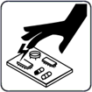**ESD-DÉCHARGE STATIQUE ELECTRIQUE**

Pendant le soudage/la découpe, une charge électrique statique peut être produite et libérée dans tous les objets avec lesquels le soudeur/la découpe entre en contact après le soudage/la découpe. Avant de toucher des cartes ou des composants électroniques, mettez un bracelet relié à la terre. Lorsque vous stockez, déplacez ou expédiez des cartes PC, utilisez des sacs et des boîtes antistatiques appropriés.

**RISQUE D'EXPOSITION À DES PIÈCES EN MOUVEMENT**

Les machines de soudage/coupage typiques peuvent comprendre plusieurs éléments mobiles, tels que des rouleaux et des ventilateurs. Les mains doivent être tenues à l'écart des éléments mobiles comme les ventilateurs. Gardez une distance de sécurité avec les pièces en mouvement. Restez à distance des points de pincement comme les rouleaux d'entraînement. Gardez les vêtements amples et les cheveux hors de la trajectoire des pièces mobiles. Toutes les portes, panneaux, couvercles et protections doivent être fermés et sécurisés. Ne permettez qu'à des personnes qualifiées de retirer les portes, panneaux, couvercles et protections doivent être fermés et sécurisés. Ne permettez qu'à des personnes qualifiées de retirer les portes, panneaux, couvertures ou protections si nécessaire pour la maintenance et le dépannage. Une fois l'entretien effectué, réinstallez les portes, panneaux, couvertures ou protections avant de reconnecter l'alimentation d'entrée.

**L'EXPLOSION DE LA BATTERIE peut causer des blessures.**

N'utilisez pas la machine à souder pour charger des batteries ou démarrer des véhicules, car cela pourrait provoquer une explosion.

**LA CHUTE D'UN ÉQUIPEMENT peut causer des blessures**

Ne soulevez que l'unité, et non le train de roulement, les bouteilles de gaz ou autres accessoires, à l'aide de l'anneau de levage. Assurez-vous de disposer d'un équipement d'une capacité suffisante pour soulever l'unité. Si vous devez déplacer l'appareil à l'aide de fourches de levage, assurez-vous qu'elles sont suffisamment longues pour atteindre l'autre côté. Lorsque vous travaillez depuis un emplacement aérien, gardez l'équipement (câbles et cordons) hors de la trajectoire des véhicules en mouvement.

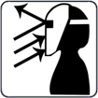**Les étincelles et les projections de métal chaud provenant de l'arc de coupe peuvent causer des blessures.**

Les projections de métal chaud générées par le hachage et le meulage peuvent causer des blessures. Portez un écran facial ou des lunettes de sécurité avec écrans latéraux homologués. Protégez votre peau en portant une protection corporelle appropriée. Pour éviter que les étincelles ne pénètrent dans vos oreilles, utilisez des bouchons d'oreille ou des protège-oreilles résistant aux flammes. Portez des lunettes de sécurité avec des écrans latéraux ou des écrans faciaux.

**L'EXPLOSION DES PIÈCES DE L'INVERSEUR peut provoquer des blessures.**

Lorsque l'électricité est connectée aux sources d'alimentation des onduleurs, les pièces défectueuses peuvent exploser ou provoquer l'explosion d'autres pièces. Coupez la source d'alimentation et commencez à entretenir les onduleurs, et portez toujours un écran facial et des manches longues pour protéger votre corps et votre peau.

**Les champs électromagnétiques peuvent provoquer des défaillances dans les appareils électriques tels que les stimulateurs cardiaques.**

Des champs électromagnétiques se forment pendant le soudage ou le découpage, ce qui peut provoquer des défaillances dans les composants électriques ou les dispositifs médicaux implantés dans la zone environnante. Les personnes qui portent des stimulateurs cardiaques ou d'autres dispositifs médicaux implantés doivent rester à l'écart des CEM émis par les soudeurs/coupeurs. Avant toute opération de soudage à l'arc, de soudage par points, de gougeage, de découpe à l'arc plasma ou de chauffage par induction, les porteurs de dispositifs médicaux implantés doivent consulter leur médecin et le fabricant du dispositif.

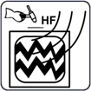**Les RADIATIONS H.F. peuvent provoquer des interférences dans les équipements électroniques.**

La radionavigation, les téléphones cellulaires, les services de sécurité, les ordinateurs et les équipements de communication peuvent être affectés par l'allumeur haute fréquence (H.F.). Cette machine à souder ne doit être installée que par des personnes qualifiées qui connaissent bien les équipements électroniques. L'utilisateur est responsable de tout problème d'interférence causé par l'installation de la soudeuse et le problème doit être rapidement résolu en faisant appel à un électricien certifié. Arrêtez immédiatement d'utiliser l'équipement si le problème d'interférence n'a pas été résolu. Faites tester et entretenir régulièrement l'installation de la machine. Pour réduire les risques d'interférence, maintenez les portes et les panneaux des sources de haute fréquence complètement étanches, maintenez les éclateurs à un niveau approprié et utilisez une mise à la terre et un blindage adéquats et suffisants.

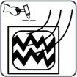**La soudure peut provoquer des interférences dans les équipements électroniques**

Les équipements électroniques, tels que les ordinateurs et les équipements pilotés par ordinateur, comme les robots, peuvent être endommagés par l'énergie électromagnétique. Gardez les câbles courts, proches les uns des autres et aussi bas que possible, pour éviter toute interférence. Le soudage doit être effectué loin de tout équipement électrique sensible. Assurez-vous que cette source de courant de soudage est installée et mise à la terre conformément aux instructions de ce manuel. Si les interférences persistent, l'utilisateur doit envisager de déplacer l'équipement, d'utiliser des câbles blindés, des filtres de ligne ou de protéger l'espace de travail.

**Mesures de sécurité importantes**

* Mettez des gants isolants secs. Évitez de toucher l'électrode à main nue. Le port de gants humides ou endommagés est interdit.
* Des blessures peuvent être causées par la projection de composants. Lors de l'entretien d'un appareil, portez toujours un écran facial. Mettez une casquette et des lunettes de sécurité. Portez un casque de soudage avec la teinte de filtre appropriée. Portez une protection corporelle complète.
* La position la plus instable de l'appareil ne doit pas être inclinée vers le haut de plus de 10°. Les composants auxiliaires tels que les bouteilles de gaz, les unités d'alimentation en fil ou les dispositifs de refroidissement peuvent avoir un impact sur la stabilité selon le type d'équipement, et il faut en tenir compte.
* Avant de changer les consommables de la torche, de travailler sur la machine, mettez-la hors tension et débranchez la fiche d'entrée.
* Après la mise hors tension, une tension dangereuse subsiste sur les condensateurs d'entrée. Ne pas entrer en contact avec des condensateurs complètement chargés. Attendez toujours 60 secondes après avoir coupé le courant avant de travailler sur la machine, et vérifiez que la tension du condensateur d'entrée est proche de zéro avant de toucher une quelconque pièce.

**Minimiser l'exposition CEM (champs électriques et magnétiques) du circuit de soudage / coupage.**

Le soudage à l'arc et les procédés connexes tels que le découpage à la gouge, le découpage au plasma et le soudage par points génèrent un champ électromagnétique autour des circuits de soudage. Certains dispositifs médicaux, comme les stimulateurs cardiaques, peuvent être affectés par les CEM. Des précautions de protection doivent être prises pour les personnes qui ont des implants médicaux. Par exemple, il faut limiter le passage ou procéder à une évaluation individuelle des risques pour les soudeurs. En suivant les procédures appropriées, l'exposition aux CEM peut être réduite. Torsadez ou scotchez les câbles ensemble, ou utilisez un cache-câble, pour les maintenir proches les uns des autres.

**Précautions concernant les dispositifs médicaux implantés:**

Avant d'effectuer ou de s'approcher de procédures de soudage à l'arc, de soudage par points, de gougeage, de découpe au plasma ou de chauffage par induction, les porteurs de dispositifs médicaux implantés doivent consulter leur médecin et le fabricant du dispositif. Ne suivez les procédures ci-dessus que si votre médecin vous a donné son accord.

Évitez de mettre votre corps entre les câbles de soudage ou de coupe. Disposez les câbles de manière à ce qu'ils soient sur le côté et loin de l'opérateur. Travaillez loin de la source de courant de soudage et ne vous asseyez pas ou ne vous appuyez pas dessus. Gardez votre tête et votre corps aussi loin que possible de l'équipement du circuit de soudage. La pince de travail doit être reliée à la pièce à souder aussi près que possible de la zone de soudure ou de coupe. Le soudage ne doit pas être effectué en portant la source de courant de soudage ou de coupe ou le dévidoir de fil. Si vous avez un dispositif médical implanté dans votre corps, vous devez consulter votre médecin avant d'effectuer ou de vous approcher d'activités de soudage à l'arc, de soudage par points, de gougeage ou de découpe à l'arc plasma. N'enroulez pas les câbles autour de votre corps et ne les enroulez pas.

Il est de la responsabilité de l'utilisateur d'installer et d'utiliser l'équipement plasma conformément aux instructions du fabricant. Si des perturbations électromagnétiques sont détectées, il est de l'obligation de l'utilisateur de résoudre le problème avec l'aide technique du fabricant. Dans d'autres circonstances, il peut être facile de résoudre le problème en reliant la machine de découpe à la terre et à la pièce de travail. Dans d'autres circonstances, il peut s'agir de construire un écran électromagnétique qui entoure la source d'énergie et la zone de travail, ainsi que d'appliquer certains filtres d'entrée.

Les équipements de coupe doivent être connectés à la source d'alimentation conformément aux instructions du fabricant. Si des interférences se produisent, des précautions supplémentaires, telles que le filtrage de l'alimentation secteur, peuvent être nécessaires. Le blindage du câble d'alimentation de l'équipement de coupe installé en permanence dans un conduit métallique ou équivalent doit être envisagé. Le blindage doit être électriquement continu sur toute sa longueur. Le blindage doit être fixé à l'alimentation électrique du matériel de coupe afin de préserver un excellent contact électrique entre le conduit et le boîtier de la source d’alimentation. L’utilisateur doit analyser tout préoccuper électromagnétique dans la région environnante avant d'installer l'appareil. L'utilisateur doit confirmer que tous les autres appareils de la région sont compatibles. Cela peut nécessiter des précautions supplémentaires. Lorsque la pièce de travail n'est pas reliée à la terre pour des raisons de sécurité électrique ou en raison de sa taille et de son emplacement, comme la coque d'un navire ou la construction d'un ouvrage en acier, une connexion reliant la pièce de travail à la terre peut minimiser les émissions dans certains cas. La pièce de travail sans mise à la terre augmente le risque de blessures pour les utilisateurs ou de dommages pour d'autres équipements électriques. La pièce de travail doit être reliée à la terre par une connexion directe à la pièce de travail. Si la connexion directe n'est pas autorisée, la mise à la terre doit être réalisée par des capacités adéquates déterminées conformément aux règles nationales.

La modification des dispositions du circuit de terre ne doit être autorisée que par une personne qualifiée pour évaluer si les modifications augmentent le risque de blessure, par exemple en activation des voies de retour de courant de coupe parallèles, qui peuvent endommager les circuits de terre d'autres équipements. La norme CEI 60974-9 fournit des conseils supplémentaires, Matériel de soudage à l'arc, partie 9 : Installation et utilisation. Les problèmes d'interférence peuvent être atténués par le blindage sélectif d'autres câbles et équipements situés à proximité directe. Pour certaines applications, le blindage de l'ensemble du système de découpe au plasma peut être envisagé.

**1.6 Warning Label**

This power supply has this warning notice attached to it. It is critical that the operator and maintenance professional comprehend the meaning of these warning symbols.

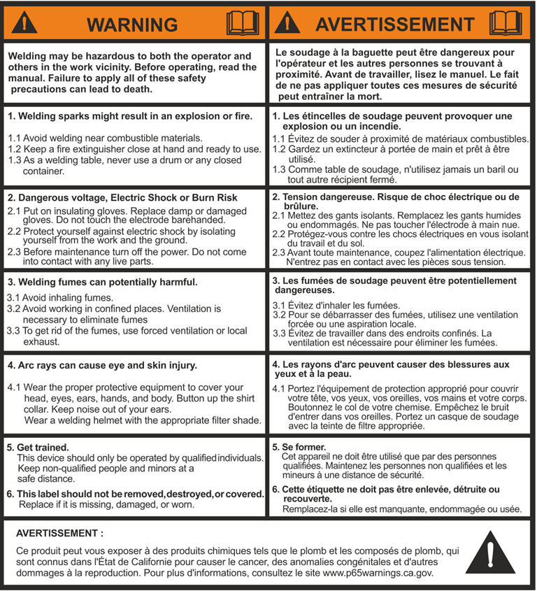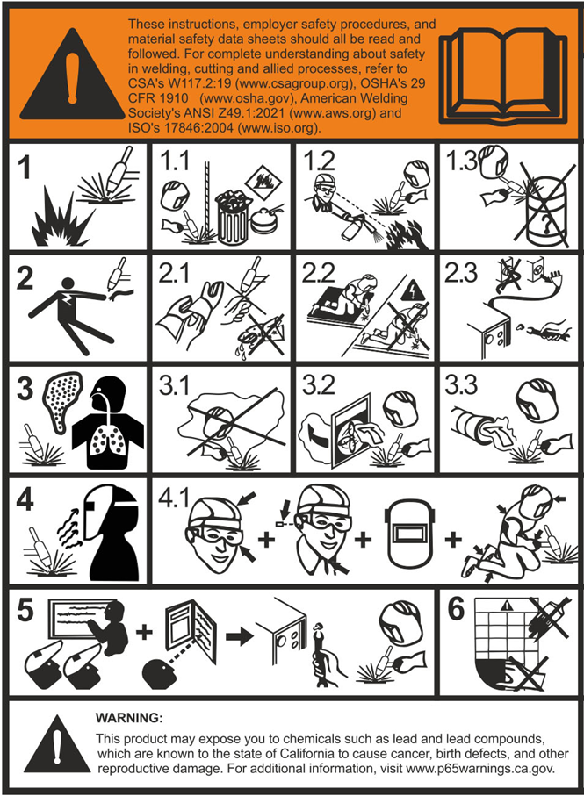

❑Introduction

Thank you for buying our product. In order to get the best performance out of the equipment and ensure the maximum lifespan of its parts, the use and maintenance instructions contained in this manual must be read and strictly complied with, as well as the safety instructions. They will help you to avoid potential hazards that may exist when working with this product or on the worksite. If repairs to the equipment are required, we recommend that our clients contact our service center workshops, as they have the necessary equipment and personnel that are specifically trained and constantly updated.

All our machines and equipment are constantly developed and so changes may be made in terms of their construction and features.

❑Description

The **TIG AC/DC 421 PULSE** series welders utilize advanced Pulse Width Modulation (PWM) and IGBT power modules, operating at medium frequency. This technology replaces bulky traditional line-frequency transformers with compact medium-frequency transformers, resulting in a portable, small, lightweight, and energy-efficient design.

All front panel parameters are continuously and steplessly adjustable, including: start current, crater arc current, welding current, base current, duty cycle, upslope time, downslope time, pre-gas flow, post-gas flow, pulse frequency, hot start, arc force, and arc length. High-frequency, high-voltage arc initiation ensures reliable arc striking.

**Description and advanced features**

* **Input Voltage**: 575V, Three-Phase
* **Technology**: IGBT inverter for stable output, increased reliability, and high duty cycle.
* Phase loss protection with automatic shutdown to prevent damage.
* **TIG Starting**: Lift TIG and HF (High Frequency) start modes for versatility, especially around sensitive electronics.
* **SMAW Welding**: Adjustable arc force, hot start, and anti-stick control for improved control and ease of use.
* **Thin Material Performance**: Excellent performance on ultra-thin materials with minimal distortion.
* **Trigger Control**: 2T/4T/Spot welding modes.
* **Design**: Modernized appearance and user-friendly panel layout.
* **Display**: LCD screen for precise setting and feedback of welding parameters.
* **Protection**: Integrated temperature, voltage, and current sensors for enhanced protection.
* **Generator Compatibility**: Designed for use with diesel generators, tolerating voltage fluctuations.
* **AC Waveforms**: Square, Sine, and Triangular.
* **AC Balance Control**: Optimizes oxide removal and cleaning during aluminum welding.
* **Adjustable AC frequency** for precise arc control.
* **Independent EP/EN amplitude adjustment** for optimized cleaning and penetration.
* **Standard Features**: Integrated heavy-duty industrial trolley and water cooler.
* **MCU control system**, responds immediately to any changes.
* In Lift TIG mode, when the tungsten electrode touches the workpiece, the current will drop to short-circuit current to protect tungsten.
* **Double purposes**: AC inverter TIG/SMAW and DC inverter TIG/SMAW, excellent performance on Al-alloy, carbon steel, stainless steel, titanium.
* **TIG AC/DC 421 PULSE** is suitable for all-position welding of stainless steel, carbon steel, alloy steel, titanium, magnesium, and copper alloys. Applications include pipe installation, mold repair, petrochemical work, architectural decoration, automotive and bicycle repair, fabrication, and general manufacturing.

**Important Notice for Air-Cooled Operation:**

If you wish to operate the machine in air-cooled mode, please make sure to install the air-cooling jumper connector before use.

If this connector is not connected, the machine will display an error indicating a disconnected water-cooling unit.

Therefore, it is essential to connect the provided jumper connector located at the back of the machine to the fixed 5-pin female connector.

We also emphasize the importance of selecting an **air-cooled torch compatible with the machine’s capacity and duty cycle. Using a water-cooled torch while the machine is set to air-cooled mode will damage the torch, and such damage is not covered under Canaweld’s warranty.**

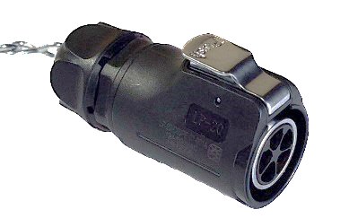

Jumper Connector

**Other Features of the Machine (Auto-switching Fan)**

The fan may be switched on and off based on the temperature sensed by a thermal sensor. Speed control is an ideal method for matching the delivery of air with the demands of the application. By controlling the fans and not running them continuously, you will be able to provide exactly the right amount of cooling or ventilation for your equipment, while providing real benefits in energy consumption, time between failures, and whole-life costs.

Here are some key benefits of using an auto-switching fan instead of a continuous-working alternative:

**Power Consumption**

A continuously working fan will always consume 100% power when switched on. Using an auto-switching fan reduces power consumption.

**Noise**

Using an auto-switching fan will also reduce noise.

**Life Expectancy**

Running at full speed, a fan will draw the most power and have the greatest power dissipation, which means its motor will be running at its hottest. This primarily affects the wires and the grease in the bearing system, which is the component with the shortest life expectancy. Using an auto-switching fan creates less heat, which will extend the life of the wire and bearings and the longevity of the fan. A longer-lasting fan means a greater interval between service intervals, saving on the cost of a replacement fan and the labor required to replace it.

**Clean parts**

Fan on demand ensures minimum dust and contamination are deposited over the electronics and other parts of the machine, so we can expect a longer life span for the parts and machines.

❑Technical Data

The general technical data of the system is summarized in

**Table 1**.

**Specifications, Quality control and Test Conditions**

The specification of the machine has been tested as International and North American standards in the lab. All the tests have been done in below conditions as CSA C22.2 No. 60974-1:19 Arc welding equipment — Part 1, Welding power sources and International Standard IEC 60974-1.

**Table 1**

|  |  |  |  |  |
| --- | --- | --- | --- | --- |
| **Model** | **TIG AC/DC 421 PULSE** | | | |
| Process | TIG | | SMAW | |
| AC | DC | AC | DC |
| Power Supply Voltage(V) | 3 ~ 575 | | | |
| Power Frequency(HZ) | 50/60 | | | |
| Primary Current @I2 Max (A) | 23 | | 28 | |
| I 1eff max (A) | 15 | | 19 | |
| Current Range (A) | 10-420 | 5-420 | 10-420 | |
| Duty Cycle @ 100% in 104°F (40°C) (A) | 305 | 315 | 305 | |
| Duty Cycle @ 60% in 104°F (40°C) (A) | 350 | 360 | 350 | |
| Duty Cycle @ X% in 104°F (40°C) (A) | 420(40%) | | 420(35%) | |
| Open Circuit Voltage (V) | 97 | | 97(14.5 with VRD active) | |
| Process | TIG AC (HF), TIG DC (HF)  TIG AC (Lift), TIG DC (Lift)  STICK AC, STICK DC | | | |
| Tungsten Diameter (in. (mm)) | 0.02, 0.04, 1/16, 3/32, 1/8, 5/32, 3/16  (0.5, 1, 1.6, 2.4, 3.2, 4.0, 4.8) | | | |
| Insulation Class | F | | | |
| Protection Class | IP21S | | | |

**The tests are performed at 104 °F (+40°C), Humidity of 50 % @ 104°F (+40°C) and altitude of below 1000 m from sea level.**

**NOTE: CANAWELD** is always striving to produce the best possible products and improving the quality. Therefore, reserves the right to change, improve or revise the specifications or design of this or any product without prior notice. Such updates or changes do not entitle the buyer of equipment previously sold or shipped to the corresponding modifications, updates, improvements, or replacement of such items. The values specified in the table above are optimal values, your values may differ. Individual equipment may vary from the above specifications due in part, but not exclusively, to any one or more of the following: variations or changes in manufactured components, installation and conditions and power grid supply conditions.

❑Usage Limits (IEC 60974-1)

TIG AC/DC welders operate intermittently, with welding periods interspersed with rest periods for tasks like part positioning, electrode maintenance, and post-weld cleaning. This welder is designed to safely deliver a maximum nominal current of I2 for a duty cycle of X%. A duty cycle represents the percentage of a 10-minute period during which the welder can operate at its rated output. Exceeding the specified duty cycle will activate a thermal overload protection switch, safeguarding internal components from overheating and preventing malfunction. After a cooling period (several minutes), the overload protection automatically resets, and the welder is ready for use again. This equipment carries an IP21S protection rating.

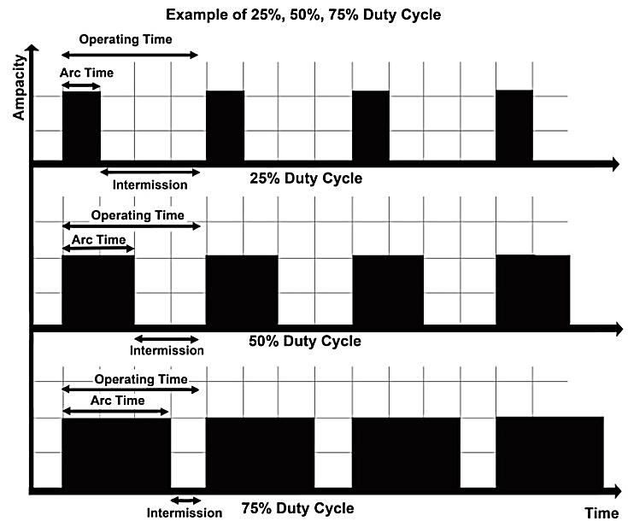

❑How to Lift Up the Machine

You'll need two lifting straps with a capacity exceeding the weight of the machine. Thread each strap through a handle on the welding machine, creating a loop under the machine. Tighten and secure the straps around the handles. You can use buckles, hooks, or other fastening mechanisms depending on your straps. If the weight feels manageable, you might be able to lift the machine with your arms while holding the straps for stability. This is best done with a partner on each side for better balance and safety. Lifting a heavy object like a welding machine can strain your back and lead to injuries, especially if done incorrectly.

Using the trolley reduces the risk of back strain and makes transportation much easier.

Warning: do not touch live electrical parts. Disconnect input power cord before moving unit. Place unit on a proper skid and secure in place before transporting with a fork lift or other vehicle.

Note: These hoisting and transportation devices conform to local and national standards. Do not use other hoisting and transportation systems.

❑Open the Packaging

Upon receiving the system:

* Remove the welding generator and all relevant accessories components from their packaging.
* Check that the weld machine is in good condition, if not report any problems immediately to the seller-distributor.
* Make sure all ventilation grilles are open and that no foreign bodies are blocking the air circulation.

❑Installation and Connections

The installation site for the system must be carefully chosen in order to ensure its satisfactory and safe use. The user is responsible for the installation and use of the system in accordance with the producer’s instructions contained in this manual. Before installing the system, the user must take into consideration the potential electromagnetic problems in the work area. In particular, we suggest that you should avoid installing the system close to:

* Signaling, control and telephone cables.
* Radio and television transmitters and receivers.
* Computers and control and measurement instruments.
* Security and protection instruments.

Persons fitted with pace-makers, hearing aids and similar equipment must consult their doctor before going near a machine in operation. The equipment’s installation environment must comply to the protection level of the frame i.e. IP 21 S (IEC 60529 publication). The system is capable of working in environments where working conditions are particularly hard.

This system is cooled by means of the forced circulation of air, and must therefore be placed in such a way that the air may be easily sucked in and expelled through the apertures made in the frame.

The equipment must be assembled as follows:

* Connect the welding machine to the utility line.
* Connect up the welding cables.

General requirements for work area:

* Ensure a clear, well lit work area with unrestricted movement for the operator.
* The work area should be well ventilated, as welding emits fumes which can be dangerous.
* Always maintain easy access to the ON/OFF switch of the welder, and the electrical mains supply.
* Do not expose the welder to rain and do not operate in damp or wet locations.

Where welding must be undertaken in environments with increased risk of electric shock, confined spaces or in the presence of flammable or explosive materials, it is important that the environment be evaluated in advance by an “expert supervisor”. It is also recommended that welding in these circumstances be carried out in the presence of persons trained to intervene in emergencies.

❑Connecting the Welding Machine to the Utility Line

Connection of the machine to the user line (electrical current) must be performed by qualified personnel.

Before connecting the welding machine to the mains power supply, make sure that rated voltage and frequency correspond to those provided by the mains power supply (The serial number and rating information is located on the case of the machine. Use the rating plate information to determine input power requirements and rated output.) and that the welding machine’s power switch is turned to “O”. Electrical installation must meet all National and Local Codes. Only a qualified electrician may do the installation. The four pole cable supplied with the system must be used for the connection to the mains power supply. This cable is made up:

* Three conductors that are used to connect the machine to the power supply.
* The fourth, which is YELLOW/ YELLOW-GREEN, is used for making the “GROUND” connection.

Connect a suitable load of normalised plug (3p + e) to the power cable and provide for an electrical socket complete with fuses or an automatic switch. The ground terminal must be connected to the ground conducting wire (YELLOW/ YELLOW-GREEN) of the supply.

**WARNING:** this machine is designed for 575VAC input. Connecting it to any other voltage will cause damage.

**Note 1:** Do not use PVC welding cable. Use SOOW or H07RN-F or an equivalent.

**Note 2:** When using extension cords, ensure they are the same gauge or thicker (larger diameter) than the original power cable supplied with the machine. Do not use extension cords with a smaller gauge (thinner diameter) than the original cable.

**Note 3:** Motor start fuses or thermal circuit breakers are recommended for this application. Check local requirements for your situation**.**

Table 2 shows the capacity values that are recommended for fuses in the line with delays.

**Table 2**

|  |  |
| --- | --- |
| **Model** | **TIG AC/DC 421 PULSE** |
| Rated Input Voltage/Frequency | 3 Phase 575V±10%, 50/60 HZ |
| Rated Input Capacity* | 16.1 KVA |
| Maximum Primary Current | 28 A |
| Input Protection | D35 |
| Recommended Cord Size (Minimum) | 10 AWG |
| Recommended Extension Cord Length | 10 ft. |
| Recommended Grounding Conductor Size | 10 AWG |

* Rated input capacity is calculated based on TIG mode at maximum input current, Actual power may vary depending on welding mode and load conditions.

**Improving the Input Supply Network:**

In case the input supply voltage network is not stable, improve it, if possible, Such as:

Reduce the number of powerful electrical devices operating simultaneously, using the same power supply.

Increase the cross section of the power supply cable in the event of a significant voltage drop. Consult an electrician for the cable cross section calculation.

If possible, ask your workshop electricity supplier, change the tap of your power transformer network, and decrease or increase your network input voltage, and receive a stable voltage for all appliances in your workshop.

❑ Connection to Generator

The machine can be connected to the generator. The THD (Total Harmonic Distortion) of the generator must be less than 5%.

Make sure the power of the generator is more than the welding machine. Make sure the power of generator is continuous duty or maximum and compare it with maximum and power of the welding machine in 100% duty cycle. A clean, stable sine wave generator can be used as a power source for the machine. Output voltage spikes can damage the components of the machine.

For full performance welding with 420A output current, a three phase generator with minimum 30KVA is required. A limited performance TIG welding can be achieved by a 18KVA 3-phase generator.

❑ Command and Control Units

In **Fig. A**:

1. TIG torch control cable connection
2. Fast coupling straight polarity
3. Fast coupling TIG torch gas tube
4. Fast coupling reverse polarity
5. Power supply switch. In the "O" position the welder is off
6. Water cooled unit connector (Power supply)
7. Mains cable
8. Welding gas input joint
9. Water cooled unit connector (Unit control)
10. Power source fuse (3A)
11. Power source fuse (3A)
12. Positive output terminal, connect the electrode holder here when welding with cellulosic electrodes.

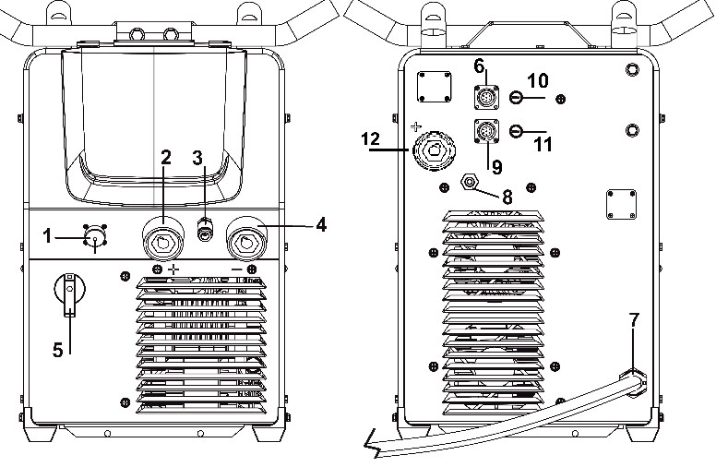

**Fig. A**

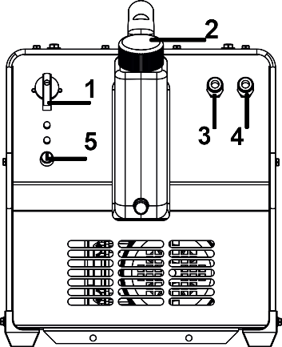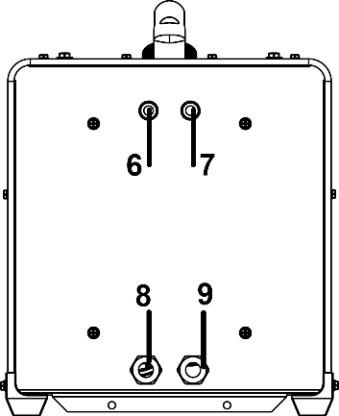

**Fig. B**

In **Fig. B**:

1. Power switch for cooling unit
2. Coolant/Water inlet
3. TIG water outlet (Blue)
4. TIG cooling water return connection (Red)
5. The cooling unit fuse
6. The fittings shown on the back panel of the cooling unit are intended for connecting the inlet and outlet water hoses from the torch. The inlet line which sends cooling water to the torch, is typically by the blue color. the outlet line which returns heated water from the torch, is usually marked red. (Reserved)
7. Refer to the description for Pos.6
8. Water cooling control connection
9. Water cooling power connection cable

**Cooling unit water level calibration:**

Ensure the proper water level by following these guidelines:

* Check the water level manually by opening the tank and visually inspecting the water inside.
* Do not overfill to prevent overflow and system inefficiency.
* If the water level is too low, add water through the intake to maintain proper operation.

**TIG connections (3 and 4)** are located on the same side as the intake (2). Connect the blue outlet to the TIG torch's water supply and the red return to the torch's water return.

**Warning:** Incorrect connection will damage the equipment.

**Cooling unit connection cables (8 and 9)** connects the water tank to the welding machine for power, control, and feedback signals.

❑ Front Panel Functions and Descriptions

Control Panel

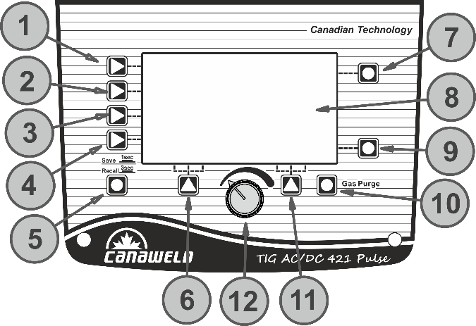

1. Welding Mode Button: Press to select SMAW, HF TIG, or Lift TIG welding mode.
2. Output Waveform Button. Press to select the output waveform: **DC Output**, **AC Square Wave**, **AC Sine Wave**, or **AC Triangle Wave**.
   1. **DC Welding Output** – Suitable for DC TIG welding.
   2. **AC Square Wave Output** – Provides a focused arc for maximum penetration, fast travel speed, and excellent directional control.
   3. **AC Sine Wave Output** – The traditional AC TIG welding waveform, offering a quieter, "soft" arc characteristic.
   4. **AC Triangle Wave Output** – Reduces heat input at the same current setting, making it especially useful for welding thin metal.
3. Trigger Mode Selection Button: Press to choose between 2T and 4T trigger modes.
4. Welding Function Button: Press to enable or disable Pulse mode and Spot welding mode.
5. Save and Recall Button (JOB): Press and hold for 3 seconds to open the JOB program or 1 second to save parameters to a JOB number.
6. Function A Button.
7. Parameter A Button: Press to select Hot Start in SMAW mode or Balance/AC Frequency in TIG mode. If not pressed within 3 seconds, the selection will be automatically canceled.
8. Screen: Displays all welding parameters, including welding voltage, welding current, and other settings.
9. Parameter B Button: Press to select Arc Force (SMAW mode) or diameter size (TIG mode). If not pressed within 3 seconds, the selection will be automatically canceled.
10. Gas Purge: Press the Gas Purge Button to release shielding gas before welding, ensuring the work area is properly covered. The gas purge operates for a limited time. If the Gas Purge Button is pressed again, the gas flow will stop.
11. Function B Button.
12. Parameter Select/Adjust Knob.

A summary of the functions and welding parameters is as follows:

|  |  |
| --- | --- |
| Pre-Gas Flow | 0.05_5 seconds |
| Post-Gas Flow | 0.1_25 seconds |
| Start current (AC,DC) | 10_420A (AC), 5_420A (DC) |
| Upslope | 0_20 seconds |
| Welding Current | TIG:10-420A (AC),TIG:5-420A (DC), SMAW:10-420A |
| Down-Slope | 0_20 seconds |
| Crater Current (End Current) | 10_420A |
| Balancing of the time | 10-90% |
| Balancing the amplitude of the current | 10_420A |
| Pulse Frequency | 0.5_999Hz |
| Pulse width | 5_95% |
| AC Frequency | 50_250HZ |
| Arc Force | 0_10 |
| Hot Start | 0_10 |

**Trigger mode selecting button (3)**

* **2T Trigger Mode:** In 2T mode, you hold the trigger to activate the welding circuit. When you release the trigger, the circuit stops. This mode doesn't require adjustment of start or crater currents. It's suitable for applications like:
  + Re-tack welding
  + Transient welding
  + Thin plate welding

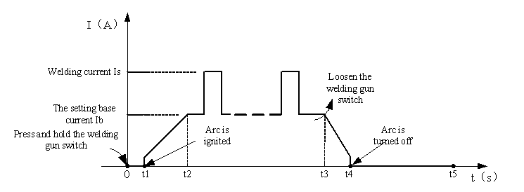

**0: Trigger Activation**, Pressing and holding the gun switch activates the electromagnetic gas valve. This allows the shielding gas to flow, protecting the weld pool from contamination.

**Pre-Gas Flow 0 - t1** (0.05 - 5.0 seconds): Before the arc ignites, a pre-determined amount of shielding gas flows for a duration between 0.05 and 5.0 seconds. This purges the welding area of any contaminants.

**Arc Ignition and Current Ramp-Up (t1 - t2):** once the pre-gas time elapses (t1), the arc ignites. The welding current then rises from its minimum setting to the desired welding current (Iw or Ib).

**Welding (t2 - t3):** As long as the gun switch is held down (t2 to t3), the arc and welding current are maintained, allowing you to complete the weld.

Note: When pulsed mode is selected, the welding current alternates between a base current and welding current. This helps control heat input and improve weld penetration. If pulsed mode is not selected, the machine will continuously output the set welding current value.

**Down-Slope (t3):** Upon releasing the gun switch (t3), the welding current doesn't cut off abruptly. Instead, it gradually decreases according to the pre-selected down-slope time setting. This helps prevent crater cracking in the weld pool.

**Arc Termination (t3 - t4):** During the down-slope period (t3 to t4), the current reduces from the set welding current (Iw orIb) to the minimum welding current setting. This allows the arc to extinguish smoothly.

**Post-Gas Flow (t4 - t5):** Even after the arc extinguishes (t4), shielding gas continues to flow for a user-adjustable post-flow time (0.1 to 25 seconds) set using the front panel knob. This protects the solidifying weld pool from contamination.

**Welding Completion (t5):** Once the post-flow time elapses (t5), the electromagnetic gas valve shuts off, stopping the flow of shielding gas. This signifies the completion of the welding process.

* **4T Trigger Mode:** In 4T mode, you activate the welding circuit by pulling and then releasing the trigger. To stop welding, simply pull and release the trigger again. This eliminates the need to hold the trigger continuously, making it ideal for longer welds. TIG machines with 4T mode often offer additional current control options. You can pre-set the start current and crater current.

**Start current:** This helps initiate the arc smoothly, especially when welding thicker materials.

**Crater current:** This reduces the welding current at the end of the weld to prevent crater cracking.

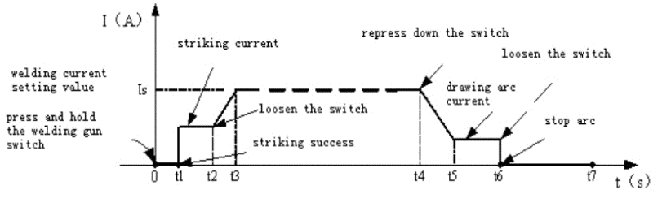

**Initiating the Weld (0 - t4):**

**Trigger Press (t0):** Pressing and holding the gun switch activates the electromagnetic gas valve. This allows shielding gas to flow, protecting the weld area from contamination.

**Pre-Gas Flow (0 – t1):** For a set time (0.05 to 5.0 seconds), shielding gas purges the area before the arc ignites, ensuring a clean weld.

**Arc Ignition and Current Ramp-Up (t1 – t2):** At t1, the arc ignites. The welding current gradually increases from a starting value (set by the welder) to the desired welding current (Iw or Ib).

**Upslope (t2):** After the initial ignition, the current smoothly ramps up to the final welding current. This upslope time can be adjusted for optimal weld quality.

**Upslope Completion (t2 – t3):** After the initial increase from the start current, the welding current smoothly reaches the final set value (Iw or Ib) during this adjustable upslope time. This helps prevent weld spatter and improves arc stability.

**Welding (t3 – t4):** Once the upslope completes (t3), you can begin welding. During this stage, the gun switch can be released and the set welding current is maintained as you create the weld.

Note: When pulsed mode is selected, the welding current alternates between a base current and welding current. This helps control heat input and improve weld penetration. If pulsed mode is not selected, the machine will continuously output the set welding current value.

**Down-Slope (t4):** Releasing the trigger again (at t4) initiates a down-slope phase. The welding current gradually decreases according to the pre-selected down-slope time setting. This helps prevent crater cracking in the weld pool by allowing the molten metal to solidify more smoothly.

**Down-Slope to Crater Current (t4 – t5):** During this adjustable down-slope period (t4 to t5), the welding current gradually reduces from the set welding current (Iw or Ib) to a pre-selected crater current. This controlled decrease helps prevent crater cracking in the weld pool as the metal solidifies.

**Crater Current Time (t5 – t6):** This option clarifies that t5 to t6 represents the duration the welding current remains at the pre-set crater current value.

**Arc Shut-Off (t6):** Releasing the trigger again (at t4) initiates the down-slope phase. Once the down-slope period concludes (t6), the arc extinguishes.

**Post-Flow (t6 – t7):** Even after the arc extinguishes, shielding gas continues to flow for a user-adjustable post-flow time (set using the front panel knob). This protects the solidifying weld pool from contamination. The post-flow time can be adjusted on the front panel (t6 onwards).

**Welding Completion (t7):** Once the post-flow time elapses (t7), the electromagnetic gas valve shuts off, stopping the flow of shielding gas. This signifies the completion of the welding process.

**Function A Button (6):**

* In **HF TIG/Lift TIG** mode, press to select **Pre-gas time**, **Pre-current**, and **Up-slope** **time**.
* In **Spot Welding mode**, press to select **Pre-gas time**.
* In the **JOB program**, press to load the parameter settings for the selected number.

**Function B Button (11):**

* In **HF TIG/Lift TIG** mode, press to select **Down-slope time**, **Post-current**, and **Post-gas time**.
* In **Spot Welding mode**, press to select **Post-gas time**.
* In the **JOB program**, press to delete the parameter settings for the selected number.

**Parameter Select/Adjust Knob (12):**

Press to select parameters such as **welding current**, **peak** **current**, **base** **current**, **pulse** **frequency**, **pulse** **width**, and **JOB** **program** **number**. Rotate to adjust the parameter values.

❑SMAW (Stick) Display Introduction

1. **Welding Mode Button**: Press to enter SMAW welding mode.
2. **Output Waveform Button**: Press to select DC output or AC Square Wave output.
3. **Parameter A Button**: Press to select Hot Start (Setting range: 0–10).
4. **Parameter B Button**: Press to select Arc Force (Setting range: 0–10).
5. **Parameter Adjust Knob:** Rotate to adjust welding current, Hot Start, and Arc Force values.
6. **Current Display**: Shows welding current during operation; otherwise, displays the selected current.
7. **Welding Voltage Display**: Shows welding voltage.

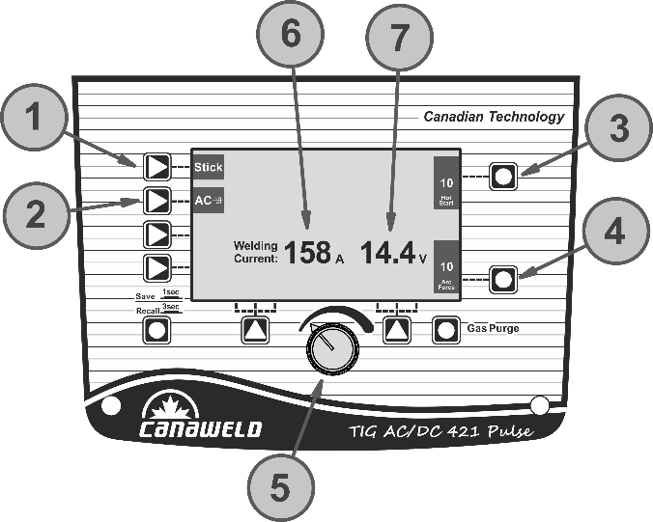

❑HF/LIFT TIG Display Introduction

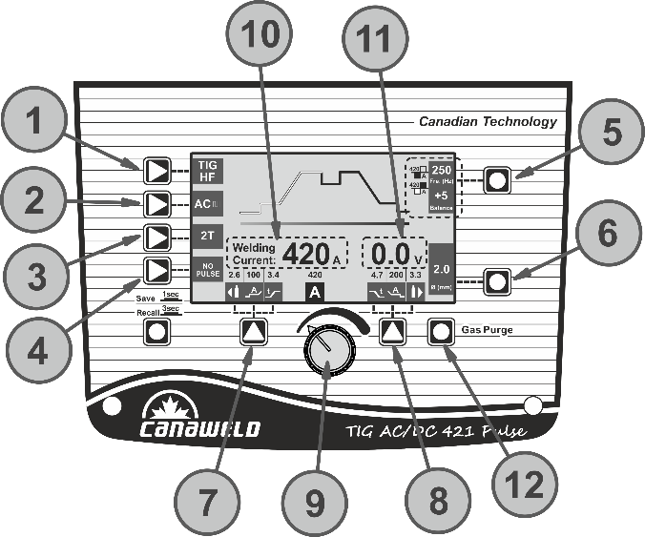

1. **Welding Mode Button**: Press to enter either TIG HF or Lift TIG welding mode.
2. **Output Waveform Button**: Press to select either DC output or AC wave output.
3. **Trigger Mode Button**: Press to select between 2T or 4T trigger mode.
4. **Welding Function Button**: Press to select one of the following welding functions: No Pulse, Pulse, Multi Spot, or Single Spot.

**Note:** Spot function is unavailable in Lift TIG mode.

1. **Parameter A Button**: Press to select either AC Balance (10 to 90%), AC Frequency (50–250 Hz), or to balance the amplitude of the current(10_420A).
2. **Parameter B Button**: Press to select the diameter size.
3. **Function A Button**: Press to select the following functions: Pre-gas time, Start arc current, or Up slope time.
4. **Function B Button**: Press to select the following functions: Down slope time, End arc current, or Post-gas time.
5. **Parameters Select/Adjust Knob**: Press to select the welding current and other parameters. Rotate to adjust the selected parameter’s value.
6. **Current Display**: Displays the welding current during operation. Otherwise, it shows the current selected.
7. **Welding Voltage Display**: Displays the welding voltage during operation.
8. **Gas Purge Selecting Button**: Allows the welder to check and adjust gas flow without striking an arc.

❑TIG Pulse Display Introduction

1. Peak current: 10_420A.
2. Base current: 10_420A, but less than Peak current.
3. Pulse frequency: 0.5_999Hz.
4. Pulse width: 5_95%.

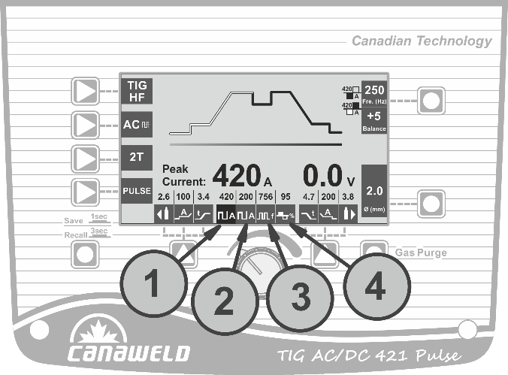

❑TIG Spot Display Introduction

1. Current display: 10_420A (AC), 5_420A (DC).
2. Ton display: 0.1_10.0s.
3. Toff display: 0.2_10.0s. (Toff can only be adjusted in multi spot mode)

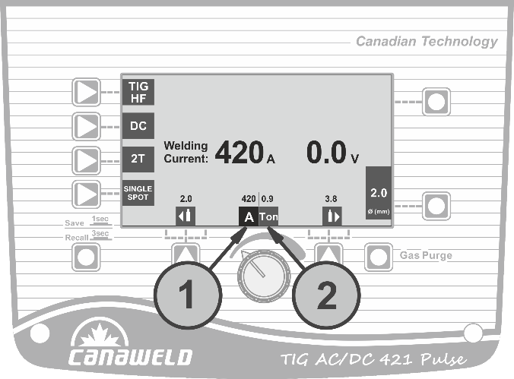

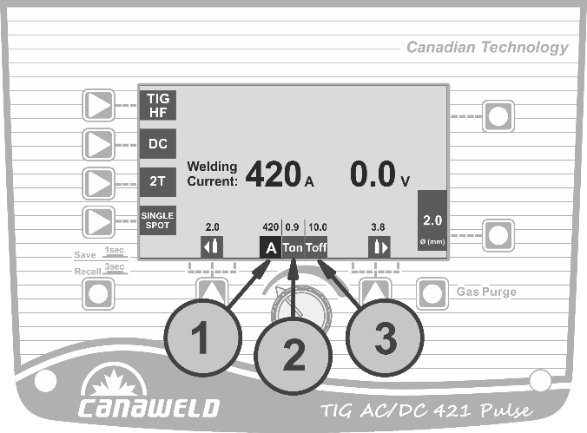

❑JOB Program Introduction

1. **Welding Mode Display**: Shows the currently selected welding state.
2. **Parameters Display**: Displays all the selected parameter values.
3. **JOB Number**: A total of 1–10 JOB numbers can store or call the selected parameter settings using the JOB button.
4. **Load/Delete Display**: Press Function A/B button to load or delete the parameter settings for the selected JOB number.

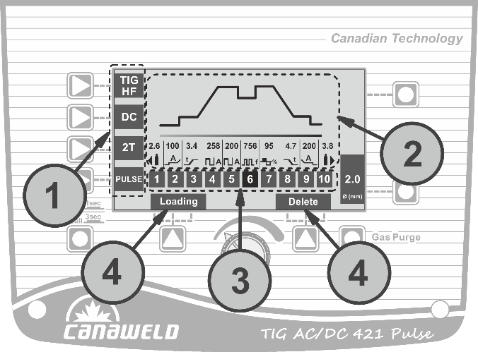

❑Optional Accessories

**Pairing and Unpairing the Remote Foot Pedal**

**Before you begin:**

* Make sure the foot pedal battery is new and fully charged.
* Set the foot pedal switch to the ON position.

**Pairing the Foot Pedal**

1. Press and hold the encoder knob on the machine.
2. While holding the knob, turn the machine ON.
3. The display will show “Connecting”.
4. At this moment press and release the foot pedal several times.
5. The machine will then enter the main operating mode and you will also hear the HF ignition sound.
6. The foot pedal is now paired. Even if you turn the machine OFF and ON again, the current can still be controlled through the pedal.

**Important:** each time you turn the machine OFF, always set the foot pedal switch back to OFF to preserve battery life.

**Unpairing the Foot Pedal**

If you want to use the foot pedal with another machine, you must first unpair it from the current machine:

1. Press and hold the encoder knob.
2. Turn the machine ON while holding the knob.
3. When the display shows “Connecting”, do not press the foot pedal.
4. After a few seconds, the pedal will automatically unpair from the machine.
5. You can now pair the foot pedal with another machine following the steps above.

**Canaweld’s** ergonomic full metal foot pedal provides durable and smooth amperage control for the TIG welding applications. Decompressing the pedal fully increases the welding amperage to the max settings. Releasing will lower current to finish weld and initiate gas post flow.

❑TIG Welding Procedure

**Application range**

Regarding materials, thickness, and welding positions, TIG welding is a versatile welding technique. It enables the production of excellent welded joints. Due to a number of intriguing benefits, the method works better than conventional fusion welding techniques. One of these benefits is its adaptability for a wide range of jobs. TIG welding has several uses and can weld practically any metallic material. Today, stainless, acid-proof, and non-scaling steels, as well as aluminum and nickel alloys, are the most often used materials. The technique is distinguished by the production of weld metal with extremely high purity and surface quality. As a result, the process is utilized when welding quality is critical, such as when making goods for the chemical and power industries, or when welding materials prone to scaling, such as titanium and zirconium. Square butt joints may be welded from one side on plate thicknesses ranging from 0.3 to 4 mm without the need of filler metal. TIG welding is mostly utilized in manual welding, but it is also used in automated welding processes such as automatic tube welding and tube sheet welding. The technique adapts itself wonderfully to automation. TIG procedure can be used to connect almost all types of metallic materials if they are at all suitable for fusion welding. It is also a highly clean procedure that ensures a high-quality welded junction while also producing very little spatter and other contaminants. TIG welding also has the unique benefit that, unlike other procedures that use consumable electrodes, the current and feeding of welding consumables are not related. As a result, the welder is able to add only the necessary amount of welding consumable at any given moment and optimize the current for the welding activity. The method is thus especially well-suited for location welding and welding root passes. Due to these benefits, the TIG method is being employed with success in several fields of industries and trade.

Special Characteristics

* High quality
* Smooth and even weld surface
* Spatter free
* Slag formation free
* Wilding without Fume

The TIG welding method, like any other welding approach, must be learned first by practice. The following are some broad pointers for putting this plan into action. In many ways, manual TIG welding is similar to the forward technique of gas welding. In both cases, the torch is held in one hand while the filler material is held in the other. In both cases, the "nozzle" is pointed away from the weld spot, and the welder uses filler metal to weld toward the hand with the filler metal. The welder may manage the amount of heat given to the workpiece in this technique by altering the length of the arc.

**DC TIG Welding**

During the process, the electrode merely serves as a footing for the arc and must not melt (the melting temperature of tungsten is more than 3300°C). When welding with direct current, the electrode is linked to the power source's negative pole, which creates the least heat. The electrode and the molten pool, throughout the welding process, are shielded by a gas, typically pure argon. Any filler material required is fed in by hand, just like in gas welding. The DC power source utilizes DC (direct current), in which the major electrical component, electrons, move in only one direction, from the negative pole (terminal) to the positive pole (terminal). There is an electrical principle at work in the DC electrical circuit that should always be considered while operating any DC circuit.

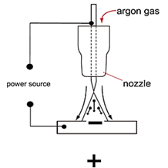

A DC circuit always has 70% of the energy (heat) on the positive side. This is important because it decides which terminal the TIG torch will be attached to (this rule applies to all the other forms of DC welding as well). An arc is formed between a tungsten electrode and the metal workpiece during DC TIG welding. An inert gas flow protects the weld region from contamination of the tungsten, molten pool, and weld area. When the TIG arc strikes an inert gas, it is ionized and superheated, altering its molecular structure and converting it to a plasma stream. The TIG arc is the plasma stream that flows between the tungsten and the workpiece and may reach temperatures of 19,000°C. It is a highly pure and focused arc that allows for the controlled melting of most metals into a weld pool. TIG welding allows the operator the most flexibility to weld the widest range of materials, thicknesses, and types. DC TIG welding produces the cleanest weld possible, with no sparks or splatter.

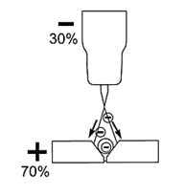

The arc's intensity is proportional to the current flowing from the tungsten. To control the power of the arc, the welder alters the welding current. Thin material typically requires a less strong arc with less heat to melt the material, requiring less current (amps), whereas thicker material requires a more powerful arc with more heat, necessitating more current (amps).

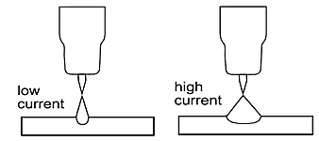

**TIG (Lift) ignition method**

In less sophisticated DC welding, the arc can be struck by lightly brushing the electrode on the workpiece. The arc ignites, when the tungsten electrode tip comes into touch with the workpiece.

The process is described below.

* Place the tungsten electrode tip on the workpiece with care and push the torch trigger afterwards (a factory set amount of current will flow, regardless of the main current set).
* Invert the torch over the torch gas nozzle edge to create a 2-3 mm gap between the electrode tip and the workpiece. The arc ignites, and the welding current is raised to the start or main current set, depending on the selected operating mode.
* Return the torch to its regular welding position.

To end the welding process, release the torch trigger or push and release (depending on the selected method).

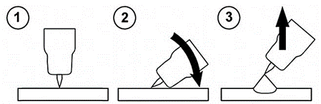

**TIG (Lift) Ignition Method**

**How to TIG Weld?**

Because there are some slight variations between gas and TIG welding, an experienced gas welder who wants to switch to TIG welding must learn a new approach. Managing the filler material, on the other hand, is typically not a problem. A proficient arc welder will find it easier to sustain the arc but will need more skills in accurately applying the filler metal.

**TIG Welding Fusion Technique**

Manual TIG welding is sometimes regarded as the most challenging of all welding procedures. Because the welder must maintain a limited arc length, tremendous care and expertise are necessary to avoid electrode contact with the work piece. TIG welding, like Oxygen Acetylene torch welding, usually takes two hands and requires the welder to manually feed a filler wire into the weld pool with one hand while managing the welding torch with the other. However, some welding involving thin materials, such as edge, corner, and butt joints, can be completed without the need of filler metal. Fusion welding is the process of melting the edges of metal objects together using just the heat and arc force generated by the TIG arc. Once the arc has been begun, the torch tungsten is maintained in position until a weld pool is formed; a circular movement of the tungsten will aid in the formation of a weld pool of the required size. Once the weld pool is formed, tilt the torch at a 75° angle and advance smoothly and evenly along the connection, fusing the materials together.

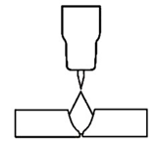

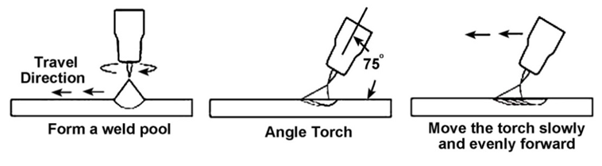

**TIG Welding with Filler Wire Technique**

In many cases, while welding stainless steel and copper, the filler material can be continuously fed into the pool's edge. However, despite the argon shielding, this approach is not recommended for welding aluminum because the aluminum wire would become so hot that scaling would occur on its surface despite the argon shielding. As the wire melts, it transports oxides into the molten pool to such an extent that the arc's cleaning effect on the oxides would be insufficient, resulting in a poor-quality weld. As a result, the wire is pulled back and forth, with the tip sinking beneath the pool's edge at regular intervals. The heavier the gauge of the filler material required to fill up the joint, the thicker the material to be welded. As a result, as the electrode tip is fed into the pool, a heavy filler wire may come into contact with it. It is better to move the torch back and forth along the weld in this case. When the arc's heat has adequately fused the weld point's edges, raise the torch 6 to 12 mm above the weld point and plunge the welding wire tip into the molten pool to be melted off. To continue the fusing process, the wire is pushed back, and the flame is pushed ahead along the weld. The flame and the filler wire both move in a rhythmic back and forth motion.

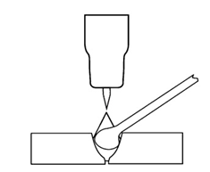

This method is recommended for welding from one side with plate thicknesses more than 6 mm. The filler material is fed in at the pool's edge and must not come into touch with the electrode tip or enter the arc, as seen in the image. The wire tip, on the other hand, must always be maintained close to the molten pool. This keeps it within the argon gas envelope that covers the arc and weld pool, preventing surface oxidation scaling as much as possible. As mentioned before and in many cases, TIG welding requires the addition of filler wire to the weld pool in order to enhance the weld and generate a robust weld. Once the arc has been begun, the torch tungsten is maintained in position until a weld pool is formed; a circular movement of the tungsten will aid in the formation of a weld pool of the required size. Once the weld pool is formed, tilt the torch at a 75° angle and move the torch smoothly and uniformly along the joint. The filler metal is added to the weld pool's leading edge. The filler wire is normally held at a 15° angle and fed into the leading edge of the molten pool; as the torch moves ahead, the arc will melt the filler wire into the weld pool. The wire is fed into the molten pool and withdrawn in a repeated process while the torch is pushed gently and evenly ahead. It is critical to retain the molten end of the filler wire within the gas shield during welding to prevent it from oxidizing and polluting the weld pool.

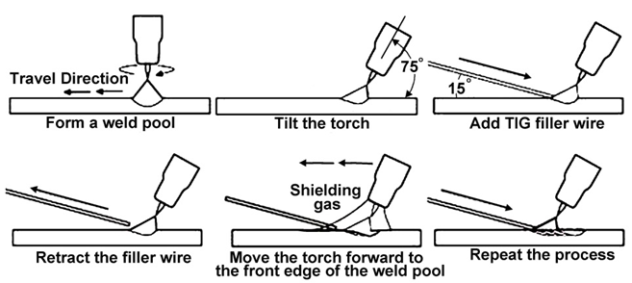

**TIG Torch**

The TIG torch should be as flexible and portable as possible. Therefore, it should be as light as possible to avoid making handling the torch uncomfortable during extended welding sessions. Additionally, it needs to be small enough to allow access in tight spaces. The electrically conducting parts must be designed so that heat buildup does not make the torch unpleasant to wield. There are TIG torches available with self-cooling capacities of up to 250 amps. When higher amperages are required, water-cooled torches should be used. It is possible to change the head angle to find the least fatiguing working position.

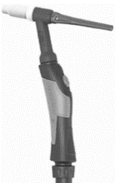

**Shielding gas**

Inert gases shield the weld pool from the negative effects of the ambient air because they do not chemically react with it or mix with other chemicals. Argon makes up around 1% of the volume of the atmosphere and is heavier than air. The best and most popular shielding gas for TIG welding is argon because it is quickly ionized and insensitive to changes in arc length.

The electrode and molten pool are mostly shielded by the gas both during welding and afterwards until they have cooled. Enough gas post-flow time guarantees that the molten metal pool cools off without any contact with ambient air. The flow rate in liters per minute is used to specify the shielding gas supply. This is defined by the weld pool size, which in turn depends on the electrode diameter, gas nozzle diameter, nozzle distance from the surface of the base material, ambient air flow, and type of shielding gas. As a general guideline, add 5 to 10 liters of shielding gas per minute to the most popular tungsten electrode diameters. Manometers can be used to measure indirect flow rate by positioning them in front of an interconnected nozzle that monitors pressure in relation to flow rate. The manometer's scale is directly calibrated in liters per minute. More particularly, float type meters and measuring devices that directly measure using glass tubes measure the actual protective gas flow rate.

**Shielding Gas for protecting the root of welding**

Root gas protects the back of the weld from the effects of air and gives the weld a surface that is resistant to acids and other substances of the kind. Stainless steel, acid-resistant steel, and titanium are examples of materials that need root gas. Pure argon or mixtures of 10% hydrogen and 90% nitrogen are the most often used shielding gases.

**TIG Process Gas Cups**

The purpose of the ceramic gas cup is to shield the tungsten and weld pool from oxidation while welding. There are nozzles of various sizes to provide the coverage required for the majority of applications. The most economical nozzles are made of 90 or 95 percent alumina oxide and are suitable for lower amperage applications. However, these nozzles tend to degrade, break, and come off when used in higher amperage applications since they are not particularly good at withstanding thermal stress.

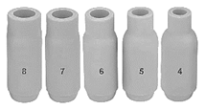

Lava nozzles are more expensive and more resistant to cracking than alumina oxide nozzles. These nozzles perform effectively in situations requiring medium to high amperage.

Some recommended electrode diameter, cup size and gas flow rate have been shown in the following simplified chart. Recommended values may differ according to the actual welding conditions and other parameters such as welding position, workpiece thickness, and ambient temperature and so on.

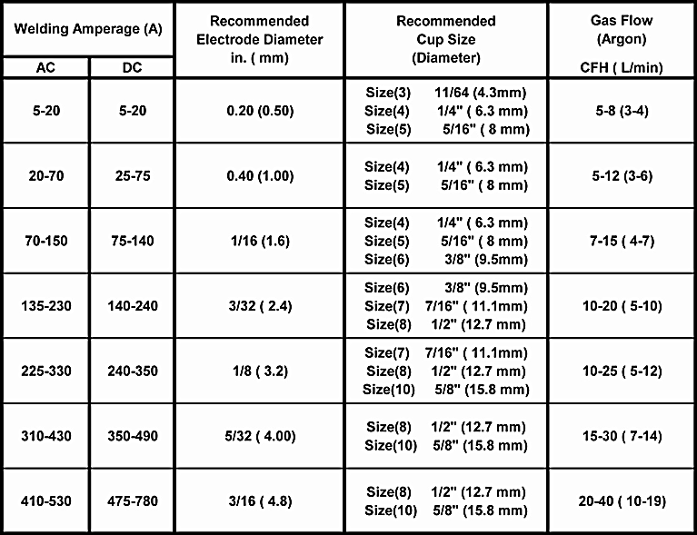

**Note:** Welding with inverter welding machines often requires less heat input (lower amperage). The recommended parameters are all approximate and are only for manual welding, not automated welding. Test the welds to ensure they meet your requirements.

**Gas Lens**

Gas lenses provide better coverage in comparison to the standard Colette bodies. Using a gas lens can reduce gas consumption up to 50%. The electrode stick-out may be increased to 15-20 mm, enabling easier access in small spaces and better welding process monitoring.

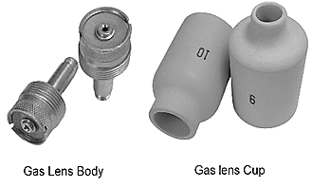

**TIG Welding Filler Metal Rod Consumables**

TIG welding typically employs rod-shaped welding consumables. Welding consumables are often chosen in accordance with the source metal. However, when specific alloying elements are utilized, the welding consumable must differ from the parent metal for metallurgical reasons. The welding consumable's diameter must be matched to the welding task. This is determined by the thickness of the material and the diameter of the tungsten electrode. Welding rods are typically 1000 mm long and to minimize mistakes, they are labeled individually with the name and/or a trade number.

**Cleaning the welding surface**

Before beginning the welding process, it is crucial to properly clean the workpiece's surfaces and the fusion faces for the best welding outcomes. Grease, corrosion, filth, and paint should be removed from the surfaces, and the surface must be bright before welding. Wherever feasible, scale layers should also be eliminated. Frequently, brushing is sufficient, but in some cases, the surface must be processed mechanically, either by grinding or another way. For corrosion-resistant materials, only stainless-steel brushes should be used; otherwise, iron particles on the surface might produce rust. In the case of aluminum, it's crucial that the surface doesn't have a heavy layer of oxide so that pores may form. Use the proper chemicals to clean the welding surfaces. Be aware that solvents containing chlorine may release toxic vapors.

**Tungsten Electrodes**

**Electrodes for TIG welding**

TIG welding normally utilizes four different types of electrodes. They are thorium-alloyed tungsten, zirconium-alloyed tungsten, rare earth-alloyed tungsten, and pure tungsten. Tungsten electrodes are non-consumable and available in a range of sizes; they are constructed of pure tungsten or a tungsten-and-other-rare-earth-element alloy. TIG welding was traditionally performed using pure tungsten electrodes. By alloying this type of electrode metal with thorium or zirconium, several advantages were obtained, including an increase in electron flow, which results in enhanced striking and re-striking and, as a consequence, higher arc stability. Furthermore, alloyed electrodes are more robust, can tolerate higher currents, and are less prone to tungsten inclusions in the weld.

**Pure tungsten (Color Code: Green)**

This electrode is made of pure tungsten and has a melting temperature of 3400°C. The electrode tip must be rounded for welding aluminum alloys. Tungsten is a rare metallic element that is used to make TIG welding electrodes. TIG relies on the hardness and high-temperature resistance of tungsten to transfer the welding current to the arc. Although pure tungsten has historically resisted heat better because it rounds out rather than creating tiny nodules, it is no longer the ideal material for AC TIG welding. Due to the properties of pure tungsten in combination with AC mode welding, the tungsten balls up, resulting in a larger arc cone and potential arc wandering. The tungsten can become so hot that it splits or falls off, contaminating the weld puddle, when the pure tungsten ball becomes larger than the tungsten's exterior diameter. Pure tungsten may still be needed for some welding processes. To focus heat into the weld and away from the electrode in these circumstances, this machine with extended balance control and AC frequency modification is useful. However, the operators won't experience all the advantages of TIG inverter technology by utilizing the pure tungsten electrode.

**Alloyed Tungsten Electrodes**

Alloyed tungsten electrodes, also known as rare earth tungsten electrodes, exceed traditional pure tungsten and help to maximize the operation's quality and productivity since they contain components like cerium or lanthanum. The right alloyed tungsten depends on the material being welded, the required amperage, and whether AC or DC welding current is used. Unlike pure tungsten, which tends to ball up, rare earth tungsten keeps its point. Additionally, rare earth tungsten alloyed is a superior choice for AC TIG welding because of features like enhanced balancing control and output frequency that remove more heat from the tungsten to reduce the nodules. It reduces nodules and keeps an electrode pointed by concentrating less heat on the tungsten. Choosing rare earth tungsten electrodes in combination with the advanced square-wave technology has another benefit that allows the use of the smaller tungsten electrodes, which provide more control and a more concentrated arc. Just keep in mind that, it is impossible to compare electrodes made by different manufacturers simply by considering the oxide percentages, because the crucial production factors, such as the distribution and particle size of the oxide, varies amongst the various producers. The only way to know which tungsten is best for you is to test it out in a real-life experiment. The ends of all tungsten electrodes are color-coded for easy identification. The most common tungsten electrodes are listed below.

**Thoriated (Thorium alloyed) (Color Code: Red)**

This electrode is commonly used in DC welding of stainless steel, mild steel, copper, titanium, and other materials. Thorium alloyed tungsten electrodes contain at least 97.30 percent tungsten and about 2 percent thorium. They are one of the most widely used electrodes in DC TIG welding and are favored for their durability and convenience of usage. Thorium, on the other hand, is a low-level radioactive threat, and many users have shifted to other options. In terms of radioactivity, thorium is an alpha emitter, although the hazards are insignificant when it is trapped in a tungsten matrix. Thoriated tungsten should never come into touch with open wounds or cuts. The most serious threat to welders is when thorium oxide enters the lungs. This can occur as a result of welding vapor exposure or swallowing of material/dust during tungsten grinding. For usage, follow the manufacturer's warnings, directions, and the material Safety Data Sheet (MSDS). Although Thoriated tungsten is still the most often utilized electrode in DC TIG applications, most industry professionals strongly advise utilizing Ceriated or Lanthanated electrodes for both AC and DC TIG welding due to radiation-related problems. This type of tungsten alloy is a good all-purpose electrode. It operates well when overloaded with additional amperage and has one of the lowest work functions. The Thoriated offers a roughly 20% increase in current carrying capacity, usually longer lifespan, and better resistance to weld contamination. Compared to pure tungsten or Zirconiated tungsten electrodes, arc beginning is simpler, and the arc is more stable with these electrodes. When welding steel, it is preferable that it keeps a pointed tip design. Because it is challenging to retain the balled end, which is required for AC welding, it is not frequently utilized with AC TIG welding.

**Rare earth-alloyed tungsten (Color Code: Purple and Turquoise)**

Rare earth-alloyed tungsten electrodes include a minimum of 98 percent tungsten and up to 1.5 percent Lanthanum, as well as tiny amounts of zirconium and Yttrium. Rare earth-alloyed tungsten electrodes have conductivity comparable to Thoriated electrodes. This often implies that the electrodes may be replaced with Thoriated electrodes without needing substantial welding process adjustments. Superior arc starting, electrode longevity, and overall cost-effectiveness are provided by rare earth alloyed. When comparing the electrodes to 2 percent Thoriated tungsten, rare earth-alloyed requires fewer re-grinding and has a longer overall lifespan. In tests, the electrodes' ignition delay actually improves over time, whereas 2 percent Thoriated tungsten begins to degrade after only 25 starts. Rare earth-alloyed tungsten electrodes operate cooler than 2 percent Thoriated tungsten with comparable energy output, prolonging overall tip lifespan. The electrodes operate well in both AC and DC applications. They may be used as a positive or negative DC electrode with a pointed end, or they can be balled for use with AC power sources.

**Ceriated (Color Code: Gray)**

Ceriated tungsten electrodes are defined as having a minimum of 97.30 percent tungsten and 1.80 to 2.20 percent cerium. Ceriated tungsten works best in low current DC welding, and typically operates with around 10% less amps than Thoriated material. The Ceriated electrodes show a slower rate of vaporization or burn-off than pure tungsten. They offer great arc starting at low amperages and have proven popular in orbital tube welding and thin sheet metal operations. They are most commonly used to weld carbon steel, stainless steel, nickel alloys, and titanium, and in some situations, they can replace 2% Thoriated electrodes. Ceriated tungsten is ideally suited for lower amperages and should last longer than un-Ceriated tungsten. Thoriated or Lanthanated tungsten is better suited for higher amperage applications. Due to its characteristics, it is often suitable for quick welding sessions or when a fixed number of welds are required before the electrode needs to be changed. This electrode may be used for AC or DC welding; however, it is typically utilized for DC welding because AC welding could cause it to break.

**Lanthanated (Color Code: Black, Gold, and Blue)**

Minimum 97.80 percent tungsten and 1, 1.5, or 2 percent of lanthanum are present in Lanthanated tungsten electrodes, which are color-coded in black, gold, and blue, respectively. Lanthanum is not radioactive. These electrodes feature strong arc starting properties, a low burn off rate, high arc stability, and good re-ignition characteristics. Starting and maintaining low current arcs generally require 15% less amps. Lanthanated tungsten has the same conductivity properties as 2% Thoriated tungsten. Lanthanated tungsten electrodes are great for improving welding capabilities. They operate well on AC or DC negative electrodes with a pointed end for DC welding, or they can be balled for use with AC sine wave power sources. Lanthanated tungsten keeps its sharpened edge well, which is useful for welding steel and stainless steel on DC or AC from square or sine wave power sources.

**Zirconiated (Zirconium alloyed) (Color Code: White, and Brown)**

Zirconiated tungsten electrodes are composed of at least 99.10 percent tungsten and 0.15 to 0.40 percent of zirconium and it is non-radioactive. This electrode was designed primarily for AC welding; however, it may also be used in DC welding, but AC welding is the most prevalent use. Zirconiated tungsten provides a highly steady arc and is tungsten spitting resistant. Because it preserves a balled tip and is very resistant to contamination, it is perfect for AC welding. It has the same or better current carrying capability than Thoriated tungsten. Zirconium electrodes have a melting point of roughly 3800°C. Zirconiated tungsten electrodes often have welding characteristics halfway between pure and Thoriated tungsten. It is ideal for welding light metals such as aluminum and magnesium.

**Tungsten Electrodes Rating for Welding Currents**

|  |  |  |  |
| --- | --- | --- | --- |
| **Tungsten**  **Diameter**  **In.(mm)** | **DC Current Amps**  **Torch Negative**  **RED (Thoriated)** | **AC Current Amps**  **Un-Balanced  White (Zirconiated)** | **AC Current Amps**  **Balanced  White (Zirconiated)** |
| **0.040 (1.0)** | **15-80** | **15-80** | **20-60** |
| **1/16 (1.6)** | **70-150** | **70-150** | **60-120** |
| **3/32 (2.4)** | **150-250** | **140-235** | **100-180** |
| **1/8 (3.2)** | **250-400** | **225-325** | **160-250** |
| **0.157(4.0)** | **400-500** | **300-400** | **200-320** |

**Note:** Welding with inverter welding machines often needed less heat input (lower amperage). The recommended parameters are all approximate and are only for manual welding, not automated welding. Test the welds to ensure they meet your requirements.

**Tungsten Preparation**

A pointed electrode produces a narrower, more concentrated arc than rounded or unprepared tungsten electrodes. This helps welders maintain a constant bead width and prevent distortion by improving arc control and accurately directing heat at the weld junction. As shown, it is critical that the electrode tip be correctly grounded. If the tip is not in good form, there is a high possibility that the arc will become unstable. The tip in the image has a 30° angle, which is ideal for low amperages.

However, when the welding current increases, the angle must be increased. The table below illustrates the appropriate electrode tip angles. The tip's extreme point should be ground off since it cannot support high currents, burns off quickly, and may contaminate the weld pool. When welding with alternating current, the electrode tip should be softly rounded. It is enough to lightly bevel the electrode's edge. If the electrode tip becomes drop-shaped during AC welding, the amperage is too high for the diameter of the electrode being used.

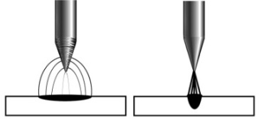

Use only diamond wheels for cutting and grinding. While tungsten is a highly hard material, a diamond wheel's surface is even harder, which allows for more precise grinding. Weld inconsistency and weld flaws can be caused by grinding with aluminum oxide or other non-diamond wheels because they can produce jagged edges, irregularities, or poor surface finishes that are not visible to the naked eye.

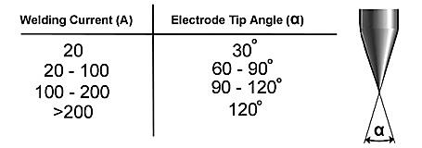

On the grinding wheel, always be sure to grind the tungsten in a longitudinal orientation. If electrodes are ground across, the electrons have to leap over the grinding marks and the arc might start before the tip and wander because tungsten electrodes are created with the molecular structure of the grain running lengthwise. The electrons flow constantly and easily to the end of the tungsten tip while grinding lengthwise with the grain. The arc starts straight and stays steady, narrow, and concentrated.

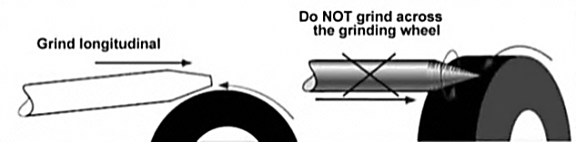

**Electrode Flatted (Truncated) Tip**

In precision arc welding, the form of the tungsten electrode tip is a significant process variable. The demand for various benefits will be balanced by a wise choice of tip/flat size. To assist in maintaining the heat created in the welding arc and lessen the chance of tungsten contamination, a truncated (flatted) tip is suggested rather than a sharp point. However, arc wander will be more likely to happen and arc starting will be more challenging the larger the flat, the weld penetration and electrode life will be improved by raising the flat to the highest height that still permits arc initiation and reduces arc wonder. To facilitate arc beginning, some welders continue to grind electrodes to a sharp point. However, they run the danger of reduced welding performance due to tip melting and the potential for the point to detach and fall into the weld pool.

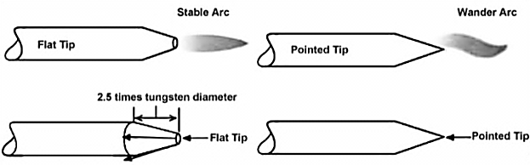

**Tungsten Electrode Grinder**

The biggest health risk to welders is inhaling or ingesting thorium oxide dust created by grinding tungsten. In order to prevent such a hazardous situation, the use of the Canaweld Tungsten Electrode Grinder Utensil is highly advised. The CANAWELD Premium Quality TIG Welding Tungsten Grinder is a time and money investment because it is carefully designed to grind welding electrodes with a precision ground finish for crisp, snappy arc starts, better arc control, clean arc transfer, longer electrode run time, and less tungsten waste. It is made to guarantee the safety of the welders’ eyes, fingers, and lungs. To make this happen, this grinder machine comes with a cover plate. See the grinder user manual for further details.

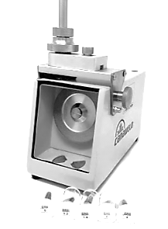

**Electrode Included Angle/Taper - DC Welding**

In addition to tip/flat preparation, tungsten electrodes for DC welding should be ground longitudinally and concentrically with diamond wheels to a particular included angle. Different angles result in various arc shapes and provide various weld penetration capacities. The advantages of blunter electrodes with a larger included angle are generally as follows:

• Be More Durable

• Can withstand higher amps without degrading

• Have superior weld penetration

• Have a thinner arc shape.

Smaller included angles and sharper electrodes offer:

• Have a larger arc

• Provide less arc welding

• Ensure a steadier arc

Weld bead size and form are determined by the included angle. In general, penetration rises, and bead width reduces as the included angle increases.

**Selecting the Size of the Electrode**

The following table can be used as a starting point to choose the suitable electrode diameter based on the necessary welding amperage.

|  |  |  |  |  |
| --- | --- | --- | --- | --- |
| **Tungsten Diameter**  **in. (mm)** | **Diameter at the Tip  in. (mm)** | **Constant Included Angle Degrees** | **Current Range Amps** | **Current Range**  **Pulsed Amps** |
| **0.040 (1.0)** | **0.0050 (0.125)** | **12** | **02 - 15** | **02 - 30** |
| **0.010 (0.25)** | **20** | **05 - 30** | **05 - 60** |
| **1/16 (1.6)** | **0.020 (0.5)** | **25** | **08 - 50** | **05 - 100** |
| **0.032 (0.8)** | **30** | **10 - 70** | **10 - 140** |
| **3/32 (2.4)** | **0.032 (0.8)** | **35** | **12 - 90** | **12 - 180** |
| **0.045 (1.1)** | **45** | **15 - 150** | **15 - 250** |
| **1/8 (3.2)** | **0.045 (1.1)** | **60** | **20 - 200** | **20 - 300** |
| **0.057 (1.5)** | **90** | **25 - 250** | **25 - 350** |

**Note:** Welding with the inverter welding machines often needed less heat input (lower amperage). The recommended parameters are all approximate and are only for manual welding, not automated welding. Test the welds to ensure they meet your requirements.

**TIG Welding Parameters**

It is important to keep in mind that just the current is set on the welding equipment when determining the welding settings. The welder controls the arc length, which dictates the arc voltage. Therefore, the arc voltage increases as the arc length does. As a starting point, a welding current that is adequate for welding typically ranges between 40 and 45 amps per millimeter of workpiece thickness.

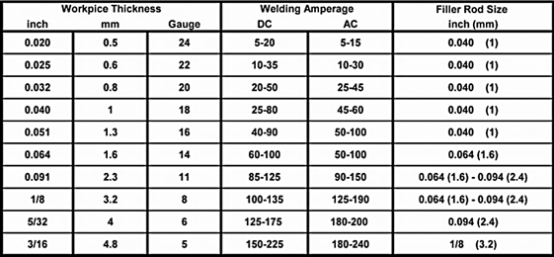

**Note:** Welding with inverter welding machines often needed less heat input (lower amperage). The recommended parameters are all approximate and are only for manual welding, not automated welding. Test the welds to ensure they meet your requirements.

**Joint Forms**

**TIG on Stainless Steel (single run welding)**

|  |  |  |  |  |  |  |
| --- | --- | --- | --- | --- | --- | --- |
| Workpiece Thickness  Gauge, in. (mm) | Joint Form | Tungsten Electrode Diameter in. (mm) | Welding Wire Diameter in. (mm) | Argon Gas Flow Rate SCFH  (L/min) | Welding Current (DCEP)  A | Welding Speed in./min  (cm/min) |
|
| 22, 0.031 (0.8) | Butt joint | 0.040 (1) | 1/16 (1.6) | 10.6 (5) | 20-50 | 26 (66) |
| 20, 0.037 (1.0) | Butt joint | 1/16 (1.6) | 1/16 (1.6) | 10.6(5) | 50-80 | 22 (56) |
| 16, 0.063 (1.5) | Butt joint | 1/16 (1.6) | 1/16 (1.6) | 14.9(7) | 65-105 | 11.8 (30) |
| Corner joint | 1/16 (1.6) (1.6)1/16 (1.6) (1.6) | 1/16 (1.6) | 14.9(7) | 75-125 | 9.8 (25) |
| 14, 0.078 (2.0) | Butt joint | 1/16 (1.6) | 3/32 (2.4) | 14.9(7) | 85-125 | 11.8 (30) |
| Corner joint | 1/16 (1.6) | 3/32 (2.4) | 14.9(7) | 95-135 | 9.8 (25) |
| 11, 1/8 (3.2) | Butt joint | 1/16 (1.6) | 3/32 (2.4) | 14.9(7) | 100-135 | 11.8 (30) |
| Corner joint | 1/16 (1.6) | 3/32 (2.4) | 14.9(7) | 115-145 | 9.8 (25) |
| 7, 3/16 (4.8) | Butt joint | 3/32 (2.4) | 1/8 (3.2) | 17 (8) | 150-225 | 9.8 (25) |
| Corner joint | 1/8 (3.2) | 1/8 (3.2) | 19.1 (9) | 175-250 | 7.9 (20) |

**Note:** Welding with inverter welding machines often needed less heat input (lower amperage). The recommended parameters are all approximate and are only for manual welding, not automated welding. Test the welds to ensure they meet your requirements.

❑TIG Welding Setup Installation

The connections of the welding machine can be seen in figures C and D.

1. **Earth Cable Connection**: Insert the earth cable plug into the positive socket on the front of the machine and tighten securely.
2. **Welding Torch Connection**: Plug the welding torch into the negative socket on the front panel and tighten it.
3. **Gas Line Connection**: Connect the gas line of the TIG gun to the gas outlet connector on the front of the machine.
4. **Control Cable for Torch Switch**: Connect the control cable of the torch switch to the 9-pin socket on the front of the machine.
5. **Water Cooling Connection**: Connect the water inlet and outlet pipes of the TIG gun to the corresponding inlet and outlet water connectors on the front of the water box.
6. **Water Box Control Cable Connection**: Connect the control cable of the water box to the socket on the rear panel of the welding machine.
7. **Gas Regulator Setup**: Connect the gas regulator to the gas cylinder, then connect the gas line to the gas regulator. Check for leaks before proceeding!
8. **Gas Line to Machine Connection**: Connect the gas line to the machine's inlet gas connector via the quick-push lock connector on the rear panel. Check for leaks to ensure proper sealing.
9. **Power Cable Connection**: Connect the welding machine's power cable to the output switch in the electric box on-site. Turn on the power switch to power up the machine.
10. **Gas Cylinder Adjustment**: Carefully open the valve of the gas cylinder and set the required gas flow rate.
11. **Voltage Measurement**: Use a Multimeter to ensure the input voltage is within the acceptable fluctuation range.
12. **Grounding Check**: Verify that the power ground is properly grounded.

**Operation for TIG Welding**

1. **Powering On the Machine**: After correctly installing the equipment as per the previous instructions, turn the power switch to the “ON” position. The screen should illuminate, the fan should start running, and the device should operate properly.
2. **Selecting Welding Mode and Output Waveform**:

* Set the welding mode to either Lift TIG or HF TIG.
* Choose the output waveform: DC or AC.

1. **Setting the Trigger Mode**:

* Select either 2T or 4T operation.

1. **Setting Welding Parameters**: Adjust the current and TIG parameter settings, including pre-gas time, slow-down time, and other necessary parameters.
2. **Preparing the Tungsten Electrode**: The tungsten electrode must be ground to a blunt point for optimal welding results. It is crucial to grind the tungsten in the direction of the grinding wheel’s rotation to ensure proper arc stability.
3. **Installing the Tungsten Electrode**: Insert the tungsten electrode into the collet, ensuring 3mm to 7mm of tungsten sticks out from the gas cup. Use the correctly sized collet for a secure fit.
4. **Tightening the Back Cap**: Securely tighten the back cap to hold the tungsten electrode in place.
5. **Starting the Welding Process**: Begin welding and, if necessary, adjust the parameter control knob to fine-tune the welding conditions.
6. **Cooling After Welding**: After completing the weld, leave the power source turned ON for 2 to 3 minutes to allow the fan to cool the internal components.
7. **Powering Off the Machine:** Switch the ON/OFF switch to the OFF position to turn off the machine.

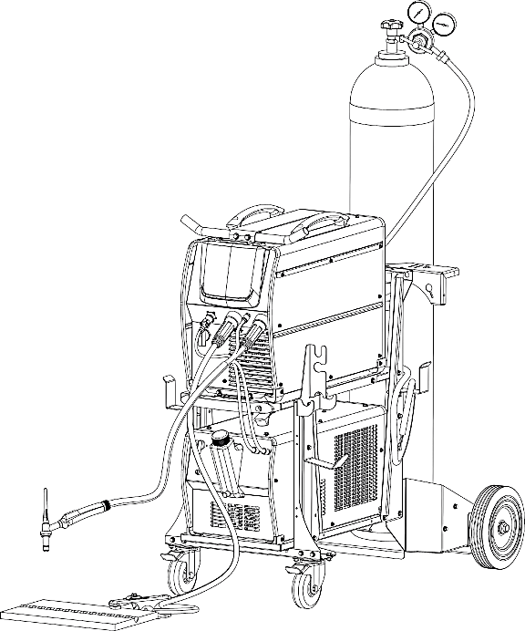

**Fig. C**

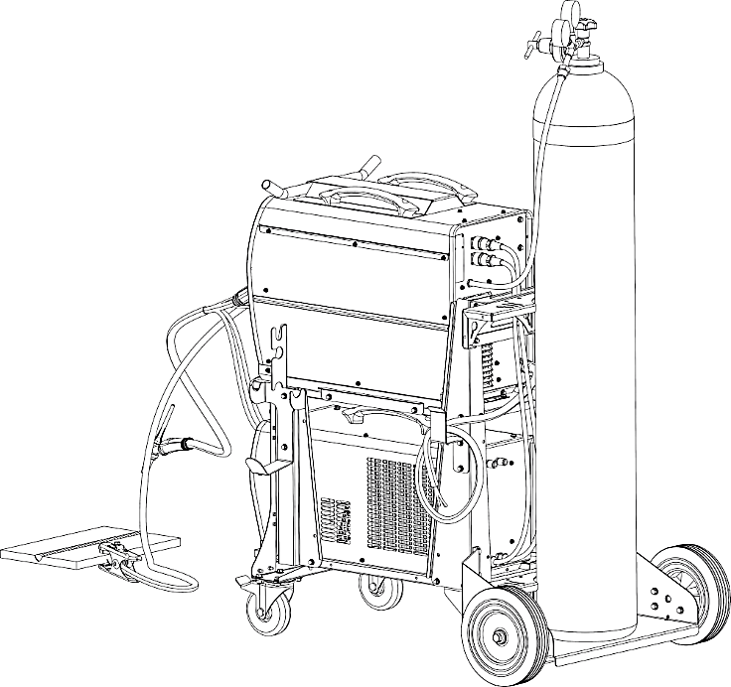

**Fig. D**

❑ Stick Welding Procedure

Manual metal arc welding, often known as stick welding, is one of the most used kinds of arc welding. A disposable electrode rod or "stick" and the base material are brought together by an electric current to form an arc. The electrode rod is constructed from a material that is compatible with the base material being joined, and it is coated with a flux that emits gaseous vapors that act as a shielding gas and as a coating of slag, as well, to protect the weld region from ambient contamination. The slag that accumulates over the weld metal after welding must be chipped away, and the electrode core itself serves as filler material.

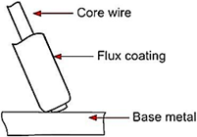

By quickly contacting the electrode to the base metal, the arc is started. At the electrode's end, a molten pool is created as the heat from the arc melts the base metal's surface. The molten pool is where the melted electrode metal is moved across the arc to create the deposited weld metal. A slag that results from the electrode coating covers and shields the deposit. There is a protective gas surrounding the arc and the surrounding areas.

Solid metal wire is the core of manual metal arc (stick) electrodes, which also include a flux covering. The wire diameter and a string of letters and numbers are used to identify these electrodes. The metal alloy and the electrode's intended purpose are identified by the letters and numbers. The metal wire core works as a conductor of the current that maintains the arc. The core wire melts and is deposited into the welding pool. The term "Flux" refers to the coating on a shielded metal arc welding electrode. Numerous distinct tasks are accomplished by the flux on the electrode. Creating a protective slag covering over the weld as it cools, establishing arc characteristics, introducing alloying components, and forming a protective gas surrounding the weld region are some of these. In addition to adding filler metal to the molten pool, covered electrodes have several other uses. The electrode's coating performs most of these extra activities.

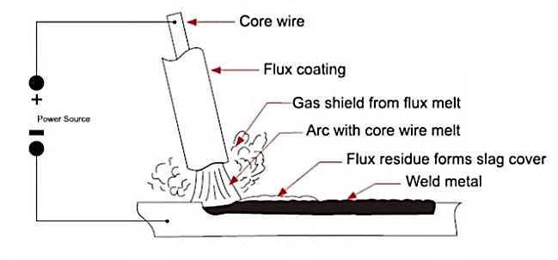

**Electrode Selection**

Choosing an electrode is typically simple because all that is required is to choose one with a composition that is comparable to the parent metal. However, there are a variety of electrodes available for various metals, each of which has unique characteristics to fit a particular sort of activity. It is advised that you speak with your welding provider to choose the ideal electrode choice.

**Arc Length**

The electrode should be carefully scraped on the work to strike the arc until the arc is formed. The smallest arc that provides a satisfactory surface for the weld should be used as the correct arc length, according to a straightforward rule. A too-long arc impairs penetration, causes spatter, and provides the weld a rough surface finish. A too-short arc will cause the electrode to stick and produce poor quality welds. The arc length for down hand welding should generally not be longer than the core wire's diameter.

**Electrode Size**

The thickness of the workpiece being welded often determines the size of the electrode, with a thicker section requiring a bigger electrode. The next chart lists the largest electrodes that may be used for different thicknesses based on the usage of a type 6013 all-purpose electrode.

**Welding Current (Amperage)**

Arc welding depends on selecting the appropriate current for the task at hand. When the current is regulated too low, it is challenging to initiate and maintain a constant arc. Beads with a noticeably rounded shape will be deposited due to the electrode's inclination to stick to the work and its poor penetration. A hot electrode undercuts and burns through the base metal while also producing a lot of splatters when there is too much current flowing through it. The maximum current that may be used for a certain operation without destroying the output, overheating the electrode, or producing a rough, spattered surface may be considered as the normal current. The allowable current ranges for a type 6013 general-purpose electrode are listed in the table.

|  |  |  |
| --- | --- | --- |
| **Steel Sheet Thickness**  **in. (mm)** | **Stick Electrode Rod Diameter**  **in. (mm)** | **Current Range**  **(Amps)** |
| **1/16 - 1/8 (1.6 – 3.17)** | **3/32 ( 2.4 )** | **45 - 95** |
| **1/8 - 1/4 (3.17 – 6.35)** | **1/8 ( 3.2 )** | **75 -130** |
| **1/4 - 3/8 (6.35 – 9.5)** | **5/32 ( 4.0 )** | **105 -185** |
| **3/8 - 1/2 (9.5 -12.5)** | **3/16 ( 4.8 )** | **150 - 225** |

**Electrode Angle**

To enable a seamless, equal transfer of metal, the electrode's angle with the work is crucial. The electrode is typically angled between 5 and 15 degrees toward the direction of motion when welding in a horizontal, above, horizontal fillet, or down hand position. The electrode should be at an angle of between 80 and 90 degrees to the workpiece while welding vertically up.

**Travel Speed**

The electrode should be moved at a pace that will provide the desired length of run in the direction of the joint being welded. To maintain the proper arc length at all times, the electrode is fed downward at the same time. While excessive travel speeds typically result in arc instability, slag inclusions, and poor mechanical characteristics, excessive travel speeds frequently result in poor fusion, lack of penetration, etc.

**Material and Joint Preparation**

The weldable material must be free of any pollutants that might contaminate the weld material and interfere with the arc, such as moisture, paint, oil, grease, mill scale, and rust. Joints may need to be prepared using sawing, punching, shearing, machining, flame cutting, and other techniques depending on the technology used. Edges should always be clean and free of debris. The type of joint will be determined by the application selected.

❑ Stick (SMAW) Welding Setup Installation

This welding machine is equipped with two output sockets. Proper connection is essential for optimal welding performance. The connections of the welding machine can be seen in figures E and F.

**SMAW (DC) Welding**

* **DCEP** **(Direct Current Electrode Positive)**

The electrode holder is connected to the positive (+) output socket. The earth lead (workpiece) is connected to the negative (-) output socket.

**Note:** This is the most common configuration, but some electrodes require different polarity.

* **DCEN** **(Direct Current Electrode Negative)**

The electrode holder is connected to the negative (-) output socket. The earth lead (workpiece) is connected to the positive (+) output socket.

**Note:** Refer to the electrode manufacturer's specifications to determine the correct polarity.

**SMAW (AC)** **Welding**

There are no specific polarity requirements for AC welding. Connect the electrode holder and earth lead as needed.

**Connection in DCEP mode:**

1. **Earth Lead Connection**: Connect the earth lead to the negative (-) output socket and tighten it.
2. **Workpiece Connection**: Attach the earth clamp firmly to the workpiece. Ensure the contact point is clean, bare metal, free from corrosion, paint, or scale to ensure proper conductivity.
3. **Electrode Lead Connection**: Connect the electrode lead to the positive (+) output socket and tighten it.
4. **Power Cable Connection**: Each machine comes with a power cable. Ensure the cable is connected based on the input voltage specified for the machine.

**Caution:** Verify the correct voltage selection to avoid damage to the equipment.

1. **Secure Power Supply Connection**: Ensure the power cable is properly connected to the corresponding input power supply terminal or socket. Prevent loose connections or oxidation at the contact points. Use a Multimeter to check that the input voltage is within the acceptable fluctuation range.
2. **Grounding Check**: Ensure the power ground is properly grounded for safe operation.

**Stick Welding Operation**

1. **Powering On the Machine**: After correctly installing the equipment as per the previous instructions, turn the power switch to the ON position. The screen should illuminate, the fan should start running, and the device should operate properly.
2. **Selecting SMAW Mode**: Set the welding mode to SMAW.
3. **Adjusting Welding Current**: Use the parameter knob to set the required welding current.
4. **Setting Hot Start and Arc Force**: Adjust the hot start and arc force settings using the parameter buttons and knob, following the instructions from the previous section.
5. **Electrode Placement**: Insert the electrode into the electrode holder and clamp it securely.
6. **Striking the Arc**: Strike the electrode against the workpiece to create an arc. Hold the electrode steady to maintain a stable arc.
7. **Commencing Welding**: Begin welding, and if necessary, adjust the welding parameter control knob to fine-tune the welding conditions.
8. **Cooling After Welding**: After completing the weld, leave the power source turned ON for 2 to 3 minutes to allow the fan to cool the internal components.

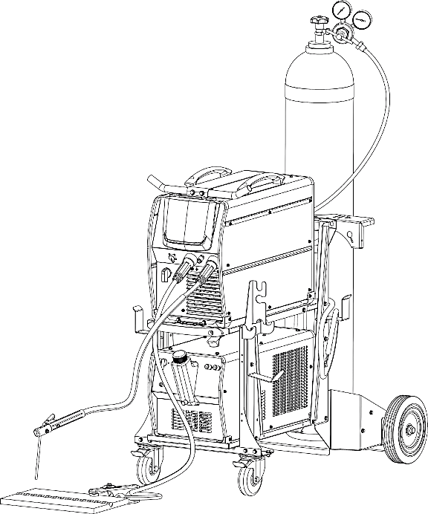

**Fig. E**

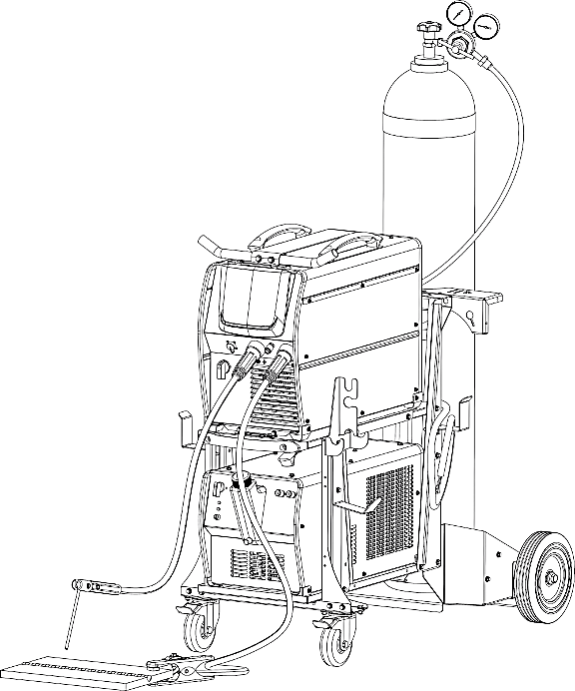

**Fig. F**

1. **Powering Off the Machine**: Turn the power switch to the OFF position.

**Important Notes**:

* When welding with cellulosic electrodes (e.g., E6010), it is essential to connect the electrode holder to the rear panel weld output connector of the machine. This configuration ensures optimal arc stability and proper operation in cellulosic mode. Failure to connect the electrode holder to the rear terminal may result in unstable arc performance or improper ignition. Please make sure to double check the connection before starting the welding process.
* Polarity Consideration: SMAW welding with DC polarity can be set up in two ways. Select the appropriate connection according to the welding technical requirements. Incorrect polarity selection may cause arc instability, excessive spatter, or poor adhesion. If such issues occur, reverse the connections and test again.
* Cable Selection for Long-Distance Welding: If the workpiece is far from the welding machine, and longer cables are required for the electrode holder and ground, use a larger cross-sectional area conductor to minimize voltage drop and ensure stable performance.

❑Welding Circuit: Cables, and Connections

Welding Cables and the Ampacity: The electrode cable and the welding clamp cable are important parts of a welding circuit. They must be very flexible and have a tough heat-resistant insulation. Connections at the electrode holder, the welding clamp, and at the power source lugs must be soldered or well crimped to assure low electrical resistance. The cross-sectional area of the cable must be sufficient size to carry the welding current with a minimum of voltage drop. Increasing the cable length necessitates increasing the cable diameter to lessen resistance and voltage drop. The below table lists the suggested American Wire Gauge (AWG) cable size to be used for various welding currents and cable lengths.

**Attention:** Don’t use PVC welding cable.

**Welding Cable Ampacity (Based on size and length (AWG))**

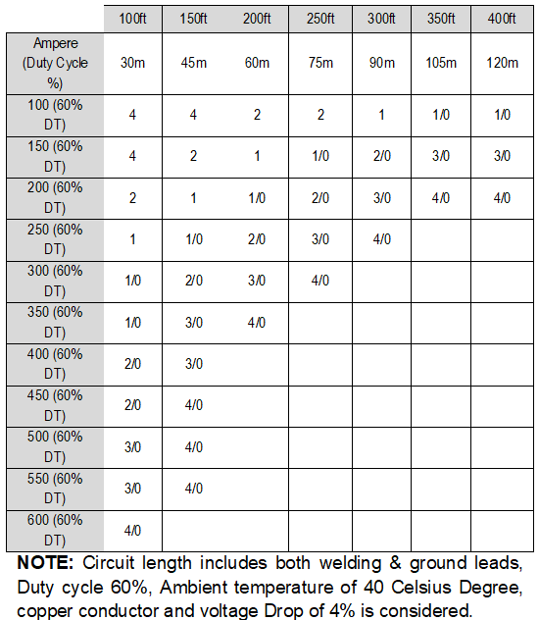

**Ampacity of Welding Cable**

|  |  |  |  |  |
| --- | --- | --- | --- | --- |
| **AWG SIZE** | **100% DT** | **60%DT** | **35%DT** | **20%DT** |
| 4 | 161 | 168 | 186 | 220 |
| 2 | 219 | 236 | 270 | 326 |
| 1 | 255 | 279 | 324 | 397 |
| 1/0 | 297 | 331 | 390 | 482 |
| 2/0 | 346 | 392 | 468 | 583 |
| 3/0 | 400 | 460 | 557 | 700 |
| The numbers are approximate in 25 Celsius degree | | | | |

When the ambient temperature differs from 25°C, the rating should be corrected by multiplying it by the appropriate factor below:

|  |  |  |  |  |
| --- | --- | --- | --- | --- |
| **Ambient temperature Celsius degree** | **30** | **35** | **40** | **45** |
| Correction factor | 0.96 | 0.91 | 0.87 | 0.82 |

❑ Maintenance

**WARNING:** Always disconnect the machine power source before doing any maintenance to avoid personal injury accidents such as electric shock and burns.

**WARNING:** For safety while maintaining the machine, please shut off the supply power and wait for 5 minutes, until capacity voltage already drop to safe voltage 36V!

By following proper maintenance procedures, the welding machine can operate safely and reliably for a long time.

**Cooling Unit Maintenance**

Disconnect the mains lead before any internal inspection of the unit. Periodically remove dust and extraneous materials from inside the unit and especially from the radiator. Make sure all of the hose tightening clips are closed, all fittings are intact and in perfect condition. Check the coolant is at the correct level.

**Grounding Maintenance**

Over time, corrosive soils with high moisture content, high salt content, and high temperatures can degrade ground rods and their connections. Despite low ground resistance values upon initial installation, these values can increase if the ground rods are eaten away. If there are intermittent electrical problems, the problem may be related to poor grounding or poor power quality. All grounds and ground connections must be checked annually as a part of normal proactive maintenance plan. Once identified, the problem can be solved by replacing or adding ground rods to the grounding system.

**Earth Clamp Maintenance**

Do not Use if the Earth clamp is damaged or in bad condition.

If the Earth clamp is not in good condition, this will cause welding current leakage or a drop voltage in the machine output, which looks like someone changing the settings on your welding machine, Often the first reaction of the operator is to change the machine settings to compensate, rather than fix the real cause of the problem.

**There are typically 3 areas of “connection” on an earth clamp that can cause a current leakage or blockage.**

* Cable to the cable lug: Lugs are probably the worst offender here! They can be hard to fit properly, sometimes the cable can be removed from the lug, the lug bolt/terminal may come loose, etc., Use a high-quality, copper tin plated cable lug and a professional crimping tool.
* Within the clamp itself: Be careful of broken clamp jaws or worn parts. Use a high-quality Earth clamp, Strong spring and other mechanical parts, Current conductive parts made from copper or brass and not Steel alloys at all.
* Clamp to workpiece connection: A weak clamp spring or improper connection to the workpiece, corroded clamping jaws or low electrical conductivity, particularly if the workpiece is rusty, causes poor electrical conduction with it and increase in heat.

Once a “connection” problem in an Earth clamp develops, the affected component will then begin to heat up. The heat will then accelerate the original problem, causing the connection to fail further, which will then cause more heat and the cycle to continue.

Conclusion:

* Do Check your earth clamp regularly. Make sure the cable lug is firmly fitted and bolted. Replace the clamp in case of weak spring, broken parts, overheating, etc.
* Do not just give your clamp a shake and reattach it. This won’t solve the problem.
* Use only high-quality, well-designed Earth clamps.

**Regular Maintenance Planning**

|  |  |
| --- | --- |
| **Date** | **Maintenance item** |
| Daily Inspection | * Check if all panel buttons, potentiometers, switches, electrical and gas connections on the front and rear sides of the machine are working properly. If not, repair or replace them. * After turning on the power source, observe / listen whether the machine has any abnormal noise or smell. If yes, try to find the reason and if you cannot find the reason, please contact the local agent or branch. * Turn on the power source to make sure the fan is working properly. Check if the fan blades move a little or starts spinning. If not, observe whether there is anything stuck in the blade, and if so, remove it. If the fan is damaged, replace it immediately. Make sure the machine is unplugged. * Observe if the connectors are loose or overheated. Observe whether the current output cable and the input power cable are damaged. If a cable is damaged, it must be wrapped, insulated, or changed. * Check gas/air connections and circuit for any probable leaks. * Check the water-cooling unit connections, fittings, tubes, hoses for any probable leaks. * Fill out the liquid coolant reservoir up to the maximum level. |
| Monthly Inspection | Use dry compressed air (with low pressure settings) to clean the inside of the machine and water-cooling unit, especially clean the dust on the heat sinks, main voltage transformer, inductor, IGBT modules, diodes, capacitors, and all PCBs, etc. Check the bolts and screws of the machine, if any bolt or screw is loose, tighten it. If it is stripped, replace it. If it is rusty, wipe the rust off the bolt and make sure it works well. Check the liquid coolant filter inside the water-cooling system and replace it if it is necessary. |
| Annual Inspection | Compare the actual value of parameters with the display value installed on the machine. If the difference is significant, the machine must be calibrated. The value of the parameters can be measured by a calibrated instrument. Check the liquid coolant filter inside the water-cooling system and replace it if it is necessary.  Check the liquid coolant strainer/filter inside the water-cooling system and clean/replace it if it is necessary.  Replace damaged hoses and connections with the genuine parts  Replace the coolant totally. |

**Note: Only professional service personnel authorized by Canaweld may service the machine!**

❑ Troubleshooting Table

**Power Supply Troubleshooting**

**Note:** Only professional service personnel authorized by Canaweld may service the machine!

If there is a problem and you can’t find the authorized professional maintenance personnel, please contact the local agent or the company branch. If there are some simple machine troubles, you can use the following information from the below table:

|  |  |  |
| --- | --- | --- |
| **PROBLEM** | **POSSIBLE REASON** | **SOLUTION** |
| Upon powering on the unit, the LCD display illuminates correctly, but the cooling fan fails to start. | Foreign object in fan | Clear out |
| Fan start capacitor faulty | Change capacitor |
| Fan motor faulty | Change fan |
| The max and min value displayed doesn’t accord with the set value | The max value is not accordant | Adjust potentiometer Imax on the control board |
| The min value is not accordant | Adjust potentiometer in the current meter |
| no open circuit voltage (SMAW) | The machine is damaged | Check the main circuit and the Pr4 |
| Arc cannot be ignited (TIG) HF spark present | Welding cables not connected to output terminals | Connect the welding cable to the welder’s output |
| The welding cable damaged | Repair or change it |
| The earth cable connected unstably | Check the earth cable |
| The welding cable is too long | Use an appropriate welding cable |
| There is oil or dust on the workpiece | Check and remove it |
| The distance between tungsten electrode and workpiece is too long | Reduce the distance (about 3mm) |
| HF ignition not sparking | The HF igniting board does not work | Discharger gap too small |
| Discharger gap too small | Adjust this distance (about 0.7mm) |
| The malfunction of the welding gun switch | Check the welding gun switch, control cable and aero socket |
| No gas flow (TIG) | Gas cylinder is close or gas pressure is low | Open or change the gas cylinder |
| Obstruction in the Valve | clean the valve or replace it if the obstruction cannot be removed |
| Electromagnetic valve is damaged | Check for loose connections or signs of wear, If the valve is damaged, it may need to be repaired or replaced |
| Gas always flows | The gas-test on the front panel is on | Gas test function must be off |
| Obstruction in the Valve | clean the valve or replace it if the obstruction cannot be removed |
| Electromagnetic valve is damaged | Check for loose connections or signs of wear, If the valve is damaged, it may need to be repaired or replaced |
| Pre-Gas Time Adjustment Knob is Damaged | Repair or change it |
| The welding current cannot be adjusted | The welding current potentiometer on the front panel connection is not good or damaged | Repair or change the potentiometer |
| Welding current display doesn’t match actual value | Minimum value displayed doesn’t match actual value | Adjusting the potentiometer on the power board |
| Maximum value displayed doesn’t match actual output | Adjusting the Imax potentiometer on the power board |
| Insufficient penetration of the molten pool | The welding current is adjusted too low | Increase the welding current |
| The alarm lamp on the front panel is on  Over heat protection | Too much welding current | Reduce the welding current or allow the machine to rest for longer periods to prevent continuous heat buildup. |
| Working time too long |

**Table 3**

❑Stick Welding Troubleshooting

**Note:** Only professional service personnel authorized by Canaweld may service the machine!

If there is a problem and you can’t find the authorized professional maintenance personnel, please contact the local agent or the company branch. If there are some simple machine troubles, you can use the following information from the below table:

|  |  |  |
| --- | --- | --- |
| **PROBLEM** | **POSSIBLE REASON** | **SOLUTION** |
| No Arc | Incomplete welding circuit | Ensure that the earth lead is properly connected to both the welding machine and the workpiece. |
| Wrong mode selected | Ensure that the correct welding mode is selected on the machine. |
| No power supply | check the Power Switch: Ensure that the power switch on the machine is set to the ON position. |
| Porosity − small cavities or holes resulting from gas pockets in weld metal | Arc length too long | Shorten the arc length. |
| Work piece dirty, contaminated or moisture | Proper surface preparation is critical for achieving a high-quality weld. Any contaminants on the metal can negatively affect the welding process, causing poor weld quality, defects, or contamination. |
| wet electrodes | Use only dry electrodes. |
| Excessive Spatter | Excessive amperage | Reduce the amperage or use a larger electrode. |
| Arc length too long | Reduce the arc length. |
| The weld sits on the surface with insufficient fusion | Work piece dirty, contaminated or moisture | Eliminate moisture, paint, grease, oil, dirt, and mill scale from the metal surface. |
| Poor welding technique | Use the proper welding technique or seek guidance to ensure correct execution. |
| Insufficient heat input | Increase the amperage or choose a larger electrode. |
| Lack of penetration | Insufficient heat input | Increase the amperage or choose a larger electrode. |
| Poor welding technique | Use the proper welding technique or seek guidance to ensure correct execution. |
| Poor joint preparation | Check the joint design and fit up, make sure the material is not too thick. Seek assistance for the correct joint design and fit up. |
| Excessive penetration - burn through | Excessive heat input | Reduce the amperage or use a smaller electrode. |
| Incorrect travel speed | Try increasing the weld travel speed. |
| Uneven weld appearance | Unsteady or wavering hand movement. | Use two hands where possible to steady up, practice your technique. |
| Distortion − movement of base metal during welding | Excessive heat input | Reduce the amperage or use a smaller electrode. |
| Poor welding technique | Use the proper welding technique or seek guidance to ensure correct execution. |
| Poor joint preparation and or joint design | Check the joint design and fit up, make sure the material is not too thick. Seek assistance for the correct joint design and fit up. |
| Electrode welds with different or unusual arc characteristic | Incorrect polarity | Change the polarity, check the electrode manufacturer for correct polarity. |

**Table 4**

❑ DC TIG Welding Troubleshooting

The following chart highlights common issues in DC TIG welding and their possible causes. For any equipment malfunctions, always refer to and follow the manufacturer’s recommendations.

|  |  |  |
| --- | --- | --- |
| **PROBLEM** | **POSSIBLE REASON** | **SOLUTION** |
| Tungsten burning away quickly | Incorrect Gas or No Gas | Use pure Argon gas. Verify that the cylinder contains gas, is properly connected, the valve is turned on, and the torch valve is open. |
| Insufficient gas flow | Verify that the gas is properly connected, and check that the hoses, gas valve, and torch are free of any restrictions. |
| Back cap not fitted correctly | Make sure the torch back cap is fitted so that the O-ring is inside the torch bod. |
| Torch connected to DC+ | Ensure the torch is connected to the **DC-** (positive) terminal. |
| Incorrect tungsten being used | Check and change the tungsten type if necessary. |
| Tungsten oxidation after the weld is completed | Keep shielding gas flowing 10-15 seconds after arc stoppage. 1 second for each 10amps of welding current. |
| Contaminated tungsten | Touching tungsten into the weld pool | Keep the tungsten electrode away from the weld puddle. Raise the torch so that the tungsten is positioned 2-5mm above the workpiece. |
| Touching the filler wire to the tungsten | Avoid letting the filler wire touch the tungsten during welding. Feed the filler wire into the leading edge of the weld pool, just in front of the tungsten. |
| Porosity - poor weld appearance and color | Wrong gas/ poor gas flow/ gas leak | Ensure the gas is connected, the valve is turned on, and check that the hoses, gas valve, and torch are not restricted. Set the gas flow to 20-40 CFH (6-12 L/min). Inspect hoses and fittings for leaks. |
| Contaminated base metal | Remove moisture and materials like paint, grease, oil and dirt from base metal. |
| Contaminated filler wire | Remove all grease, oil or moisture from filler metal. |
| Incorrect filler wire | Check the filler wire and change if necessary. |
| Yellowish residue or smoke on the alumina nozzle and discoloration of the tungsten | Incorrect Gas | Use pure Argon gas. |
| Insufficient gas flow | Set the gas flow between 20-40 CFH (10-20 l/min) flow rate. |
| Alumina gas nozzle too small | Increase the size of the alumina gas nozzle. |
| Unstable Arc during DC welding | Torch connected to DC+ | Ensure the torch is connected to the **DC-** (positive) terminal. |
| Contaminated base metal | Remove materials like paint, grease, oil and dirt, including mill scale from base metal. |
| Tungsten is contaminated | Remove 10mm of the contaminated tungsten electrode and re-grind it. |
| Arc length too long | Lower the torch so that the tungsten is positioned 2-5mm above the workpiece. |
| Arc instability during DC welding. | Poor gas flow | Check and set the gas flow between 20-40 CFH flow rate |
| Incorrect arc length | Lower the torch so that the tungsten is positioned 2-5mm above the workpiece. |
| Tungsten incorrect or in poor condition | Ensure the correct type of tungsten is being used. Remove 10mm from the weld end of the tungsten and re-sharpen the rod. |
| Improperly prepared tungsten | Grind marks should run lengthwise along the tungsten, not in a circular pattern. Use the proper grinding method and wheel. |
| Contaminated base metal or filler wire | Remove contaminating materials like paint, grease, oil and dirt, including mill scale from base metal. Remove all grease and oil from filler metal. |
| Arc difficult to start or will not start DC welding | Incorrect machine set up | Check machine set up is correct |
| No gas, incorrect gas flow | heck the gas is connected and cylinder valve open, check hoses, gas valve and torch are not restricted. Set the gas flow between 20-40 CFH flow rate. |
| Incorrect tungsten size or type | Check and change the size and or the tungsten if required. |
| Loose connection | Check all connectors and tighten. |
| Earth clamp not connected to work | Connect the earth clamp directly to the work piece wherever possible. |

**Table 5**

❑ Error Codes

The machine is protected against problems and if any error occurred the display shows messages depending to the type of error. The below table provides a summary of all the error conditions that may arise on the machine.

**Please Note: if the fault persists look for the cause of the fault and contact our technical department if necessary.**

|  |  |  |
| --- | --- | --- |
| **Error Type** | **Error code** | **Description** |
| Thermal relay | E01 | Over-heating (1st thermal relay) |
| E02 | Over-heating (2nd thermal relay) |
| E03 | Over-heating (3rd thermal relay) |
| E04 | Over-heating (4th thermal relay) |
| E09 | Over-heating (Program in default) |
| Welding machine | E10 | Phase loss detected. |
| E11 | No water |
| E12 | No gas |
| E13 | Under voltage |
| E14 | Over voltage |
| E15 | Over current |
| Switch | E20 | Faulty button on control panel when machine is turned on. |
| E21 | Other issues observed on the control panel when powering on the machine. |
| E22 | Torch malfunction detected upon powering on the machine. |
| E23 | Torch fault detected during welding operation. |
| Accessory | E30 | torch disconnected - Reconnect securely. |
| E31 | Water cooler disconnection |
| Communication | E41 | Communication error |

**Table 6**

❑ Meaning of Graphic Symbols on Machine

The following section describes the graphic symbols used on the machine and in this manual.

Each symbol identifies a specific function, operating mode or safety related information. Operators must understand these symbols before using the equipment.

Familiarity with the graphic symbols will:

* Ensure proper and safe operation of the machine.
* Draw attention to potential hazards and necessary precautions.
* Reduce the risk of equipment misuses or damage.

Always refer to this section whenever you are uncertain about the meaning of a symbol on the machine.

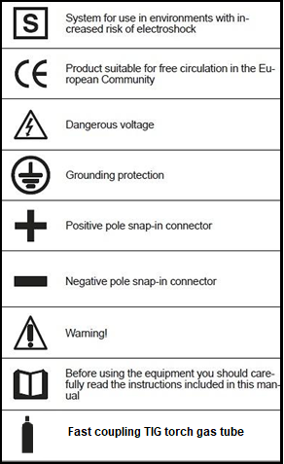

❑ Wiring Diagram

