

TIG AC DC 231 Pulse

Owner’s Manual

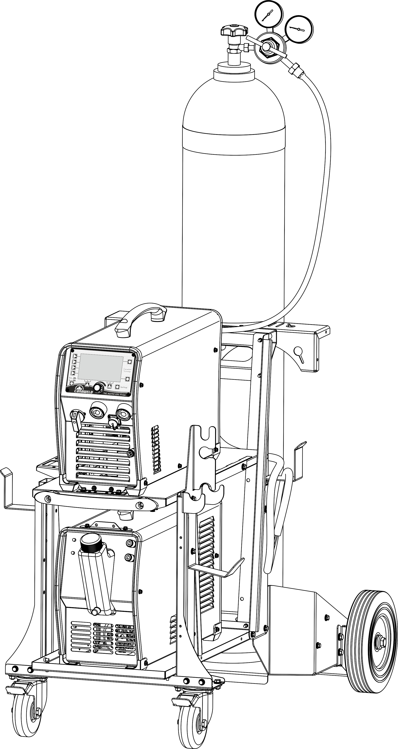

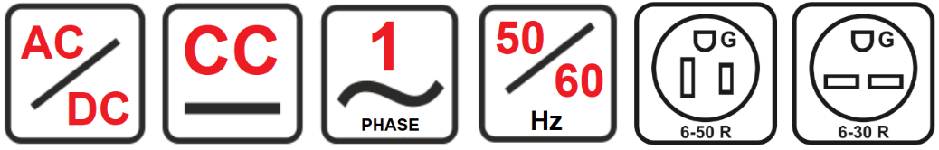

Thank You
From
Canaweld

Thank you for choosing a Canaweld machine, with 40+ years of welding equipment manufacturing experience overseas, you can feel confident that you have made the right choice.

Since the 1980s, the founders of Canaweld have been actively involved in research & development, production and sales within the welding and cutting industries. They have filed countless patents and set new standards in the welding industry.

For over a decade the founders of Canaweld, have been members of the Technical Committee (TC 26) of the International Electro-Technical Commission (IEC). IEC is the world’s leading organization on international standards for all electrical, electronic, and related technologies.

The company has also been an expert member of the Canadian Standards Association (CSA), within the Technical Committee, responsible for Canadian standards of welding and cutting machines.

Canaweld was created with the aim of providing our customers with advanced technologies. Our products, from design to assembly, are created with years of experience in research & development, materials engineering, quality control and testing.

Canaweld machines are among the best in the world in terms of quality.
The materials used in our designs are some of the best available on the market.
We believe in the high performance of our equipment and, therefore, offer a 3-year warranty.

We use strict test procedures, and our expectations exceed the required standards. For example, according to International Standards, machines must be tested at 40°C (104°F), but Canaweld tests the machines at both 40°C and 50°C (122°F). In doing so, we ensure that our machines will continue to operate even in hot climates.

Finally, all machines are only packaged and shipped when they pass strict mandatory tests.

This user manual should be read carefully to fully understand the machine you have purchased and how to maintain it in the best operating condition.

For more information on our full line of products please visit our website or contact a dealer in your local area, our dealer list can be found on our website: www.canaweld.com

Table of contents
Safety Precautions & Symbols (English) 2
Précautions de Sécurité et les Symboles (French) 7
Introduction 12
Description 12
Technical Data 13
Usage Limits (IEC 60974-1) 13
How to Lift Up the Machine 14
Open the Packaging 14
Installation and Connections 14
Connecting the Welding Machine to The Utility Line 14
Command and Control Units 15
Optional Accessories 16
Water-Cooling Unit 16
TIG Welding Procedure 17
TIG Welding Setup 24
TIG Display Introduction 25
TIG PULSE Display Introduction 25
TIG Stitch/Cold (Tack) Welding Display Introduction 25
Reservoir Filling 25
Cooling Unit Connections 26
Eliminate the Air Bubbles in the System 26
Checking the Coolant Level 26
TIG Welding with Air-Cooled Torch 26
JOB Program Introduction 26
Stick Welding Procedure 27
Stick (SMAW) Welding Setup 28
Stick Welding Display Introduction 28
Maintenance 29
Troubleshooting Table 29
Cooling Unit Troubleshooting 31
Error Codes 32
Meaning of Graphic Symbols on Machine 32
TIG AC/DC 231 Pulse Wiring Diagram 33
Cooling Unit Wiring Diagram 34

Safety Precautions & Symbols (English)
  - General Safety Precautions
Users of Canaweld welding and plasma cutting equipment are ultimately responsible for ensuring that everyone working on or around the equipment follow all safety measures. Safety precautions must fulfill the criteria for welding or plasma cutting equipment of this sort. In addition to the usual workplace laws, the following guidelines should be followed. To keep yourself and others safe, read, obey, and save these critical safety warnings and operating instructions. You are entirely responsible for the Product's safe operation. Canaweld does not and cannot give any assurances or warranties about the product's safety in your environment. This device is not designed for use in residential areas where the electrical power comes from a public low-voltage supply source. Due to both conducted and radiated disturbances, it may be challenging to ensure electromagnetic compatibility of the equipment in certain regions. This product is only for removing metal. Any other usage might result in bodily harm and/or damage to the equipment. In the event of a malfunction, contact a professional for assistance.
All work must be done by skilled employees who are familiar with how the welding or plasma cutting equipment works. Incorrect equipment operation can lead to dangerous circumstances, resulting in harm to the operator and equipment damage. Anyone who works with welding or plasma cutting equipment should understand how it works, where the emergency stops are situated, what safety measures should be followed, and how to utilize plasma cutting and/or welding.
Use approved personal safety equipment, such as safety glasses, flame-resistant clothes, and safety gloves. Avoid wearing scarves, bracelets, rings, and other loose-fitting items that may become stuck or cause burns. The operator must guarantee that no unauthorized personnel are present in the equipment's working area when it is turned on and no one is exposed to the arc when it is struck. The work environment must be free from drafts and appropriate for the job. The return cable must be securely connected and working on high voltage equipment must be done by a qualified electrician only. A proper and clearly marked fire extinguishing equipment must be close at hand. While the equipment is in operation, do not lubricate or maintain it.
  - Safety Precautions & Symbol
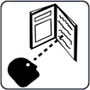
Before working on the machine, read the owner's manual.
Read the safety information at the beginning of the requirements manual. To fully understand the machine's capabilities and safety measures, read this manual thoroughly. Follow the Owner's Manuals, industry standards, and national, province, state, and local.

DANGER!
The symbol indicates a dangerous action that will result in death or serious injury if not prevented. The potential dangers or hazards are depicted in the symbols next to them or discussed in the text.
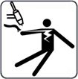
ELECTRIC SHOCK
Touching electrical components can cause fatal electric shock and severe burns. By using a dry insulating mat or cover, insulate yourself from the workpiece and ground. While the machine is powered on, do not remove the machine cover, or touch any electrical components or circuits without a pair of proper and dry insulating gloves. Equipment that has been incorrectly placed or grounded is a hazard. ELECTRIC SHOCK can cause death or severe injuries. Do not touch any active electrical components. Wear dry insulating gloves and body protection with no holes in them. Use dry insulating mats or blankets large enough to avoid any direct touch with the work or ground to isolate oneself from the work and ground. If the torch pieces touch the work or the ground, do not touch them. Inspect the input power cable and ground conductor on a regular basis for aging or bare wiring; repair promptly if damaged; bare wiring can kill. When not in use, turn off all equipment. Do not utilize cables that are worn, broken, undersized, or repaired. Avoid wrapping the torch cable around your body. If codes demand it, connect the workpiece to a good electrical (earth) ground. Only use well-maintained equipment. Repair or replace broken pieces at the same time. When operating above floor level, use a safety harness. Maintain the integrity of all panels and coverings. Do not try to bypass or overcome the safety mechanisms. Only use the torch types which indicated in the owner's manual. When the trigger is pressed, keep your hands away from the electrode/tungsten tip and the arc. Clamp the work cable to the workpiece (not a component that will fall away) or the worktable as close to the welding area as possible. When not attached to the workpiece, insulate the work clamp to avoid contact with any metal objects. Before inspecting, cleaning, or replacing torch parts, and before installing or repairing this machine, turn off the power. Install, ground, and operate this equipment in accordance with its owner's manual and any national, province, state, and local laws. Always ensure that the input power cord ground wire is correctly connected to the ground terminal and the cord connector is attached to a properly grounded receptacle outlet. Attach the correct grounding conductor first while establishing input connections. Maintain cables by keeping them dry, clear of oil and grease, and away from hot metal and sparks.

High DC VOLTAGE exists inside the machine even after turning off.
Even after disconnecting the input power, there
is dangerous DC voltage in inverter welding power sources. Before touching any parts, turn off the inverter, disconnect the input power, and wait for the input capacitors to discharge.
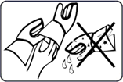
BURNS AND ELECTRIC SHOCK RISK WEAR DRY INSULATED GLOVES.
When replacing the consumables, always use dry insulated gloves. During welding, the consumables get extremely hot, and serious burns are possible. If the power supply is turned on, touching the consumables might cause an electric shock. Never touch the exposed parts of the welding torch/electrode holder of the machine, change or clean consumables while the machine is on, because the shocking voltage between the parts will be extremely dangerous and even fatal.

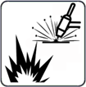
WELDING can result in a fire or explosion.
From the welding arc, hot metal and sparks are ejected that can cause fire or explosion. Before performing any welding, double-check that the location is safe. Welding has the potential to start a fire or explosion. Remove all combustible materials around the work area. If this isn't feasible, use certified covers to firmly cover them. Avoid welding in areas where flying sparks might ignite combustible materials. Make sure you and others are safe from flying sparks and hot metal. Be aware that welding sparks and hot materials can easily pass-through minor gaps and holes and onto surrounding places. Keep an eye out for flames and a fire extinguisher nearby. Welding on a ceiling, floor, bulkhead, or wall might result in a fire on the concealed side. Do not weld on combustible-filled containers or closed containers like tanks, drums, or pipelines unless they have been adequately prepared according to relevant safety standards. Check the area for sparks, glowing embers, and flames when the task is completed. Only use the proper fuses or circuit breakers. Do not oversize or bypass them. All work should be done in accordance with applicable safety regulations, and a fire watcher and extinguisher should be available. To avoid welding currents from traveling too long, perhaps unknown courses and generating electric shock, sparks, and fire dangers, connect the work cable to the work as near to the welding area as possible. Never weld on containers containing potentially combustible products; they must first be emptied and thoroughly cleaned. Never perform welding where combustible dust, gas, or liquid vapors (such as gasoline) are present in the atmosphere. Welding pressurized cylinders, pipelines, or containers is prohibited. Wear flame-resistant, long-lasting body protection (leather, heavy cotton, wool). Oil-free clothes, such as leather gloves, a thick shirt, cuffless pants, work boots with electrical insulated sole, and a hat, are all recommended for body protection. Avoid placing the device near or on flammable materials. Before performing any welding, make sure you don't have any combustibles on you, such as butane lighter or matches.

EXCESSIVE NOISE HAZARD
Be cautious if there is excessive noise in the workplace. Wear hearing protection if the noise level is too high. Workers nearby are also impacted by noise and may require hearing protection.

Hot PARTS HAZARD
All welded pieces become extremely hot immediately after welding or cutting, causing burns to anybody in touch with exposed skin. After welding or cutting, do not contact the workpiece, ground clamp, or electrode holder/torch instantly, and wait for a cooling interval before picking them up. To avoid burns, use proper equipment while working with hot parts, and use thick insulating welding/cutting gloves and clothes as well.
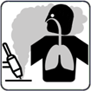
WELDING/CUTTING FUMES HAZARD
Welding and cutting generate gases and fumes. The inhalation of these gases and vapors might be hazardous. These gases and fumes can replace oxygen in the body, causing harm or death. Keep your head away from the welding or cutting area and avoid inhaling the fumes and gases. If the weld/cut is indoors, ventilate the environment or utilize local forced ventilation at the weld site to eliminate smoke and gas. Wear an authorized air supply respirator if ventilation is insufficient. Only work inside if you are properly ventilated or using an air-supplied respirator. For any materials being used, read the Material Safety Data Sheet (MSDS) and the manufacturer's instructions.

DANGEROUS GASES AND FUMES HAZARD
Welding and cutting coated metal, such as stainless steel, are not permitted, unless the coating has been removed from the weld or cut area, and the area is thoroughly ventilated, and an air-supplied respirator is used as well. During welding or cutting, the coating and all metals containing these elements can produce harmful fumes. Do not cut containers that contain poisonous or reactive products or containers that have previously held toxic or reactive materials; they must first be emptied and thoroughly cleaned. Cut away from degreasing, cleaning, or spraying processes. The arc's heat and light can combine with vapors to produce very poisonous and unpleasant fumes.

DANGEROUS GAS HAZARD FROM THE SHIELDING / CUTTING GAS CYLINDERS
Turn off the shielding/cutting gas, when not in use. These gases can displace air, lowering oxygen levels and resulting in harm or death.
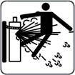
CYLINDERS can explode if they are damaged.
Excessive heat, mechanical shocks, physical damage, slag, open flame, sparks, and arcs should all be avoided while using compressed gas cylinders. Keep cylinders away from any electrical or cutting/welding circuits. Never allow a welding torch/electrode holder or plasma arc torch to make electrical contact with a cylinder. An explosion will occur if you cut a pressurized cylinder. When the cylinder is not in use or attached for use, keep the protective cap on the valve. To avoid falling or tipping, install and secure cylinders in an upright position by chaining them to a fixed support or equipment cylinder rack. Lift and move cylinders with the proper equipment, procedures, and a sufficient number of people. Read and obey the directions on compressed gas cylinders, associated equipment, and Compressed Gas Association (CGA). Use just the right compressed gas cylinders, regulators, hoses, and fittings for the job, and keep them and their parts in excellent working order. When opening the cylinder valve, face away from the valve outlet. When opening the valve, make sure you're not standing in front of or behind the regulator.
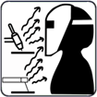
WELDING/CUTTING RAYS HAZARD
The visible and invisible light (ultraviolet and infrared rays) produced by the welding or cutting process can burn the eyes and skin. Wear an appropriate welding helmet with suitably shaded filter lenses to protect your face and eyes from welding rays. Cover any exposed skin, arms, or neck. Wear protective clothing made of flame-resistant material (leather, thick cotton, or wool). Protect people from flashes, glare, and sparks by using a safety screen or barriers.

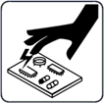
ESD- ELECTROSTATIC DISCHARGE
During welding/cutting, an electric static charge can be produced and released into any items contacted by the welder/cutter after welding/cutting. Before touching any boards or electronic components, put on a grounded wrist strap. When storing, moving, or shipping PC boards, use proper static-proof bags and boxes.

MOVING PARTS HAZARD
Typical welding/cutting machines may include several moving elements, such as rollers and fans. Hands should be kept away from moving elements like fans. Keep a safe distance from moving parts. Keep your distance from pinch spots like drive rolls. Keep loose garments and hair out of the path of moving parts. All doors, panels, covers, and guards should be closed and secured. Only allow qualified individuals to remove doors, panels, coverings, or guards as needed for maintenance and troubleshooting. When the maintenance is performed, reinstall the doors, panels, covers, or guards before reconnecting the input power.
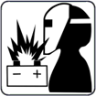
BATTERY EXPLOSION can cause injury.
Do not use welding machine to charge batteries or jump start vehicles that can cause explosion.


FALLING EQUIPMENT can cause injury.
Lift just the unit, not the gas cylinders, or other attachments together. Make sure you have equipment with adequate capacity to raise the unit. If you're going to relocate the unit using lift forks, be sure they're long enough to reach the other side. When working from an aerial location, keep equipment (cables and cords) out of the way of moving vehicles.
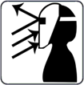
Sparks and hot metal blow out from the cutting arc can cause injury.
Flying hot metal generated by chopping and grinding can cause injury. Wear a face shield or safety goggles with side shields that are approved. Protect your skin by wearing suitable body protection. To prevent sparks from entering your ears, use flame-resistant ear plugs or earmuffs. Wear safety glasses with side shields or wear face shields.
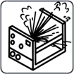
EXPLODING INVERTER PARTS can cause injury.
When electricity is connected to inverter power sources, faulty parts can explode or cause other parts to explode. Turn off the power source and then start to service the inverters, and always wear a face shield and long sleeves to protect your body and skin.
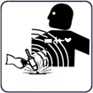
EMF- ELECTRIC MAGNETIC FIELDS can cause fault in electrical devices such as pacemakers.
Electric magnetic fields are formed during welding or cutting, which might cause faults in electrical components or Implanted Medical Devices in the surrounding area. Those who wear pacemakers or other implanted medical devices should stay away from EMF emitted by welders/cutters. Before arc welding, spot welding, gouging, plasma arc cutting, or induction heating operations, wearers of implanted medical devices should consult their doctor and the device manufacturer.
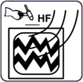
H.F. RADIATION can cause interference in electronic equipment.
Radio navigation, Cellular phones, safety services, computers, and communication equipment can be affected by high frequency (H.F.) igniter. This welding machine should only be installed by qualified people who are knowledgeable about electronic equipment. The user is responsible for having any interference issues caused by the installation of the welding machine and the issue must be quickly resolved by having a certified electrician. Stop using the equipment immediately if the interference issue has not been solved. Have the machine installation tested and maintained regularly. To reduce the chance of interference, maintain high-frequency source doors and panels completely sealed, keep spark gaps at the proper setting, and employ proper and sufficient grounding and shielding.
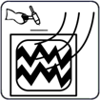
Welding can cause interference in electronic equipment.
Electronic equipment, such as computers and computer-driven equipment, such as robots, can be harmed by electromagnetic energy. Keep cables short, close together, and low as possible, to prevent any interference. Welding should be done far away from any sensitive electrical equipment. Ensure that this welding power source is installed and grounded in accordance with the instructions in this manual. If interference still occurs, the user should consider relocating the equipment, employing shielded cables, utilizing line filters, or shielding the workspace.
1.3 Important Safety Precautions
- Put on dry insulating gloves. Avoid touching the electrode with your bare hand. Wearing damp or damaged gloves is not permitted.
- Injuries can be caused by flying components. When servicing a unit, always wear a face shield. Put on a cap and safety glasses. Wear a welding helmet with the appropriate filter shade. Wear full bodily protection.
- The most unstable position of the equipment must not be inclined up more than 10°. Auxiliary components such as gas cylinders, wire feed units, or cooling devices may impact stability depending on the kind of equipment, and they must be considered.
- Before changing torch consumables, working on the machine, turn off the power and unplug the input plug.
- After the power is switched off, dangerous voltage remains on the input capacitors. Do not touch fully charged capacitors. Always wait 60 seconds after turning off the power before working on the machine and check the input capacitor voltage to ensure it is near zero before touching any parts.
1.4 Minimizing EMF (Electrical and Magnetic Fields) Exposure from the Welding / Cutting Circuit.
Arc welding and related processes such as gouge, plasma arc cutting, and spot welding generate an EMF field surrounding the welding circuits. Some medical devices, such as pacemakers, can be affected by EMF. Protective precautions for those who have medical implants must be implemented. For example, limit passing by or do individual risk assessments for welders. By following the relevant procedures, EMF exposure can be reduced. Twist or tape cables together, or use a cable cover, to keep them close together.
Precautions about Implanted Medical Devices
Before performing or going near arc welding, spot welding, gouging, plasma arc cutting, or induction heating procedures, implanted medical device wearers should consult their doctor and the device manufacturer. Follow the above procedures only if your doctor has approved you.
Avoid putting your body between welding or cutting cables. Arrange the wires so that they are to one side and away from the operator. Work away from the welding power source and do not sit or lean on it. Keep your head and body as far away from the welding circuit's equipment as possible.
Work clamp should be connected to the workpiece as near to the weld or cut area as possible. Welding should not be done while carrying the welding or cutting power source or wire feeder. If you have an Implanted Medical Device in your body, you should consult your doctor before doing or going near arc welding, spot welding, gouging, or plasma arc cutting activities. Do not wrap cables around your body or coil them. It is the user's responsibility to install and operate the equipment in accordance with the manufacturer's instructions. If electromagnetic disturbances are detected, it is the user's obligation to fix the problem with the manufacturer's technical help. In other circumstances, resolving the problem may be easy by connecting the machine to the earth and the workpiece. In other circumstances, it might include building an electromagnetic screen that encloses the power source and the work area, along with applying some input filters. Cutting/welding equipment must be connected to the power source in accordance with the manufacturer's instructions. If interference occurs, further precautions, such as mains supply filtering, may be required. Shielding the supply cable of permanently installed equipment in metallic conduit or equivalent should be considered. The shielding should be electrically continuous over its whole length. The shielding should be attached to the power supply to preserve excellent electrical contact between the conduit and the power source enclosure. The user must analyze any electromagnetic concerns in the surrounding region before installing the device. The user must confirm that all other devices in the area are compatible. This may necessitate extra precautions. Where the workpiece is not tied to earth for electrical safety or because of its size and location, such as a ship's hull or constructing steel work, a connection linking the workpiece to earth may minimize emissions in some cases. The workpiece without earth increases the danger of harm to users or damage to other electrical equipment. The workpiece should be connected to earth by a direct connection to the workpiece. If direct connection is not permitted, bonding should be accomplished via adequate capacitances determined in accordance with national rules. Changing the earth circuit arrangements should be authorized only by someone who is qualified to assess whether the alterations would raise the danger of injury, such as by enabling parallel cutting/welding current return pathways, which may damage the earth circuits of other equipment. IEC 60974-9 provides additional advice, Arc Welding Equipment, Part 9: Installation and Use.
Interference concerns may be alleviated by selective screening and shielding of other cables and equipment in the direct vicinity. For some particular applications, screening of the complete cutting/welding system may be considered.
1.5 Grounding of Welding/Cutting Machines:
In an electric circuit, there is an active wire that supplies power, a neutral wire that returns the current, and a 'grounding wire' that provides an additional path for electrical current to safely return to the ground in the event of a short circuit. A copper conductor is connected from the wiring system's metal rod to a set of ground connection terminals in the service panel.
Because electricity always seeks the shortest path to the earth, if the neutral wire is broken or interrupted, it is the grounding wire that provides a direct path to the ground. Because of this direct physical connection, the earth can act as the path of least resistance, preventing an appliance or person from becoming the shortest path.
Importance of Electrical Grounding
Protects Against Electrical Overloads
You may occasionally experience power surges or be struck by lightning during severe weather conditions. These occurrences may generate dangerously high levels of electricity, which can destroy your electrical appliances. By grounding the electrical system, all excess electricity is directed to the earth rather than frying the system's connected appliances. The appliances will be secure and safe from large electrical surges.
Stabilizes the Voltage Levels
Grounding the electrical system makes it easier to distribute the right amount of power to the right places. This ensures that the circuits are never overloaded and, as a result, do not blow. The earth can be regarded as a common reference point for any electrical system's voltage sources. This aids in maintaining stable voltage levels throughout the electrical system.
Earth Conducts with Least Resistance
One of the primary reasons for grounding your electrical appliances is that the earth is a great conductor, capable of carrying all excess electricity with minimal resistance. When you ground the electrical system and connect it to the earth, you are allowing excess electricity to flow somewhere without resistance rather than through you or your appliances.
Prevents Serious Damage and Death
When you fail to ground the electrical system, you endanger your appliances and even your life. When high voltage is passed through a device, it is fried and irreparably damaged. An excess of electricity can even start a fire, endangering your property and the lives of your loved ones.
Welding and Cutting Equipment Grounding
Welding/cutting machines are typically grounded via a third grounding wire connected to their electrical connections. Mobile engine-driven generator welding units should be grounded by connecting a cable from the machine's ground stud to a metal stake driven into the ground. Always follow the manufacturer's instructions for properly grounding the model being used.
Auxiliary receptacles on welding machines may or may not be protected by a ground-fault circuit interrupter (GFCI). In wet or damp areas, GFCI adapters or "pigtails" should be used. Tools, extension cords, and other items plugged into these receptacles must be grounded or double insulated.
When connecting the work piece to the welding table, make sure the table is grounded as well (typically a cable from the table leg to the building structure). Avoid grounding to a structure that is a long distance away from the weld. Never use flammable liquid pipelines as a ground, and never use electrical conduit as a ground.
Precautions to prevent an electrical shock.
To reduce the extent of live parts, ensure that all cables are in good condition, with no bare insulation or frayed wires.
Keep cables safe from vehicle traffic and other hazards so they don't get damaged, cut, or pinched.
Check that the rod electrode holder is properly insulated.
During a welding/cutting operation, always keep your hands and body dry. Avoid standing in water, on wet surfaces, using wet hands, or wearing sweaty clothing. Never immerse energized (hot) electrode holders or torches in water.
Avoid coming into direct contact with live welding equipment and the workpiece. Connect the work or metal to a good electrical ground. Always shield yourself from the work and the ground. If performing arc welding in wet or high humidity conditions, wear appropriate protective equipment such as rubber boots and rubber pads. Wear rubber gloves beneath your welding gloves. Use an insulating mat under the operator if the welding/cutting operation must be performed on steel or another conductive material. Put the welding or cutting machine in close proximity. In the event of an emergency or an accident, the machine can be quickly turned off to cut off the power source. When not in use or on breaks, turn off the welding or cutting machine. Before leaving the cutting/welding area, disconnect the machine from the power grid. When moving from one working position to another, do not hold or move the torch/electrode holder and the Ground (Earth) return cable at the same time If the power source to the equipment has not been cut.
What should I do in case of an electric shock?
Call for medical assistance right away.
DO NOT USE YOUR "BARE HANDS" on the victim until he or she is away from the live electrical source. If an appliance or electrical equipment is the electrical source, turn off the power at the fuse box or circuit breaker panel, or, if possible, turn off the appliance or electrical equipment and unplug it. Simply turning off the equipment is insufficient.
If the electricity cannot be turned off and the victim is still in contact with the electrical source, determine whether the victim should be moved, or the wire should be pushed away from the victim (call for emergency help if the wire is a high voltage power line).
Wear dry gloves or cover your hands with cloth if you must move a victim away from a live contact, and stand on dry insulating material such as cardboard, wood, or clothes. When attempting to move the victim, ensure that you have good footing and will not slip or fall.
Move the wire or power source away from the victim or push the victim off the live electrical source with a dry piece of wood, broom, or other dry, insulating object or material.
If there is a risk of neck or spinal injuries (for example, from a fall), do not move the victim unless absolutely necessary.
If the victim is not breathing, provide artificial respiration.
If the victim's heart has stopped, perform CPR (only if you are trained in CPR).
Apply a sterile dressing to burns. There could be burns where the power source touched the victim and where the electricity exited the body (to ground). Electrical burns may appear minor on the surface, but they can be severe deep within the tissue. Maintain the victim's comfort, warmth, and rest, and keep an eye on his or her breathing.
Information Sources for Grounding
American Welding Society, ANSI Z49.1:2005 "Safety in Welding, Cutting & Allied Processes."
National Fire Protection Association, NFPA 70, "National Electrical Code", 2005.
American Welding Society, Safety and Health Fact Sheet No. 29, "Grounding of Portable and Vehicle Mounted Welding Generators", July 2004.
American Welding Society, AWS A3.0-2001, "Standard Welding Terms and Definitions"
Guide for Helmet Shade Number
When cutting or watching, use face protection (helmet or shield) with appropriate filter glasses to protect your face and eyes from arc rays and sparks (see Safety Standards). The suggested colors in the table below are offered for the convenience of the operator.
Process | Welding Current (A) | Minimum Protective Shade Size | Recommended∗ Shade Size
Gas Tungsten Arc Welding (GTAW) | Less than 50 | 8 | 10
Gas Tungsten Arc Welding (GTAW) | 50 to 150 | 8 | 12
Gas Tungsten Arc Welding (GTAW) | 150 to 500 | 10 | 14
Shielded Metal Arc Welding (SMAW) | Less than 60 | 7 | 10
Shielded Metal Arc Welding (SMAW) | 60 to 160 | 8 | 10
Shielded Metal Arc Welding (SMAW) | 160 to 250 | 10 | 12
Shielded Metal Arc Welding (SMAW) | 250 to 550 | 11 | 14
Recommendation: take a shade that is too dark to see the weld zone.
Then try a lighter shade which ensures sufficient view of the weld zone without going below the minimum.
Additional Safety Information
Safety in Welding, Cutting, and Allied Processes, CSA Standard W117.2 from Canadian Standards Association. Website: www.csagroup.org
OSHA Occupational Safety and Health Standards for General Industry, Title 29, Code of Federal Regulations (CFR), Part 1910.177 Subpart N, Part 1910 Subpart Q, and Part 1926, Subpart J. Website: www.osha.gov
OSHA Important Note Regarding the ACGIH TLV, Policy Statement on the Uses of TLVs and BEIs. Website: www.osha.gov.
Applications Manual for the Revised NIOSH Lifting Equation from the National Institute for Occupational Safety and Health (NIOSH). Website: www.cdc.gov/niosh.
Standard for Fire Prevention During Welding, Cutting, and Other Hot Work,
NFPA Standard 51B from National Fire Protection Association. Website: www.nfpa.org.
Safety in Welding, Cutting, and Allied Processes, American Welding Society standard ANSI Standard Z49.1. Website: www.aws.org.
Safe Handling of Compressed Gases in Cylinders, CGA Pamphlet P-1 from Compressed Gas Association. Website: www.cganet.com.
Safe Practices for Welding and Cutting Containers that have Held Combustibles, American Welding Society Standard AWS A6.0 from Global Engineering Documents. Website: www.global.ihs.com.
Safe Practices for the Preparation of Containers and Piping for Welding and Cutting, American Welding Society Standard AWS F4.1 from Global Engineering Documents.
Website: www.global.ihs.com.
Safe Practice for Occupational and Educational Eye and Face Protection, ANSI Standard Z87.1 from American National Standards Institute. Website: www.ansi.org.
Précautions de Sécurité et les Symboles (French)
Mesures de sécurité generals
Les utilisateurs d'équipement de soudage et de coupage au plasma Canaweld sont en fin de compte responsables de s'assurer que toute personne travaillant sur ou autour de l'équipement respecte toutes les mesures de sécurité. Les mesures de sécurité doivent répondre aux critères d'un équipement de soudage ou de découpe au plasma de ce type. En plus des lois habituelles sur le lieu de travail, les directives suivantes doivent être suivies. Pour assurer votre sécurité et celle des autres, lisez, respectez et conservez ces avertissements de sécurité et instructions d'utilisation essentiels. Vous êtes entièrement responsable de l'utilisation sûre du produit. Canaweld ne donne et ne peut donner aucune assurance ou garantie quant à la sécurité du produit dans votre environnement. Cet appareil n'est pas conçu pour être utilisé dans des zones résidentielles où l'alimentation électrique provient d'une source publique de basse tension. En raison des perturbations conduites et rayonnées, il peut être difficile d'assurer la compatibilité électromagnétique de l'appareil dans certaines régions. Ce produit est uniquement destiné à enlever du métal. Toute autre utilisation peut entraîner des blessures corporelles et/ou endommager l'équipement. En cas de dysfonctionnement, contactez un professionnel pour obtenir de l'aide. Tous les travaux doivent être effectués par des employés qualifiés qui connaissent le fonctionnement de l'équipement de soudage ou de découpe au plasma. Une utilisation incorrecte de l'équipement peut conduire à des circonstances dangereuses, entraînant des blessures pour l'opérateur et des dommages pour l'équipement. Toute personne qui travaille avec un équipement de soudage ou de découpe au plasma doit comprendre comment il fonctionne, où se trouvent les arrêts d'urgence, quelles sont les mesures de sécurité à respecter et comment utiliser la découpe au plasma et/ou le soudage. Utilisez des équipements de sécurité personnelle approuvés, tels que des lunettes de sécurité, des vêtements résistant aux flammes et des gants de sécurité. Évitez de porter des écharpes, des bracelets, des bagues et d'autres articles amples qui pourraient se coincer ou causer des brûlures. L'opérateur doit garantir qu'aucune personne non autorisée ne se trouve dans la zone de travail de l'équipement lorsqu'il est allumé et que personne n'est exposé à l'arc lorsqu'il est amorcé. L'environnement de travail doit être exempt de courants d'air et adapté à la tâche. Le câble de retour doit être solidement connecté et les travaux sur les équipements à haute tension ne doivent être effectués que par un électricien qualifié. Un équipement d'extinction d'incendie approprié et clairement identifié doit être à portée de main. Pendant que l'équipement est en fonctionnement, ne le lubrifiez pas et ne l'entretenez pas.
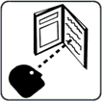
Précautions et symboles de sécurité
Avant de travailler sur la machine, lisez le manuel d'utilisation.
Lisez les informations de sécurité au début du manuel. Trouvez chaque partie à étudier dans le manuel pour bien comprendre les capacités de la machine. Respectez les manuels du propriétaire, les normes industrielles et les exigences nationales, provinciales, étatiques et locales.
DANGER !
Le symbole indique une action dangereuse qui entraînera la mort ou des blessures graves si elle n'est pas évitée. Les dangers ou risques potentiels sont représentés par les symboles qui leur sont accolés ou discutés dans le texte.
CHOC ELECTRIQUE
Le contact avec des composants électriques peut provoquer un choc électrique mortel et des brûlures graves. En utilisant un tapis isolant sec ou une couverture, isolez-vous de la pièce à travailler et de la terre. Lorsque la machine est sous tension, ne retirez pas le capot de la machine et ne touchez pas les composants ou circuits électriques sans un gant isolant sec et approprié. Un équipement mal placé ou mal mis à la terre présente un risque. Les CHOCS ELECTRIQUES peuvent causer la mort ou des blessures graves. Ne pas entrer en contact avec des composants électriques actifs. Porter des gants isolants secs et des protections corporelles non trouées. Utiliser des tapis ou des couvertures isolants secs suffisamment grands pour éviter tout contact direct avec l'ouvrage ou le sol afin de s'isoler de l'ouvrage et du sol. Si les pièces de la torche entrent en contact avec l'ouvrage ou le sol, ne pas les toucher.
Inspectez régulièrement le câble d'alimentation d'entrée et le conducteur de terre pour vérifier qu'ils ne sont pas vieillissants ou dénudés ; réparez-les rapidement s'ils sont endommagés ; les fils dénudés peuvent tuer. Lorsque vous n'utilisez pas l'appareil, éteindre tous les équipements. N'utilisez pas de câbles usés, cassés, sous-dimensionnés ou réparés. Évitez d'enrouler le câble du chalumeau autour de votre corps. Si les codes l'exigent, connectez la pièce de travail à une bonne mise à la terre électrique (earth). N'utilisez que du matériel bien entretenu. Réparez ou remplacez les pièces cassées en même temps. Lorsque vous travaillez au-dessus du niveau du sol, utilisez un harnais de sécurité. Maintenez l'intégrité de tous les panneaux et revêtements.N'essayez pas de contourner ou de surmonter les mécanismes de sécurité. N'utilisez que les types de torche indiqués dans le manuel d'utilisation. Lorsque vous appuyez sur la gâchette, gardez vos mains de l'électrode/du bout du tungstène et de l'arc. Fixez le câble de travail à la pièce (et non à un élément qui va tomber) ou à la table de travail, aussi près que possible de la zone de soudage. Lorsqu'elle n'est pas fixée à la pièce, isolez la pince de travail pour éviter tout contact avec des objets métalliques.
Avant d'inspecter, de nettoyer ou de remplacer des pièces de la torche, et avant d'installer ou de réparer cette machine, mettez-la hors tension. Installez, mettez à la terre et utilisez cet équipement conformément au manuel d'utilisation et aux lois nationales, provinciales, nationales et locales. Assurez-vous toujours que le fil de terre du cordon d'alimentation d'entrée est correctement connecté à la borne de terre et que le connecteur du cordon est fixé à une prise de courant correctement mise à la terre. Fixez d'abord le bon conducteur de mise à la terre lorsque vous établissez les connexions d'entrée. Entretenez les câbles en les gardant au sec, exempts d'huile et de graisse, et à l'écart du métal chaud et des étincelles.
Une tension continue élevée existe à l'intérieur de la machine même après l'avoir éteinte.
Même après avoir déconnecté l'alimentation d'entrée, il existe une tension continue dangereuse dans les sources d'alimentation de soudage de l'onduleur. Avant de toucher une quelconque pièce, éteignez l'onduleur, déconnectez l'alimentation d'entrée et attendez que les condensateurs d'entrée se déchargent.
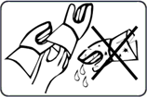
RISQUE DE BRÛLURES ET DE CHOCS ÉLECTRIQUES - PORTER DES GANTS SECS ISOLÉS
Lors du remplacement des consommables, utilisez toujours des gants secs et isolés. Pendant le soudage, les consommables deviennent extrêmement chauds et des brûlures graves sont possibles. Si l'alimentation électrique est sous tension, le fait de toucher les consommables peut provoquer un choc électrique. Ne touchez jamais les parties exposées de la torche de soudage/du porte-électrode de la machine, ne changez pas ou ne nettoyez pas les consommables lorsque la machine est allumée, car la tension de choc entre les pièces sera extrêmement dangereuse, voire mortelle.
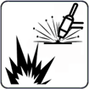
La soudure peut provoquer un incendie ou une explosion.
L'arc de soudage projette du métal chaud et des étincelles qui peuvent provoquer un incendie ou une explosion. Avant d'effectuer toute soudure, vérifiez que l'endroit est sûr. Le soudage est susceptible de déclencher un incendie ou une explosion. Retirez tous les matériaux combustibles autour de la zone de travail. Si cela n'est pas possible, utilisez des couvertures certifiées pour les recouvrir fermement. Évitez de souder dans des zones où des étincelles pourraient enflammer des matériaux combustibles. Assurez-vous que vous et les autres personnes êtes à l'abri des étincelles et du métal chaud. Sachez que les étincelles de soudage et les matériaux chauds peuvent facilement passer à travers de petits trous et interstices et atteindre les endroits environnants. Gardez un œil sur les flammes et un extincteur à proximité.Le soudage sur un plafond, un plancher, une cloison ou un mur peut provoquer un incendie sur le côté caché. Ne soudez pas sur des récipients remplis de combustible ou des récipients fermés tels que des réservoirs, des fûts ou des canalisations, à moins qu'ils n'aient été préparés de manière adéquate conformément aux normes de sécurité en vigueur.
Une fois la tâche terminée, vérifiez l'absence d'étincelles, de braises incandescentes et de flammes dans la zone. N'utilisez que les fusibles ou les disjoncteurs appropriés. Ne les surdimensionnez pas et ne les contournez pas. Tous les travaux doivent être effectués conformément aux règles de sécurité en vigueur, et un surveillant d'incendie et un extincteur doivent être disponibles. Pour éviter que les courants de soudage ne se déplacent trop longtemps, peut-être sur des parcours inconnus, et ne génèrent des chocs électriques, des étincelles et des risques d'incendie, connectez le câble de travail à l'ouvrage aussi près que possible de la zone de soudage. Ne soudez jamais sur des récipients contenant des produits potentiellement combustibles; ils doivent d'abord être vidés et soigneusement nettoyés. Ne jamais effectuer de soudage lorsque des poussières, des gaz ou des vapeurs liquides combustibles (comme l'essence) sont présents dans l'atmosphère. Il est interdit de souder des bouteilles, des canalisations ou des conteneurs sous pression. Portez des protections corporelles résistantes aux flammes et de longue durée (cuir, coton lourd, laine). Pour la protection corporelle, il est recommandé de porter des vêtements exempts d'huile, tels que des gants en cuir, une chemise épaisse, un pantalon sans revers, des bottes de travail avec une semelle isolée électriquement et un chapeau.
Évitez de placer l'appareil à proximité ou sur des matériaux inflammables. Avant d'effectuer des travaux de soudage, assurez-vous que vous n'avez pas de combustibles sur vous, comme un briquet au butane ou des allumettes.

RISQUE DE BRUIT EXCESSIF
Soyez prudent s'il y a un bruit excessif sur le lieu de travail. Portez des protections auditives si le niveau sonore est trop élevé. Les travailleurs à proximité sont également touchés par le bruit et peuvent avoir besoin de protections auditives.
DANGER LIÉ AUX PIÈCES CHAUDES
Toutes les pièces soudées deviennent extrêmement chaudes immédiatement après le soudage ou le coupage, provoquant des brûlures à toute personne en contact avec la peau exposée. Après le soudage ou le coupage, ne pas toucher instantanément la pièce, la pince de masse ou le porte-électrode/la torche, et attendre un intervalle de refroidissement avant de les ramasser. Pour éviter les brûlures, utilisez un équipement approprié lorsque vous travaillez avec des pièces chaudes, ainsi que des gants et des chiffons de soudage/coupage épais et isolants.
RISQUE DE FUMÉES DE SOUDAGE/COUPAGE
Le soudage et le coupage génèrent des gaz et des fumées. L'inhalation de ces gaz et vapeurs peut être dangereuse. Ces gaz et vapeurs peuvent remplacer l'oxygène dans le corps, ce qui peut causer des dommages ou la mort. Tenez votre tête éloignée de la zone de soudage ou de découpage et évitez d'inhaler les fumées et les gaz. Si la soudure/le découpage a lieu à l'intérieur, ventilez l'environnement ou utilisez une ventilation forcée locale sur le site de soudure pour éliminer la fumée et les gaz. Porter un appareil respiratoire à adduction d'air autorisé si la ventilation est insuffisante. Ne travaillez à l'intérieur que si vous êtes correctement ventilé ou si vous utilisez un respirateur à adduction d'air. Pour tous les matériaux utilisés, lisez la fiche de données de sécurité (FDS) et les instructions du fabricant.

RISQUE DE GAZ ET DE FUMÉES DANGEREUX
Le soudage et le coupage de métaux revêtus, comme l'acier inoxydable, ne sont pas autorisés, à moins que le revêtement n'ait été retiré de la zone de soudage ou de coupage, et que la zone soit bien ventilée et qu'un masque respiratoire à adduction d'air soit également utilisé. Pendant le soudage ou le découpage, le revêtement et tous les métaux contenant ces éléments peuvent produire des fumées nocives. Ne coupez pas les récipients qui contiennent des produits toxiques ou réactifs ou les récipients qui ont précédemment contenu des matériaux toxiques ou réactifs ; ils doivent d'abord être vidés et soigneusement nettoyés. Coupez à l'écart des processus de dégraissage, de nettoyage ou de pulvérisation. La chaleur et la lumière de l'arc peuvent se combiner aux vapeurs et produire des fumées très toxiques et désagréables.

DANGER DE GAZ DANGEREUX PROVENANT DES CYLINDRES DE GAZ DE BLINDAGE / DE COUPE
Éteignez le gaz de protection/de coupe lorsqu'il n'est pas utilisé, car ces gaz peuvent déplacer l'air, abaisser les niveaux d'oxygène et entraîner des blessures ou la mort.
RISQUE DE RAYONS DE SOUDAGE/ COUPAGE
La lumière visible et invisible (rayons ultraviolets et infrarouges) produite par le processus de soudage ou de coupage peut brûler les yeux et la peau. Portez un casque de soudage approprié avec des lentilles filtrantes convenablement ombragées pour protéger votre visage et vos yeux des rayons de soudage. Couvrez toute peau, bras ou cou exposés. Portez des vêtements de protection fabriqués dans un matériau résistant aux flammes (cuir, coton épais ou laine). Protégez les personnes contre les éclairs, l'éblouissement et les étincelles en utilisant un écran ou des barrières de sécurité.
Les CYLINDRES peuvent exploser s'ils sont endommagés.
La chaleur excessive, les chocs mécaniques, les dommages physiques, les scories, les flammes nues, les étincelles et les arcs électriques doivent être évités lors de l'utilisation des bouteilles de gaz comprimé.
Tenir les bouteilles à l'écart de tout circuit électrique ou de tout circuit de coupure ou de soudage. Ne laissez jamais une torche de soudage/un porte-électrode ou une torche à arc plasma entrer en contact électrique avec une bouteille. Une explosion se produira si vous coupez une bouteille sous pression. Lorsque la bouteille n'est pas utilisée ou fixée pour être utilisée, gardez le bouchon de protection sur le robinet. Pour éviter de tomber ou de basculer, installez et fixez les bouteilles en position verticale en les enchaînant à un support fixe ou à un support de bouteilles d'équipement. Soulevez et déplacez les bouteilles avec l'équipement et les procédures appropriés et un nombre suffisant de personnes. Lisez et respectez les instructions figurant sur les bouteilles de gaz comprimé, l'équipement associé et la Compressed Gas Association (CGA). Utilisez les bouteilles de gaz comprimé, les détendeurs, les tuyaux et les raccords qui conviennent le mieux à votre travail et maintenez-les, ainsi que leurs pièces, en excellent état de fonctionnement. Lorsque vous ouvrez le robinet de la bouteille, ne vous approchez pas de la sortie du robinet. Lorsque vous ouvrez le robinet, assurez-vous de ne pas vous tenir devant ou derrière le détendeur.
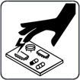
ESD-DÉCHARGE STATIQUE ELECTRIQUE
Pendant le soudage/la découpe, une charge électrique statique peut être produite et libérée dans tous les objets avec lesquels le soudeur/la découpe entre en contact après le soudage/la découpe. Avant de toucher des cartes ou des composants électroniques, mettez un bracelet relié à la terre. Lorsque vous stockez, déplacez ou expédiez des cartes PC, utilisez des sacs et des boîtes antistatiques appropriés.
RISQUE D'EXPOSITION À DES PIÈCES EN MOUVEMENT
Les machines de soudage/coupage typiques peuvent comprendre plusieurs éléments mobiles, tels que des rouleaux et des ventilateurs. Les mains doivent être tenues à l'écart des éléments mobiles comme les ventilateurs. Gardez une distance de sécurité avec les pièces en mouvement. Restez à distance des points de pincement comme les rouleaux d'entraînement. Gardez les vêtements amples et les cheveux hors de la trajectoire des pièces mobiles. Toutes les portes, panneaux, couvercles et protections doivent être fermés et sécurisés. Ne permettez qu'à des personnes qualifiées de retirer les portes, panneaux, couvercles et protections doivent être fermés et sécurisés. Ne permettez qu'à des personnes qualifiées de retirer les portes, panneaux, couvertures ou protections si nécessaire pour la maintenance et le dépannage. Une fois l'entretien effectué, réinstallez les portes, panneaux, couvertures ou protections avant de reconnecter l'alimentation d'entrée.
L'EXPLOSION DE LA BATTERIE peut causer des blessures.
N'utilisez pas la machine à souder pour charger des batteries ou démarrer des véhicules, car cela pourrait provoquer une explosion.
LA CHUTE D'UN ÉQUIPEMENT peut causer des blessures
Ne soulevez que l'unité, et non le train de roulement, les bouteilles de gaz ou autres accessoires, à l'aide de l'anneau de levage. Assurez-vous de disposer d'un équipement d'une capacité suffisante pour soulever l'unité. Si vous devez déplacer l'appareil à l'aide de fourches de levage, assurez-vous qu'elles sont suffisamment longues pour atteindre l'autre côté. Lorsque vous travaillez depuis un emplacement aérien, gardez l'équipement (câbles et cordons) hors de la trajectoire des véhicules en mouvement.
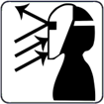
Les étincelles et les projections de métal chaud provenant de l'arc de coupe peuvent causer des blessures.
Les projections de métal chaud générées par le hachage et le meulage peuvent causer des blessures. Portez un écran facial ou des lunettes de sécurité avec écrans latéraux homologués. Protégez votre peau en portant une protection corporelle appropriée. Pour éviter que les étincelles ne pénètrent dans vos oreilles, utilisez des bouchons d'oreille ou des protège-oreilles résistant aux flammes. Portez des lunettes de sécurité avec des écrans latéraux ou des écrans faciaux.
L'EXPLOSION DES PIÈCES DE L'INVERSEUR peut provoquer des blessures.
Lorsque l'électricité est connectée aux sources d'alimentation des onduleurs, les pièces défectueuses peuvent exploser ou provoquer l'explosion d'autres pièces. Coupez la source d'alimentation et commencez à entretenir les onduleurs, et portez toujours un écran facial et des manches longues pour protéger votre corps et votre peau.
Les champs électromagnétiques peuvent provoquer des défaillances dans les appareils électriques tels que les stimulateurs cardiaques.
Des champs électromagnétiques se forment pendant le soudage ou le découpage, ce qui peut provoquer des défaillances dans les composants électriques ou les dispositifs médicaux implantés dans la zone environnante. Les personnes qui portent des stimulateurs cardiaques ou d'autres dispositifs médicaux implantés doivent rester à l'écart des CEM émis par les soudeurs/coupeurs. Avant toute opération de soudage à l'arc, de soudage par points, de gougeage, de découpe à l'arc plasma ou de chauffage par induction, les porteurs de dispositifs médicaux implantés doivent consulter leur médecin et le fabricant du dispositif.
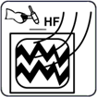
Les RADIATIONS H.F. peuvent provoquer des interférences dans les équipements électroniques.
La radionavigation, les téléphones cellulaires, les services de sécurité, les ordinateurs et les équipements de communication peuvent être affectés par l'allumeur haute fréquence (H.F.). Cette machine à souder ne doit être installée que par des personnes qualifiées qui connaissent bien les équipements électroniques. L'utilisateur est responsable de tout problème d'interférence causé par l'installation de la soudeuse et le problème doit être rapidement résolu en faisant appel à un électricien certifié. Arrêtez immédiatement d'utiliser l'équipement si le problème d'interférence n'a pas été résolu. Faites tester et entretenir régulièrement l'installation de la machine. Pour réduire les risques d'interférence, maintenez les portes et les panneaux des sources de haute fréquence complètement étanches, maintenez les éclateurs à un niveau approprié et utilisez une mise à la terre et un blindage adéquats et suffisants.
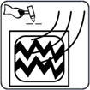
La soudure peut provoquer des interférences dans les équipements électroniques
Les équipements électroniques, tels que les ordinateurs et les équipements pilotés par ordinateur, comme les robots, peuvent être endommagés par l'énergie électromagnétique. Gardez les câbles courts, proches les uns des autres et aussi bas que possible, pour éviter toute interférence. Le soudage doit être effectué loin de tout équipement électrique sensible. Assurez-vous que cette source de courant de soudage est installée et mise à la terre conformément aux instructions de ce manuel. Si les interférences persistent, l'utilisateur doit envisager de déplacer l'équipement, d'utiliser des câbles blindés, des filtres de ligne ou de protéger l'espace de travail.
Mesures de sécurité importantes
- Mettez des gants isolants secs. Évitez de toucher l'électrode à main nue. Le port de gants humides ou endommagés est interdit.
- Des blessures peuvent être causées par la projection de composants. Lors de l'entretien d'un appareil, portez toujours un écran facial. Mettez une casquette et des lunettes de sécurité. Portez un casque de soudage avec la teinte de filtre appropriée. Portez une protection corporelle complète.
- La position la plus instable de l'appareil ne doit pas être inclinée vers le haut de plus de 10°. Les composants auxiliaires tels que les bouteilles de gaz, les unités d'alimentation en fil ou les dispositifs de refroidissement peuvent avoir un impact sur la stabilité selon le type d'équipement, et il faut en tenir compte.
- Avant de changer les consommables de la torche, de travailler sur la machine, mettez-la hors tension et débranchez la fiche d'entrée.
- Après la mise hors tension, une tension dangereuse subsiste sur les condensateurs d'entrée. Ne pas entrer en contact avec des condensateurs complètement chargés. Attendez toujours 60 secondes après avoir coupé le courant avant de travailler sur la machine, et vérifiez que la tension du condensateur d'entrée est proche de zéro avant de toucher une quelconque pièce.
Minimiser l'exposition CEM (champs électriques et magnétiques) du circuit de soudage / coupage.
Le soudage à l'arc et les procédés connexes tels que le découpage à la gouge, le découpage au plasma et le soudage par points génèrent un champ électromagnétique autour des circuits de soudage. Certains dispositifs médicaux, comme les stimulateurs cardiaques, peuvent être affectés par les CEM. Des précautions de protection doivent être prises pour les personnes qui ont des implants médicaux. Par exemple, il faut limiter le passage ou procéder à une évaluation individuelle des risques pour les soudeurs. En suivant les procédures appropriées, l'exposition aux CEM peut être réduite. Torsadez ou scotchez les câbles ensemble, ou utilisez un cache-câble, pour les maintenir proches les uns des autres.
Précautions concernant les dispositifs médicaux implantés:
Avant d'effectuer ou de s'approcher de procédures de soudage à l'arc, de soudage par points, de gougeage, de découpe au plasma ou de chauffage par induction, les porteurs de dispositifs médicaux implantés doivent consulter leur médecin et le fabricant du dispositif. Ne suivez les procédures ci-dessus que si votre médecin vous a donné son accord.
Évitez de mettre votre corps entre les câbles de soudage ou de coupe. Disposez les câbles de manière à ce qu'ils soient sur le côté et loin de l'opérateur. Travaillez loin de la source de courant de soudage et ne vous asseyez pas ou ne vous appuyez pas dessus. Gardez votre tête et votre corps aussi loin que possible de l'équipement du circuit de soudage. La pince de travail doit être reliée à la pièce à souder aussi près que possible de la zone de soudure ou de coupe. Le soudage ne doit pas être effectué en portant la source de courant de soudage ou de coupe ou le dévidoir de fil. Si vous avez un dispositif médical implanté dans votre corps, vous devez consulter votre médecin avant d'effectuer ou de vous approcher d'activités de soudage à l'arc, de soudage par points, de gougeage ou de découpe à l'arc plasma. N'enroulez pas les câbles autour de votre corps et ne les enroulez pas.
Il est de la responsabilité de l'utilisateur d'installer et d'utiliser l'équipement plasma conformément aux instructions du fabricant. Si des perturbations électromagnétiques sont détectées, il est de l'obligation de l'utilisateur de résoudre le problème avec l'aide technique du fabricant. Dans d'autres circonstances, il peut être facile de résoudre le problème en reliant la machine de découpe à la terre et à la pièce de travail. Dans d'autres circonstances, il peut s'agir de construire un écran électromagnétique qui entoure la source d'énergie et la zone de travail, ainsi que d'appliquer certains filtres d'entrée.
Les équipements de coupe doivent être connectés à la source d'alimentation conformément aux instructions du fabricant. Si des interférences se produisent, des précautions supplémentaires, telles que le filtrage de l'alimentation secteur, peuvent être nécessaires. Le blindage du câble d'alimentation de l'équipement de coupe installé en permanence dans un conduit métallique ou équivalent doit être envisagé. Le blindage doit être électriquement continu sur toute sa longueur. Le blindage doit être fixé à l'alimentation électrique du matériel de coupe afin de préserver un excellent contact électrique entre le conduit et le boîtier de la source d’alimentation. L’utilisateur doit analyser tout préoccuper électromagnétique dans la région environnante avant d'installer l'appareil. L'utilisateur doit confirmer que tous les autres appareils de la région sont compatibles. Cela peut nécessiter des précautions supplémentaires. Lorsque la pièce de travail n'est pas reliée à la terre pour des raisons de sécurité électrique ou en raison de sa taille et de son emplacement, comme la coque d'un navire ou la construction d'un ouvrage en acier, une connexion reliant la pièce de travail à la terre peut minimiser les émissions dans certains cas. La pièce de travail sans mise à la terre augmente le risque de blessures pour les utilisateurs ou de dommages pour d'autres équipements électriques. La pièce de travail doit être reliée à la terre par une connexion directe à la pièce de travail. Si la connexion directe n'est pas autorisée, la mise à la terre doit être réalisée par des capacités adéquates déterminées conformément aux règles nationales.
La modification des dispositions du circuit de terre ne doit être autorisée que par une personne qualifiée pour évaluer si les modifications augmentent le risque de blessure, par exemple en activation des voies de retour de courant de coupe parallèles, qui peuvent endommager les circuits de terre d'autres équipements. La norme CEI 60974-9 fournit des conseils supplémentaires, Matériel de soudage à l'arc, partie 9 : Installation et utilisation. Les problèmes d'interférence peuvent être atténués par le blindage sélectif d'autres câbles et équipements situés à proximité directe. Pour certaines applications, le blindage de l'ensemble du système de découpe au plasma peut être envisagé.
1.6 Warning Label
This power supply has this warning notice attached to it. It is critical that the operator and maintenance professional comprehend the meaning of these warning symbols.
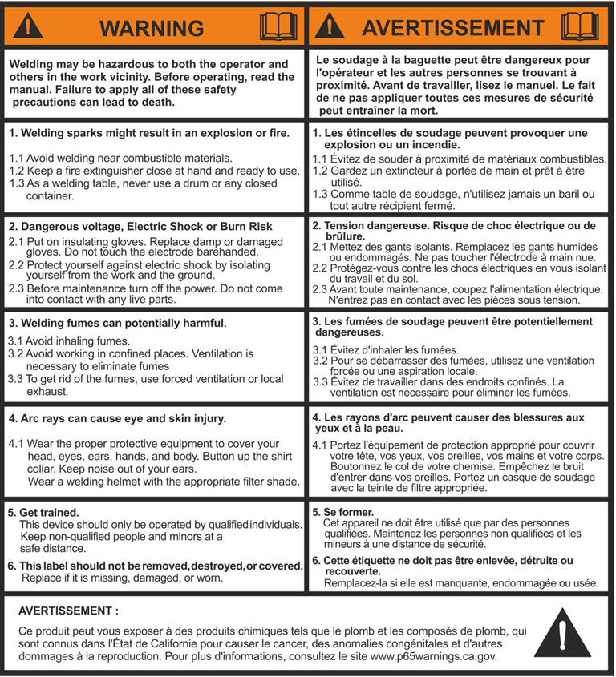
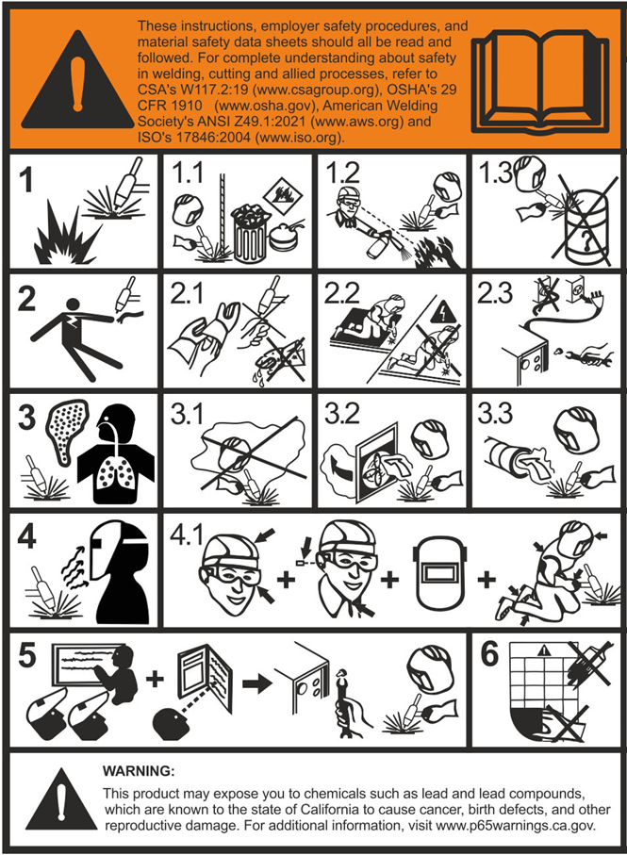

Introduction
Thank you for buying our product. In order to get the best performance out of the equipment and ensure the maximum lifespan of its parts, the use and maintenance instructions contained in this manual must be read and strictly complied with, as well as the safety instructions. They will help you to avoid potential hazards that may exist when working with this product or on the worksite. If repairs to the equipment are required, we recommend that our clients contact our service center workshops, as they have the necessary equipment and personnel that are specifically trained and constantly updated.
All our machines and equipment are constantly developed and so changes may be made in terms of their construction and features.
Description
The TIG AC/DC 231 Pulse is an industrial, heavy-duty, powerful, portable, and versatile water cooled welding machine. The professional pulse features of the machine combined with its HF start, make it ideal for welders looking to perform high-quality TIG welds even on very thin materials with no distortion.
The welding machine is an inverter-based arc welding power source optimized for AC/DC TIG and Stick welding. It is portable, lightweight, and easy-to-transport. The advanced waveforms, and pulse controls make the best professional choice for all industrial workshops. The welding machine offers excellent welding performance and various professional functions.
Description and advanced features
- Progressive square wave AC waveform for increased torch speed, depth of penetration, and rapid cooling of weld pools.
- Adjustable soft welding start and minimal distortion on thinner materials.
- Adjustable powerful start which is required for thicker materials.
- Adjustable balance settings which provide full control to mix the cleaning and penetration sequences, during aluminum welding.
- High frequency (HF) for perfect arc start and stability.
- Tested in (104°F/40°C), designed for the toughest conditions.
- Digital control of all welding parameters.
- Amperage control is accessible by foot pedal.
- Pulse TIG welding allows for better arc control and reduces work piece distortion.
- Ideal for welding thin materials.
- Excellent welding characteristics in Stick mode with the most common rods.
- Ability to use up to 165 feet (50 meters) leads without any power loss at the welding circuit.
- Digital adjustment of pre-flow, initial amperage, welding amperage, initial slope, pulse parameters, final slope, and post flow on its highly visible LCD display.
- Arc Force automatically selects the best welding arc dynamics (in Stick mode).
- Ability to pre-set all welding parameters.
- Fan cooled and thermally protected against overheating.
- Metal face panel.
- Activate or disable the VRD function instantly with a simple front panel switch.
Important Notice for Air-Cooled Operation:
If you wish to operate the machine in air-cooled mode, please make sure to install the air-cooling jumper connector before use.
If this connector is not connected, the machine will display an error indicating a disconnected water-cooling unit.
Therefore, it is essential to connect the provided jumper connector located at the back of the machine to the fixed 5-pin female connector.
We also emphasize the importance of selecting an air-cooled torch compatible with the machine’s capacity and duty cycle. Using a water-cooled torch while the machine is set to air-cooled mode will damage the torch, and such damage is not covered under Canaweld’s warranty.
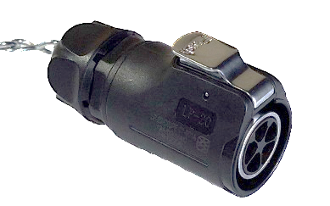
Jumper Connector
Other Features of the Machine (Auto-switching Fan)
The fan may be switched on and off based on the temperature sensed by a thermal sensor. Speed control is an ideal method for matching the delivery of air with the demands of the application. By controlling the fans and not running them continuously, you will be able to provide exactly the right amount of cooling or ventilation for your equipment, while providing real benefits in energy consumption, time between failures, and whole-life costs.
Here are some key benefits of using an auto-switching fan instead of a continuous-working alternative:
Power Consumption
A continuously working fan will always consume 100% power when switched on. Using an auto-switching fan reduces power consumption.
Noise
Using an auto-switching fan will also reduce noise.
Life Expectancy
Running at full speed, a fan will draw the most power and have the greatest power dissipation, which means its motor will be running at its hottest. This primarily affects the wires and the grease in the bearing system, which is the component with the shortest life expectancy. Using an auto-switching fan creates less heat, which will extend the life of the wire and bearings and the longevity of the fan. A longer-lasting fan means a greater interval between service intervals, saving on the cost of a replacement fan and the labor required to replace it.
Clean parts
Fan on demand ensures minimum dust and contamination are deposited over the electronics and other parts of the machine, so we can expect a longer life span for the parts and machines.
TIG AC/DC 231 Pulse is suitable for all-positions welding for various plates and profiles. Weldable materials are all types of carbon steels, low-alloy steels, alloyed stainless, nickel alloys, aluminum and its alloys, copper and its alloys, titanium, magnesium, and other nonferrous alloys.
TIG AC/DC 231 Pulse can be used in: Aerospace, Aluminum Industries, Automotive Parts and Bodies, Passenger Car Industries, Training schools, Metal Building, Manufacturing, Medical Industries, Railcar, Boat/Yacht, Shipbuilding, Light Fabrication, Food Industries and High Purity Processing, Mechanical Contractors, Installation, Restoring, Maintenance and repair-field operation, Plumbing & HVAC, Civil Construction, Infrastructure & roofing Work/Service Trucks, Farm and Ranch.
Technical Data
The general technical data of the system is summarized in Table 1. Specifications, Quality control and Test Conditions
The specification of the machine has been tested as International and North American standards in the lab. All the tests have been done in below conditions as CSA C22.2 No. 60974-1:19 Arc welding equipment — Part 1, Welding power TIG AC/DC 231 Pulse sources and International Standard IEC 60974-1.
The tests are performed at 104 °F (+40°C), Humidity of 50 % @ 104°F (+40°C) and altitude of below 1000 m from sea level.
Table 1
Model | Unit | TIG AC/DC 231 Pulse
Process |  | TIG AC | TIG DC | STICK
Single-phase input 50/60 Hz | V | 220 ±15%
Primary current @I₂ Max | A | 26 |  | 30
I ₁eff max | A | 20 |  | 19.2
Current range | A | 10-230 |  | 20-200
Duty cycle @ 100% in 104°F(40°C) | A | 190 | 165 | 140
Duty cycle @ 60% in 104°F(40°C) | A | 200 | 180 | 160
Duty cycle @ X% in 104°F(40°C) | A | 230  (30%) | 230  (25%) | 200  (35%)
Open circuit voltage | V | 74 |  | 74
Voltage Reduction Device (VRD) | V | _ |  | 14
Output voltage range | V | 10.4-19.2 |  | 20.8-28
STICK PARAMETERS
Stick Modes |  |  |  | AC,DC
Arc Force |  |  |  | 0-10
Hot Start |  |  |  | 0-10
TIG PARAMETERS
TIG Welding Process |  | HF, LIFT
TIG Welding Modes |  | 2T, 4T, Pulse, No Pulse, Stitch, Cold Stitch, TACK, Cold TACK
Pre-Gas Duration | Sec. | 0.05 - 5
Initial Welding Current | A | 10-230 | 5-230
Slope UP Duration | Sec. | 0 - 20
Principal Welding Current | A | 10-230 | 5-230
Slope Down Duration | Sec. | 0 - 20
Final Welding Current | A | 10-230 | 5-230
Post Gas Duration | Sec. | 0.1 - 25
TIG PULSE PARAMETERS
Pulse Duty Cycle | % | 5 - 95
Base Current | A | 10-230 | 5-230
Pulsation Frequency | PPS | 0.5 - 999
TIG AC PARAMETERS
Wave Shape |  | Square Wave, Sinusoidal Wave, Triangular Wave
Balance | % | 30-90
Frequency | HZ | 50 - 250
TIG SEQUENCE PARAMETERS
ON Time (Stitch and Cold) | Sec. | 0.1 - 10
OFF Time (Stitch and Cold) | Sec. | 0.2 - 25
Standards |  | IEC60974-1, IEC60974-3
Protection class |  | IP21S
Insulation class |  | F
Dimensions (D x W x H) | inch (mm) | 24 x 8.5 x 16.5  (610 x 215 x 420)
Weight | Ib. (kg) | 42 (19)
IMPORTANT NOTE: CANAWELD is always striving to produce the best possible products and improving the quality. Therefore, reserves the right to change, improve or revise the specifications or design of this or any product without prior notice. Such updates or changes do not entitle the buyer of equipment previously sold or shipped to the corresponding modifications, updates, improvements, or replacement of such items. The values specified in the table above are optimal values, your values may differ. Individual equipment may vary from the above specifications due in part, but not exclusively, to any one or more of the following: variations or changes in manufactured components, installation and conditions and power grid supply conditions.
Usage Limits (IEC 60974-1)
The use of a welder is typically discontinuous, in that it is made up of effective work periods (welding) and rest periods (for the positioning of parts, the replacement of electrode and underflushing operations etc. This welder is dimensioned to supply a I2 max nominal current in complete safety for a period of work of X% of the total usage time. The regulations in force establish the total usage time to be 10 minutes. The work cycle is considered to be X% of this period of time. When the work cycle permitted is exceeded, the internal NTC thermal sensors detect the temperature rise and trigger the thermal protection system. This protection automatically disconnects the power stage, protecting the welding machine’s internal components against dangerous overheating and preventing incorrect functioning of the machine. After several minutes the overheat cut-off rearms automatically and the welder is ready for use again (Automatic reset error). This equipment is built to have a protection level of IP 21 S.
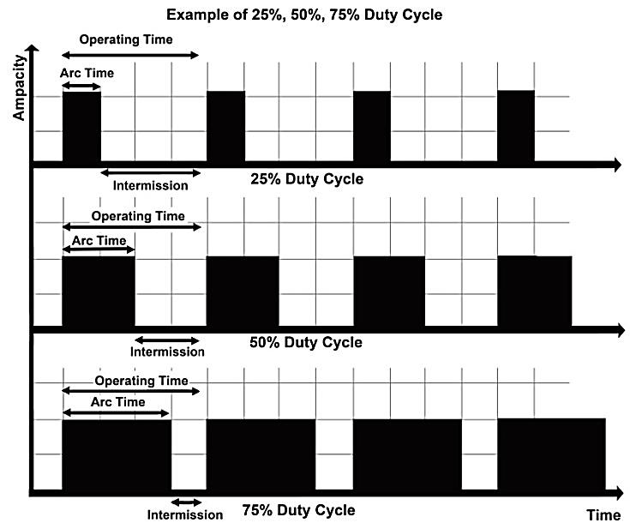
How to Lift Up the Machine
The power supply includes a handle for hand lifting only. Be sure unit is lifted and transported safely and securely.
Warning: do not touch live electrical parts. Disconnect input power cord before moving unit. Handle is not for mechanical lifting.
Open the Packaging
Upon receiving the system:
- Remove the welding generator and all relevant accessories components from their packaging.
- Check that the weld machine is in good condition, if not report any problems immediately to the seller-distributor.
- Make sure all ventilation grilles are open and that no foreign bodies are blocking the air circulation.
Installation and Connections
The installation site for the system must be carefully chosen in order to ensure its satisfactory and safe use. The user is responsible for the installation and use of the system in accordance with the producer’s instructions contained in this manual. Before installing the system, the user must take into consideration the potential electromagnetic problems in the work area. In particular, we suggest that you should avoid installing the system close to:
- Signaling, control and telephone cables.
- Radio and television transmitters and receivers.
- Computers and control and measurement instruments.
- Security and protection instruments.
Persons fitted with pace-makers, hearing aids and similar equipment must consult their doctor before going near a machine in operation. The equipment’s installation environment must comply to the protection level of the frame i.e. IP 21 S (IEC 60529 publication). The system is capable of working in environments where working conditions are particularly hard.
This system is cooled by means of the forced circulation of air, and must therefore be placed in such a way that the air may be easily sucked in and expelled through the apertures made in the frame.
The equipment must be assembled as follows:
- Connect the welding machine to the utility line.
- Connect up the welding cables.
General requirements for work area:
- Ensure a clear, well lit work area with unrestricted movement for the operator.
- The work area should be well ventilated, as welding emits fumes which can be dangerous.
- Always maintain easy access to the ON/OFF switch of the welder, and the electrical mains supply.
- Do not expose the welder to rain and do not operate in damp or wet locations.
Where welding must be undertaken in environments with increased risk of electric shock, confined spaces or in the presence of flammable or explosive materials, it is important that the environment be evaluated in advance by an “expert supervisor”. It is also recommended that welding in these circumstances be carried out in the presence of persons trained to intervene in emergencies.
Connecting the Welding Machine to The Utility Line
Connection of the machine to the user line (electrical current) must be performed by qualified personnel.
Before connecting the welding machine to the mains power supply, make sure that rated voltage and frequency correspond to those provided by the mains power supply (The serial number and rating information is located on the bottom of the machine. Use the rating plate information to determine input power requirements and rated output.) and that the welding machine’s power switch is turned to “O”. Electrical installation must meet all National and Local Codes. Only a qualified electrician may do the installation. The three pole cable supplied with the system must be used for the connection to the mains power supply. This cable is made up:
- Two conductors that are used to connect the machine to the power supply.
- The third, which is YELLOW GREEN, is used for making the “GROUND” connection.
Connect a suitable load of normalised plug (2p + e) to the power cable and provide for an electrical socket complete with fuses or an automatic switch. The ground terminal must be connected to the ground conducting wire (YELLOW- GREEN) of the supply.
TIG AC/DC 231 Pulse machines can be connected to 220V±15%.
Please note that, before connecting electricity, check the voltage of the network.
Check if the circuit breaker or fuse is suitable for the machine as well.
Note: If the supply voltage continuously exceeds the safe operating voltage range, it will shorten the life of the machine.
IMPORTANT:
DO NOT to connect the machine to a voltage higher than 220+15% V.
Receptacles Types:
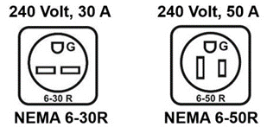
Note: Receptacle circuit testers will easily check the continuity of the grounding conductor. Receptacle circuit testers are available at electrical supply or hardware stores; these inexpensive test devices plug into an electrical outlet. Indicator lights show whether the grounding circuit is available at the outlet, as well as other circuit tests. If the test device shows the absence of a ground connection or other circuit problem, call a qualified electrician for assistance. This is a simple test and should be done periodically.
Always consult with a qualified electrician to test circuits, installation proper fuses and grounding.
Table 2 shows the capacity values that are recommended for fuses in the line with delays.

Table 2
Model | TIG ACDC 231 PULSE
Rated input voltage/frequency | 1 Phase 220V±15%, 50/60 HZ
Rated input capacity (KVA) | 6.6
Maximum primary current (A) | 30
Input protection (A) | D35
Recommended cord size (Minimum) | 10 AWG
Recommended Extension Cord Length (Maximum) | 30 ft.
Recommended Grounding Conductor Size (Minimum) | 10 AWG
Attention: Do not use PVC cable for Earth clamp and cable set. Use SOOW, H07RN-F or an equivalent.
Note 1: The Effective Input Current should be used to determine cable size and supply requirements.
Improving the Input Supply Network:
In case the input supply voltage network is not stable, improve it, if possible, Such as:
Reduce the number of powerful electrical devices operating simultaneously, using the same power supply.
Increase the cross section of the power supply cable in the event of a significant voltage drop. Consult an electrician for the cable cross section calculation.
If possible, ask your workshop electricity supplier, change the tap of your power transformer network, and decrease or increase your network input voltage, and receive a stable voltage for all appliances in your workshop.
Command and Control Units
In Fig. A:
- Fast coupling straight polarity.
- TIG weld auxiliary 9 pin control connector (torch button, remote control and pedal)
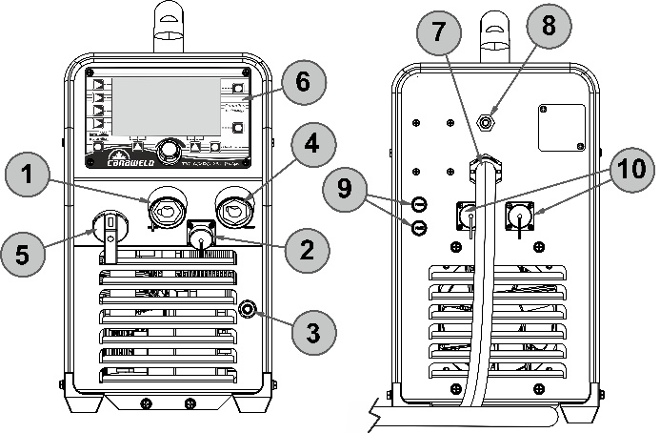
Fig. A
Pin No. | Function
1, 2 | TIG Torch Trigger Switch Connections
5,6,7 | 10k-Ohm Foot Pedal Potentiometer connections
9- Pin Control Connector
- Fast coupling TIG torch gas tube.
- Fast coupling reverse polarity.
- Power supply switch. In the "O" position the welder is off.
- Control panel.
- Mains cable.
- Welding gas input joint.
- Fuse holders, two 3A / 250VAC UL certified fuses for water-cooling unit protection.
- Water cooled unit connector, to connect power source to the water-cooled unit. Connect the BLUE (COLD water supply) hose to the BLUE water inlet quick push-to-lock fitting connector and RED (HOT water return) hose to the RED water inlet quick push-to-lock fitting connector on the front panel of the water-cooled unit. Check for Leaks!

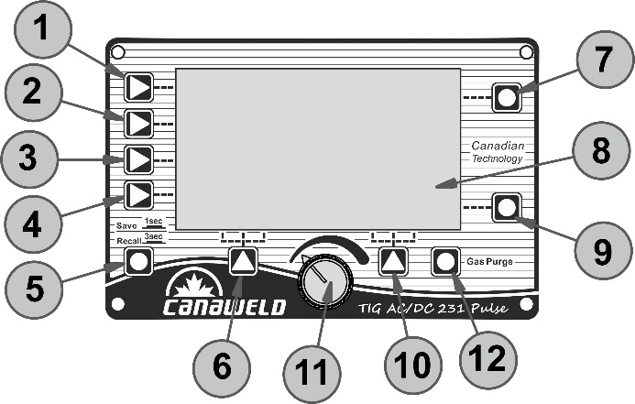
Fig. B
In Fig. B:
- Welding process, the TIG ACDC 231 PULSE offers 3 welding processes HF TIG, LIFT TIG and STICK. each time the button is pushed, the welding machine switches to select the welding process.
- Output waveform, it makes it possible to control the following wave shapes: DC, AC square wave, AC sine wave, AC triangle wave.
- DC welding is suitable for TIG DC welding.
- AC square wave focuses arc for maximum penetration, fast travel speed with best directional control.
- AC Sine Wave is a traditional AC TIG welding wave form. It has a quieter, ‘soft’ arc characteristic.
- AC Triangle Wave reduces heat input for the same current setting. Be especially useful for welding thin metal.
- Welding mode, the machine offers 2 welding modes 2T and 4T.
- Welding function key: Press it to select the opening or closing of No-Pulse, Pulse mode, Cold (Tack) and Stitch welding mode.
- JOB key: Press it for 3 sec. to open JOB program and press it for 1 sec. to save parameters into JOB number.
- Function A key. In HF TIG/ Lift TIG, press it to select pre-gas time, initial welding current and slope up time; In Cold (Tack) welding mode, press it to select pre-gas time; In JOB program, press it to load the parameter settings for the selected number.
- Parameter A key: Press it to select Hot Start, AC Frequency or Balance. If the key is not pressed within 3 sec., the selection will be automatically removed.
- LCD Screen: It will show all welding parameters, such as welding voltage, welding current and other parameters set.
- Parameter B key: Press it to select Electrode Diameter, Arc-Force. If the key is not pressed within 3 sec., the selection will be automatically removed.
- Function B key: In HF TIG/ Lift TIG, press it to select slope down duration, final welding current and post gas time; In Cold (Tack) welding mode, press it to select post gas time; In JOB program, press it to delete the parameter settings for the select number.
- Parameters select/adjust knob. Press it to select parameters, such as principal welding current, peak current, base current, pulse frequency, pulse width and the JOB program number. Rotate it to adjust parameters’ value.
- Gas purge, press to start/stop shielding gas flow.
Optional Accessories
Pairing and Unpairing the Remote Foot Pedal
Before you begin:
- Make sure the foot pedal battery is new and fully charged.
- Set the foot pedal switch to the ON position.
Pairing the Foot Pedal
- Press and hold the encoder knob on the machine.
- While holding the knob, turn the machine ON.
- The display will show “Connecting”.
- At this moment press and release the foot pedal several times.
- The machine will then enter the main operating mode and you will also hear the HF ignition sound.
- The foot pedal is now paired. Even if you turn the machine OFF and ON again, the current can still be controlled through the pedal.
Important: each time you turn the machine OFF, always set the foot pedal switch back to OFF to preserve battery life.
Unpairing the Foot Pedal
If you want to use the foot pedal with another machine, you must first unpair it from the current machine:
- Press and hold the encoder knob.
- Turn the machine ON while holding the knob.
- When the display shows “Connecting”, do not press the foot pedal.
- After a few seconds, the pedal will automatically unpair from the machine.
- You can now pair the foot pedal with another machine following the steps above.
Canaweld’s ergonomic full metal foot pedal provides durable and smooth amperage control for the TIG welding applications. Decompressing the pedal fully increases the welding amperage to the max settings. Releasing will lower current to finish weld and initiate gas post flow.
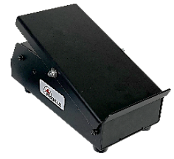

Water-Cooling Unit
High amperage TIG welding needs a strong, heavy-duty water-cooled torch. The TIG AC/DC 231 Pulse has a superb detachable water-cooling unit installed to reduce the temperature of the water-cooled torch components. The CU-H1's high cooling efficiency provides a cooler, more comfortable weld compared to traditional air-cooling procedures and the other competitors' water-cooling systems. This cooling device efficiently transfers the heat from the arc away from the handle of the gun or torch and into the airflow that exits at the back of the cooler. Keep in mind, the coolant temperature of the cooling unit is influenced by the outside ambient air temperature. The CU-H1's efficiency components result in a small reservoir size, as well as a portable, light-weight device in contrast to conventional coolers that require a large reservoir size. Some electrical connections between the water-cooling unit and the water-cooled torch are required. A closed-loop design that circulates the coolant liquid while utilizing a heat exchanger, prevents the system from overheating. To power up the cooling unit and have the necessary communication to create matching error when the liquid coolant pressure lowers, the unit must be connected to the TIG AC/DC 231 Pulse machine through two sets of 3-Pin and 5-Pin connections.
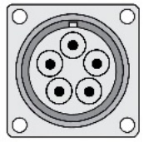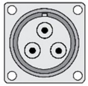
An internal pressure switch is included inside the water-cooling unit to keep the system from losing pressure or running low or out of liquid coolant. Always verify the connections of the cooling unit to the machine and to the water-cooled torch and check the coolant liquid level to keep it in the recommended threshold levels. Use the recommended coolant liquid from Canaweld to avoid the liquid coolant freezing.
WARNING: It is important to note that using any coolant other than those introduced and supplied by Canaweld will void the warranty on the radiator, pump, or other parts that come into contact with the coolant.
Attention: Danger of electric shock. Always wear a dry insulating pair of gloves and work shoes. Electrical connections of the cooling unit carry 220VAC when the machine is ON. Turn OFF the machine before connecting or disconnecting the electrical connections.
The Canaweld’s CU-H1 is an independent circulating cooling system for keeping cold the Canaweld’s water-cooled torches during the high-amperage and heavy-duty cycle welding jobs. All Canaweld’s water-cooled torches have standard coolant "In" and "OUT" connections that easily can be connected to the push-to-lock fittings inlets of the cooling unit. The cooler has a special 220 V power input plug that makes it very simple to power on by just connecting to the matching receptacle on the back of the machine. The coolant is delivered to the welding torch or gun by the pump, which pulls its supply from the coolant reservoir which can easily be filled out. In order to remove the coolant's heat energy, the coolant flow is passed through a heat exchanger and then deposited in the coolant reservoir. The pump functions and the presence of sufficient amounts of the coolant in the system are always monitored by a high-quality liquid pressure switch.
The CU-H1 is incredibly simple to use and just requires just one power switch on the rear panel to turn it on. Simple steps may be taken to add coolant to the reservoir, and hand-pushing is all that is required to connect the coolant "In" and "OUT" connectors.
Specifications
Table 3
Model | CU-H1
Rated input voltage/frequency | 1 Phase 220V, 50/60 HZ
Maximum input current | 1.3A
Operating Flow Rate (Typical) | 0.60 gal./min ( 2.3 liter/min)
Maximum Flow Rate | 1.45 gal./min (5.5 liter/min)
Operating Pressure (Typical) | 68 psi (469 KPa, 4.7 Bar)
Coolant tank capacity | 1.5 gal. (5.6 Liter)
Weight (Empty tank) | 40 lb. ( 18 Kg)
Recommended Operating  Temperature, (With the recommended coolant) | -10°C to +40°C
Dimensions (L x W x H) | 26 x 9 x 16 ( 660 x 230 x 41 ) in. (mm)
IP rating | IP23S
Recommended Coolant Type
Ambient Temperature | When there are  TIG and Plasma Machines | When there are  MIG Machines
Above 32°F or 0°C | Deionized, Distilled, or Clean Tap Water
Under 32°F (0°C) to 11°F (-12°C) | Torch Coolant  30% PG Mixture | ZERO PROPYLENE  LONG LIFE 30%
Under 11°F (-12°C) to -29.2°F(-34°C) | - | ZERO PROPYLENE  LONG LIFE 50%
- A combination of 50% pure industrial grade ethylene glycol or other recommended coolant and 50% distilled/ de-ionized water should be used for applications below freezing.
- Any cooling liquid other than the one that is advised might damage the equipment.
- Any Canaweld warranties on parts (such as a pump or radiator and etc.) damaged by coolants other than those listed in the table are void in the event that such damage occurs.
Important note:
Ethylene glycol-containing coolants are harmful to both people and animals. They must not be carelessly thrown out, especially when liquids are involved. To find out about proper disposal procedures or recycling information, contact your neighborhood Environmental Protection Agency (EPA) office.
Thermal Efficiency
The CU-H1's high cooling efficiency provides a cooler, more comfortable weld compared to traditional air-cooling procedures and the other competitors' water-cooling systems. This cooling device efficiently transfers the heat from the arc away from the handle of the gun or torch and into the airflow that exits at the back of the cooler. Keep in mind, the coolant temperature of the cooling unit is influenced by the outside ambient air temperature. The CU-H1's efficiency components result in a small reservoir size, as well as a portable, light-weight device in contrast to conventional coolers that require a large reservoir size.

Operation Environment
CU-H1 cooling machine can provide rated outputs at rated duty cycles when the following environmental conditions prevail:
- The elevation of the welding operation must be above sea level and less than 1000 meters.
- Temperature range of operation must be from -10°C to +40°C.
- The relative humidity must be less than 90% (at 20°C).
- The machine must be placed above the floor level, with the maximum tilting angle not exceeding 10°.
- The equipment must be protected from heavy rain or intense sunlight in hot weather.
- The concentration of dust, acid, or corrosive gas in the surrounding air or material must not exceed the usual limit.
- Adequate ventilation must be applied during the welding process. There should be at least 1ft. (or 30cm) between the machine and the wall.
- There should be at least 1m between the machine and the workpiece during the welding process.
TIG Welding Procedure
Application range
Regarding materials, thickness, and welding positions, TIG welding is a versatile welding technique. It enables the production of excellent welded joints. Due to a number of intriguing benefits, the method works better than conventional fusion welding techniques. One of these benefits is its adaptability for a wide range of jobs. TIG welding has several uses and can weld practically any metallic material. Today, stainless, acid-proof, and non-scaling steels, as well as aluminum and nickel alloys, are the most often used materials. The technique is distinguished by the production of weld metal with extremely high purity and surface quality. As a result, the process is utilized when welding quality is critical, such as when making goods for the chemical and power industries, or when welding materials prone to scaling, such as titanium and zirconium. Square butt joints may be welded from one side on plate thicknesses ranging from 0.3 to 4 mm without the need of filler metal. TIG welding is mostly utilized in manual welding, but it is also used in automated welding processes such as automatic tube welding and tube sheet welding. The technique adapts itself wonderfully to automation. TIG procedure can be used to connect almost all types of metallic materials if they are at all suitable for fusion welding. It is also a highly clean procedure that ensures a high-quality welded junction while also producing very little spatter and other contaminants. TIG welding also has the unique benefit that, unlike other procedures that use consumable electrodes, the current and feeding of welding consumables are not related. As a result, the welder is able to add only the necessary amount of welding consumable at any given moment and optimize the current for the welding activity. The method is thus especially well-suited for location welding and welding root passes. Due to these benefits, the TIG method is being employed with success in several fields of industries and trade.
Special Characteristics
- High quality
- Smooth and even weld surface
- Spatter free
- Slag formation free
- Wilding without Fume
The TIG welding method, like any other welding approach, must be learned first by practice. The following are some broad pointers for putting this plan into action. In many ways, manual TIG welding is similar to the forward technique of gas welding. In both cases, the torch is held in one hand while the filler material is held in the other. In both cases, the "nozzle" is pointed away from the weld spot, and the welder uses filler metal to weld toward the hand with the filler metal. The welder may manage the amount of heat given to the workpiece in this technique by altering the length of the arc.
DC TIG Welding
During the process, the electrode merely serves as a footing for the arc and must not melt (the melting temperature of tungsten is more than 3300°C). When welding with direct current, the electrode is linked to the power source's negative pole, which creates the least heat. The electrode and the molten pool, throughout the welding process, are shielded by a gas, typically pure argon. Any filler material required is fed in by hand, just like in gas welding. The DC power source utilizes DC (direct current), in which the major electrical component, electrons, move in only one direction, from the negative pole (terminal) to the positive pole (terminal). There is an electrical principle at work in the DC electrical circuit that should always be considered while operating any DC circuit.
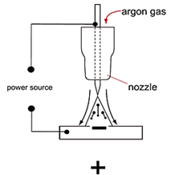
A DC circuit always has 70% of the energy (heat) on the positive side. This is important because it decides which terminal the TIG torch will be attached to (this rule applies to all the other forms of DC welding as well). An arc is formed between a tungsten electrode and the metal workpiece during DC TIG welding. An inert gas flow protects the weld region from contamination of the tungsten, molten pool, and weld area. When the TIG arc strikes an inert gas, it is ionized and superheated, altering its molecular structure and converting it to a plasma stream. The TIG arc is the plasma stream that flows between the tungsten and the workpiece and may reach temperatures of 19,000°C. It is a highly pure and focused arc that allows for the controlled melting of most metals into a weld pool. TIG welding allows the operator the most flexibility to weld the widest range of materials, thicknesses, and types. DC TIG welding produces the cleanest weld possible, with no sparks or splatter.
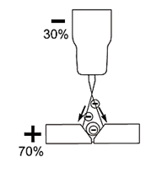
The arc's intensity is proportional to the current flowing from the tungsten. To control the power of the arc, the welder alters the welding current. Thin material typically requires a less strong arc with less heat to melt the material, requiring less current (amps), whereas thicker material requires a more powerful arc with more heat, necessitating more current (amps).
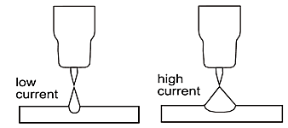
TIG (Lift) ignition method
In less sophisticated DC welding, the arc can be struck by lightly brushing the electrode on the workpiece. The arc ignites, when the tungsten electrode tip comes into touch with the workpiece.
The process is described below.
- Place the tungsten electrode tip on the workpiece with care and push the torch trigger afterwards (a factory set amount of current will flow, regardless of the main current set).
- Invert the torch over the torch gas nozzle edge to create a 2-3 mm gap between the electrode tip and the workpiece. The arc ignites, and the welding current is raised to the start or main current set, depending on the selected operating mode.
- Return the torch to its regular welding position.
To end the welding process, release the torch trigger or push and release (depending on the selected method).
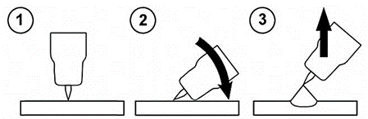
TIG (Lift) Ignition Method
How to TIG Weld?
Because there are some slight variations between gas and TIG welding, an experienced gas welder who wants to switch to TIG welding must learn a new approach. Managing the filler material, on the other hand, is typically not a problem. A proficient arc welder will find it easier to sustain the arc but will need more skills in accurately applying the filler metal.
TIG Welding Fusion Technique
Manual TIG welding is sometimes regarded as the most challenging of all welding procedures. Because the welder must maintain a limited arc length, tremendous care and expertise are necessary to avoid electrode contact with the work piece. TIG welding, like Oxygen Acetylene torch welding, usually takes two hands and requires the welder to manually feed a filler wire into the weld pool with one hand while managing the welding torch with the other. However, some welding involving thin materials, such as edge, corner, and butt joints, can be completed without the need of filler metal. Fusion welding is the process of melting the edges of metal objects together using just the heat and arc force generated by the TIG arc. Once the arc has been begun, the torch tungsten is maintained in position until a weld pool is formed; a circular movement of the tungsten will aid in the formation of a weld pool of the required size. Once the weld pool is formed, tilt the torch at a 75° angle and advance smoothly and evenly along the connection, fusing the materials together.
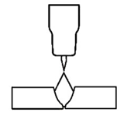
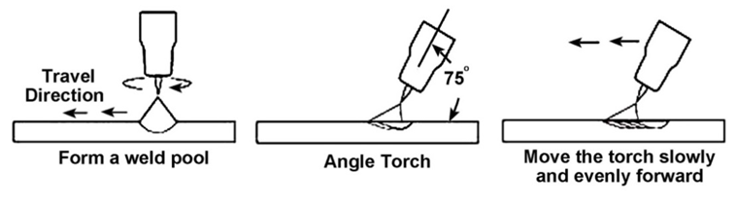
TIG Welding with Filler Wire Technique
In many cases, while welding stainless steel and copper, the filler material can be continuously fed into the pool's edge. However, despite the argon shielding, this approach is not recommended for welding aluminum because the aluminum wire would become so hot that scaling would occur on its surface despite the argon shielding. As the wire melts, it transports oxides into the molten pool to such an extent that the arc's cleaning effect on the oxides would be insufficient, resulting in a poor-quality weld. As a result, the wire is pulled back and forth, with the tip sinking beneath the pool's edge at regular intervals.
The heavier the gauge of the filler material required to fill up the joint, the thicker the material to be welded. As a result, as the electrode tip is fed into the pool, a heavy filler wire may come into contact with it. It is better to move the torch back and forth along the weld in this case. When the arc's heat has adequately fused the weld point's edges, raise the torch 6 to 12 mm above the weld point and plunge the welding wire tip into the molten pool to be melted off. To continue the fusing process, the wire is pushed back, and the flame is pushed ahead along the weld. The flame and the filler wire both move in a rhythmic back and forth motion.
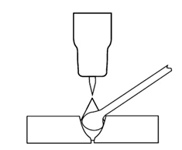
This method is recommended for welding from one side with plate thicknesses more than 6 mm.
The filler material is fed in at the pool's edge and must not come into touch with the electrode tip or enter the arc, as seen in the image. The wire tip, on the other hand, must always be maintained close to the molten pool. This keeps it within the argon gas envelope that covers the arc and weld pool, preventing surface oxidation scaling as much as possible.
As mentioned before and in many cases, TIG welding requires the addition of filler wire to the weld pool in order to enhance the weld and generate a robust weld. Once the arc has been begun, the torch tungsten is maintained in position until a weld pool is formed; a circular movement of the tungsten will aid in the formation of a weld pool of the required size. Once the weld pool is formed, tilt the torch at a 75° angle and move the torch smoothly and uniformly along the joint. The filler metal is added to the weld pool's leading edge. The filler wire is normally held at a 15° angle and fed into the leading edge of the molten pool; as the torch moves ahead, the arc will melt the filler wire into the weld pool. The wire is fed into the molten pool and withdrawn in a repeated process while the torch is pushed gently and evenly ahead. It is critical to retain the molten end of the filler wire within the gas shield during welding to prevent it from oxidizing and polluting the weld pool.
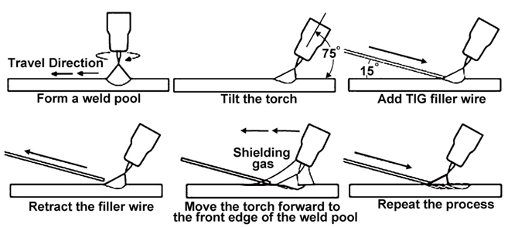
TIG Torch
The TIG torch should be as flexible and portable as possible. Therefore, it should be as light as possible to avoid making handling the torch uncomfortable during extended welding sessions. Additionally, it needs to be small enough to allow access in tight spaces. The electrically conducting parts must be designed so that heat buildup does not make the torch unpleasant to wield. There are TIG torches available with self-cooling capacities of up to 250 amps. When higher amperages are required, water-cooled torches should be used. It is possible to change the head angle to find the least fatiguing working position.
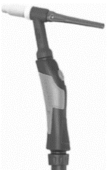
Shielding gas
Inert gases shield the weld pool from the negative effects of the ambient air because they do not chemically react with it or mix with other chemicals. Argon makes up around 1% of the volume of the atmosphere and is heavier than air. The best and most popular shielding gas for TIG welding is argon because it is quickly ionized and insensitive to changes in arc length.
The electrode and molten pool are mostly shielded by the gas both during welding and afterwards until they have cooled. Enough gas post-flow time guarantees that the molten metal pool cools off without any contact with ambient air.
The flow rate in liters per minute is used to specify the shielding gas supply. This is defined by the weld pool size, which in turn depends on the electrode diameter, gas nozzle diameter, nozzle distance from the surface of the base material, ambient air flow, and type of shielding gas. As a general guideline, add 5 to 10 liters of shielding gas per minute to the most popular tungsten electrode diameters. Manometers can be used to measure indirect flow rate by positioning them in front of an interconnected nozzle that monitors pressure in relation to flow rate. The manometer's scale is directly calibrated in liters per minute. More particularly, float type meters and measuring devices that directly measure using glass tubes measure the actual protective gas flow rate.
Shielding Gas for protecting the root of welding
Root gas protects the back of the weld from the effects of air and gives the weld a surface that is resistant to acids and other substances of the kind. Stainless steel, acid-resistant steel, and titanium are examples of materials that need root gas. Pure argon or mixtures of 10% hydrogen and 90% nitrogen are the most often used shielding gases.
TIG Process Gas Cups
The purpose of the ceramic gas cup is to shield the tungsten and weld pool from oxidation while welding. There are nozzles of various sizes to provide the coverage required for the majority of applications.
The most economical nozzles are made of 90 or 95 percent alumina oxide and are suitable for lower amperage applications. However, these nozzles tend to degrade, break, and come off when used in higher amperage applications since they are not particularly good at withstanding thermal stress.
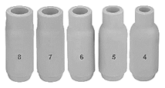
Lava nozzles are more expensive and more resistant to cracking than alumina oxide nozzles. These nozzles perform effectively in situations requiring medium to high amperage.
Some recommended electrode diameter, cup size and gas flow rate have been shown in the following simplified chart. Recommended values may differ according to the actual welding conditions and other parameters such as welding position, workpiece thickness, and ambient temperature and so on.
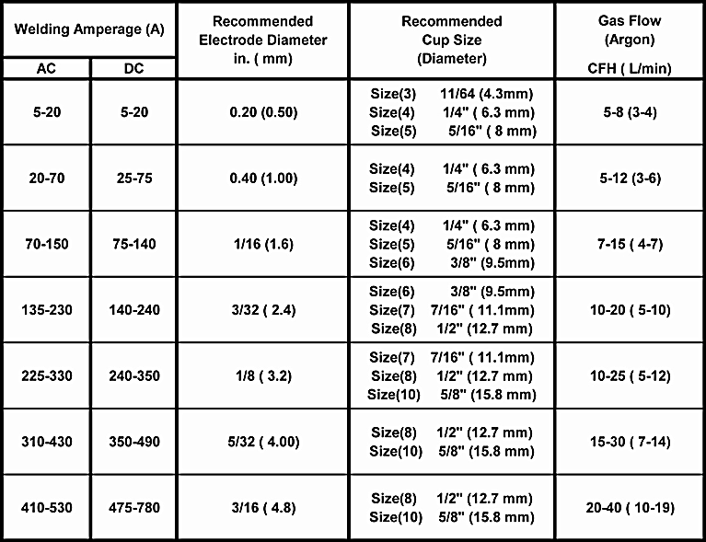
Note: Welding with inverter welding machines often requires less heat input (lower amperage). The recommended parameters are all approximate and are only for manual welding, not automated welding. Test the welds to ensure they meet your requirements.

Gas Lens
Gas lenses provide better coverage in comparison to the standard Colette bodies. Using a gas lens can reduce gas consumption up to 50%. The electrode stick-out may be increased to 15-20 mm, enabling easier access in small spaces and better welding process monitoring.
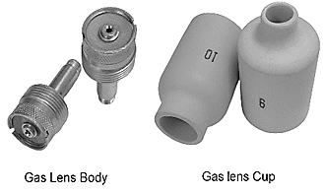
TIG Welding Filler Metal Rod Consumables
TIG welding typically employs rod-shaped welding consumables. Welding consumables are often chosen in accordance with the source metal. However, when specific alloying elements are utilized, the welding consumable must differ from the parent metal for metallurgical reasons.
The welding consumable's diameter must be matched to the welding task. This is determined by the thickness of the material and the diameter of the tungsten electrode. Welding rods are typically 1000 mm long and to minimize mistakes, they are labeled individually with the name and/or a trade number.
Cleaning the welding surface
Before beginning the welding process, it is crucial to properly clean the workpiece's surfaces and the fusion faces for the best welding outcomes. Grease, corrosion, filth, and paint should be removed from the surfaces, and the surface must be bright before welding. Wherever feasible, scale layers should also be eliminated. Frequently, brushing is sufficient, but in some cases, the surface must be processed mechanically, either by grinding or another way. For corrosion-resistant materials, only stainless-steel brushes should be used; otherwise, iron particles on the surface might produce rust. In the case of aluminum, it's crucial that the surface doesn't have a heavy layer of oxide so that pores may form. Use the proper chemicals to clean the welding surfaces. Be aware that solvents containing chlorine may release toxic vapors.
Tungsten Electrodes
Electrodes for TIG welding
TIG welding normally utilizes four different types of electrodes. They are thorium-alloyed tungsten, zirconium-alloyed tungsten, rare earth-alloyed tungsten, and pure tungsten. Tungsten electrodes are non-consumable and available in a range of sizes; they are constructed of pure tungsten or a tungsten-and-other-rare-earth-element alloy. TIG welding was traditionally performed using pure tungsten electrodes. By alloying this type of electrode metal with thorium or zirconium, several advantages were obtained, including an increase in electron flow, which results in enhanced striking and re-striking and, as a consequence, higher arc stability. Furthermore, alloyed electrodes are more robust, can tolerate higher currents, and are less prone to tungsten inclusions in the weld.
Pure tungsten (Color Code: Green)
This electrode is made of pure tungsten and has a melting temperature of 3400°C. The electrode tip must be rounded for welding aluminum alloys. Tungsten is a rare metallic element that is used to make TIG welding electrodes. TIG relies on the hardness and high-temperature resistance of tungsten to transfer the welding current to the arc. Although pure tungsten has historically resisted heat better because it rounds out rather than creating tiny nodules, it is no longer the ideal material for AC TIG welding. Due to the properties of pure tungsten in combination with AC mode welding, the tungsten balls up, resulting in a larger arc cone and potential arc wandering. The tungsten can become so hot that it splits or falls off, contaminating the weld puddle, when the pure tungsten ball becomes larger than the tungsten's exterior diameter. Pure tungsten may still be needed for some welding processes. To focus heat into the weld and away from the electrode in these circumstances, this machine with extended balance control and AC frequency modification is useful. However, the operators won't experience all the advantages of TIG inverter technology by utilizing the pure tungsten electrode.
Alloyed Tungsten Electrodes
Alloyed tungsten electrodes, also known as rare earth tungsten electrodes, exceed traditional pure tungsten and help to maximize the operation's quality and productivity since they contain components like cerium or lanthanum. The right alloyed tungsten depends on the material being welded, the required amperage, and whether AC or DC welding current is used. Unlike pure tungsten, which tends to ball up, rare earth tungsten keeps its point. Additionally, rare earth tungsten alloyed is a superior choice for AC TIG welding because of features like enhanced balancing control and output frequency that remove more heat from the tungsten to reduce the nodules. It reduces nodules and keeps an electrode pointed by concentrating less heat on the tungsten. Choosing rare earth tungsten electrodes in combination with the advanced square-wave technology has another benefit that allows the use of the smaller tungsten electrodes, which provide more control and a more concentrated arc. Just keep in mind that, it is impossible to compare electrodes made by different manufacturers simply by considering the oxide percentages, because the crucial production factors, such as the distribution and particle size of the oxide, varies amongst the various producers. The only way to know which tungsten is best for you is to test it out in a real-life experiment. The ends of all tungsten electrodes are color-coded for easy identification. The most common tungsten electrodes are listed below.
Thoriated (Thorium alloyed) (Color Code: Red)
This electrode is commonly used in DC welding of stainless steel, mild steel, copper, titanium, and other materials. Thorium alloyed tungsten electrodes contain at least 97.30 percent tungsten and about 2 percent thorium. They are one of the most widely used electrodes in DC TIG welding and are favored for their durability and convenience of usage. Thorium, on the other hand, is a low-level radioactive threat, and many users have shifted to other options. In terms of radioactivity, thorium is an alpha emitter, although the hazards are insignificant when it is trapped in a tungsten matrix. Thoriated tungsten should never come into touch with open wounds or cuts. The most serious threat to welders is when thorium oxide enters the lungs. This can occur as a result of welding vapor exposure or swallowing of material/dust during tungsten grinding. For usage, follow the manufacturer's warnings, directions, and the material Safety Data Sheet (MSDS). Although Thoriated tungsten is still the most often utilized electrode in DC TIG applications, most industry professionals strongly advise utilizing Ceriated or Lanthanated electrodes for both AC and DC TIG welding due to radiation-related problems.
This type of tungsten alloy is a good all-purpose electrode. It operates well when overloaded with additional amperage and has one of the lowest work functions. The Thoriated offers a roughly 20% increase in current carrying capacity, usually longer lifespan, and better resistance to weld contamination. Compared to pure tungsten or Zirconiated tungsten electrodes, arc beginning is simpler, and the arc is more stable with these electrodes. When welding steel, it is preferable that it keeps a pointed tip design. Because it is challenging to retain the balled end, which is required for AC welding, it is not frequently utilized with AC TIG welding.
Rare earth-alloyed tungsten (Color Code: Purple and Turquoise)
Rare earth-alloyed tungsten electrodes include a minimum of 98 percent tungsten and up to 1.5 percent Lanthanum, as well as tiny amounts of zirconium and Yttrium. Rare earth-alloyed tungsten electrodes have conductivity comparable to Thoriated electrodes. This often implies that the electrodes may be replaced with Thoriated electrodes without needing substantial welding process adjustments. Superior arc starting, electrode longevity, and overall cost-effectiveness are provided by rare earth alloyed. When comparing the electrodes to 2 percent Thoriated tungsten, rare earth-alloyed requires fewer re-grinding and has a longer overall lifespan. In tests, the electrodes' ignition delay actually improves over time, whereas 2 percent Thoriated tungsten begins to degrade after only 25 starts. Rare earth-alloyed tungsten electrodes operate cooler than 2 percent Thoriated tungsten with comparable energy output, prolonging overall tip lifespan. The electrodes operate well in both AC and DC applications. They may be used as a positive or negative DC electrode with a pointed end, or they can be balled for use with AC power sources.
Ceriated (Color Code: Gray)
Ceriated tungsten electrodes are defined as having a minimum of 97.30 percent tungsten and 1.80 to 2.20 percent cerium. Ceriated tungsten works best in low current DC welding, and typically operates with around 10% less amps than Thoriated material. The Ceriated electrodes show a slower rate of vaporization or burn-off than pure tungsten. They offer great arc starting at low amperages and have proven popular in orbital tube welding and thin sheet metal operations. They are most commonly used to weld carbon steel, stainless steel, nickel alloys, and titanium, and in some situations, they can replace 2% Thoriated electrodes. Ceriated tungsten is ideally suited for lower amperages and should last longer than un-Ceriated tungsten. Thoriated or Lanthanated tungsten is better suited for higher amperage applications. Due to its characteristics, it is often suitable for quick welding sessions or when a fixed number of welds are required before the electrode needs to be changed. This electrode may be used for AC or DC welding; however, it is typically utilized for DC welding because AC welding could cause it to break.
Lanthanated (Color Code: Black, Gold, and Blue)
Minimum 97.80 percent tungsten and 1, 1.5, or 2 percent of lanthanum are present in Lanthanated tungsten electrodes, which are color-coded in black, gold, and blue, respectively. Lanthanum is not radioactive. These electrodes feature strong arc starting properties, a low burn off rate, high arc stability, and good re-ignition characteristics. Starting and maintaining low current arcs generally require 15% less amps. Lanthanated tungsten has the same conductivity properties as 2% Thoriated tungsten. Lanthanated tungsten electrodes are great for improving welding capabilities. They operate well on AC or DC negative electrodes with a pointed end for DC welding, or they can be balled for use with AC sine wave power sources. Lanthanated tungsten keeps its sharpened edge well, which is useful for welding steel and stainless steel on DC or AC from square or sine wave power sources.
Zirconiated (Zirconium alloyed) (Color Code: White, and Brown)
Zirconiated tungsten electrodes are composed of at least 99.10 percent tungsten and 0.15 to 0.40 percent of zirconium and it is non-radioactive. This electrode was designed primarily for AC welding; however it may also be used in DC welding, but AC welding is the most prevalent use. Zirconiated tungsten provides a highly steady arc and is tungsten spitting resistant. Because it preserves a balled tip and is very resistant to contamination, it is perfect for AC welding. It has the same or better current carrying capability than Thoriated tungsten. Zirconium electrodes have a melting point of roughly 3800°C. Zirconiated tungsten electrodes often have welding characteristics halfway between pure and Thoriated tungsten. It is ideal for welding light metals such as aluminum and magnesium.
Tungsten Electrodes Rating for Welding Currents
Tungsten  Diameter  In.(mm) | DC Current Amps  Torch Negative  RED (Thoriated) | AC Current Amps  Un-Balanced  White (Zirconiated) | AC Current Amps  Balanced  White (Zirconiated)
0.040 (1.0) | 15-80 | 15-80 | 20-60
1/16 (1.6) | 70-150 | 70-150 | 60-120
3/32 (2.4) | 150-250 | 140-235 | 100-180
1/8 (3.2) | 250-400 | 225-325 | 160-250
0.157(4.0) | 400-500 | 300-400 | 200-320
Note: Welding with inverter welding machines often needed less heat input (lower amperage). The recommended parameters are all approximate and are only for manual welding, not automated welding. Test the welds to ensure they meet your requirements.
Tungsten Preparation
A pointed electrode produces a narrower, more concentrated arc than rounded or unprepared tungsten electrodes. This helps welders maintain a constant bead width and prevent distortion by improving arc control and accurately directing heat at the weld junction. As shown, it is critical that the electrode tip be correctly grounded. If the tip is not in good form, there is a high possibility that the arc will become unstable. The tip in the image has a 30° angle, which is ideal for low amperages.
However, when the welding current increases, the angle must be increased. The table below illustrates the appropriate electrode tip angles. The tip's extreme point should be ground off since it cannot support high currents, burns off quickly, and may contaminate the weld pool. When welding with alternating current, the electrode tip should be softly rounded. It is enough to lightly bevel the electrode's edge. If the electrode tip becomes drop-shaped during AC welding, the amperage is too high for the diameter of the electrode being used.
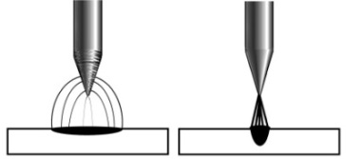
Use only diamond wheels for cutting and grinding. While tungsten is a highly hard material, a diamond wheel's surface is even harder, which allows for more precise grinding. Weld inconsistency and weld flaws can be caused by grinding with aluminum oxide or other non-diamond wheels because they can produce jagged edges, irregularities, or poor surface finishes that are not visible to the naked eye.
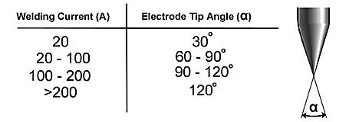
On the grinding wheel, always be sure to grind the tungsten in a longitudinal orientation. If electrodes are ground across, the electrons have to leap over the grinding marks and the arc might start before the tip and wander because tungsten electrodes are created with the molecular structure of the grain running lengthwise. The electrons flow constantly and easily to the end of the tungsten tip while grinding lengthwise with the grain. The arc starts straight and stays steady, narrow, and concentrated.
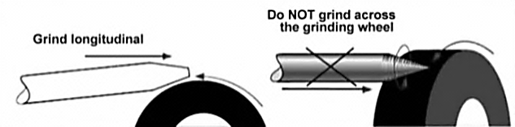

Electrode Flatted (Truncated) Tip
In precision arc welding, the form of the tungsten electrode tip is a significant process variable. The demand for various benefits will be balanced by a wise choice of tip/flat size. To assist in maintaining the heat created in the welding arc and lessen the chance of tungsten contamination, a truncated (flatted) tip is suggested rather than a sharp point. However, arc wander will be more likely to happen and arc starting will be more challenging the larger the flat, the weld penetration and electrode life will be improved by raising the flat to the highest height that still permits arc initiation and reduces arc wonder. To facilitate arc beginning, some welders continue to grind electrodes to a sharp point. However, they run the danger of reduced welding performance due to tip melting and the potential for the point to detach and fall into the weld pool.
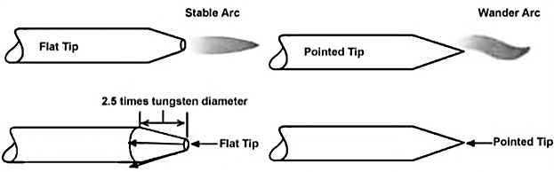
Tungsten Electrode Grinder
The biggest health risk to welders is inhaling or ingesting thorium oxide dust created by grinding tungsten. In order to prevent such a hazardous situation, the use of the Canaweld Tungsten Electrode Grinder Utensil is highly advised.
The CANAWELD Premium Quality TIG Welding Tungsten Grinder is a time and money investment because it is carefully designed to grind welding electrodes with a precision ground finish for crisp, snappy arc starts, better arc control, clean arc transfer, longer electrode run time, and less tungsten waste. It is made to guarantee the safety of the welders’ eyes, fingers, and lungs. To make this happen, this grinder machine comes with a cover plate. See the grinder user manual for further details.
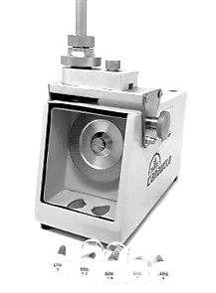
Electrode Included Angle/Taper - DC Welding
In addition to tip/flat preparation, tungsten electrodes for DC welding should be ground longitudinally and concentrically with diamond wheels to a particular included angle. Different angles result in various arc shapes and provide various weld penetration capacities. The advantages of blunter electrodes with a larger included angle are generally as follows:
• Be More Durable
• Can withstand higher amps without degrading
• Have superior weld penetration
• Have a thinner arc shape.
Smaller included angles and sharper electrodes offer:
• Have a larger arc
• Provide less arc welding
• Have a more steady arc
Weld bead size and form are determined by the included angle. In general, penetration rises, and bead width reduces as the included angle increases.
Selecting the Size of the Electrode
The following table can be used as a starting point to choose the suitable electrode diameter based on the necessary welding amperage.
Tungsten Diameter  in. (mm) | Diameter at the Tip  in. (mm) | Constant Included Angle Degrees | Current Range Amps | Current Range  Pulsed Amps
0.040 (1.0) | 0.0050 (0.125) | 12 | 02 - 15 | 02 - 30
0.040 (1.0) | 0.010 (0.25) | 20 | 05 - 30 | 05 - 60
1/16 (1.6) | 0.020 (0.5) | 25 | 08 - 50 | 05 - 100
1/16 (1.6) | 0.032 (0.8) | 30 | 10 - 70 | 10 - 140
3/32 (2.4) | 0.032 (0.8) | 35 | 12 - 90 | 12 - 180
3/32 (2.4) | 0.045 (1.1) | 45 | 15 - 150 | 15 - 250
1/8 (3.2) | 0.045 (1.1) | 60 | 20 - 200 | 20 - 300
1/8 (3.2) | 0.057 (1.5) | 90 | 25 - 250 | 25 - 350
Note: Welding with the inverter welding machines often needed less heat input (lower amperage). The recommended parameters are all approximate and are only for manual welding, not automated welding. Test the welds to ensure they meet your requirements.
TIG Welding Parameters
It is important to keep in mind that just the current is set on the welding equipment when determining the welding settings. The welder controls the arc length, which dictates the arc voltage. Therefore, the arc voltage increases as the arc length does. As a starting point, a welding current that is adequate for welding typically ranges between 40 and 45 amps per millimeter of workpiece thickness.
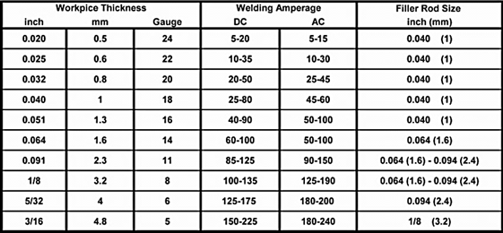
Note: Welding with inverter welding machines often needed less heat input (lower amperage). The recommended parameters are all approximate and are only for manual welding, not automated welding. Test the welds to ensure they meet your requirements.
Joint Forms
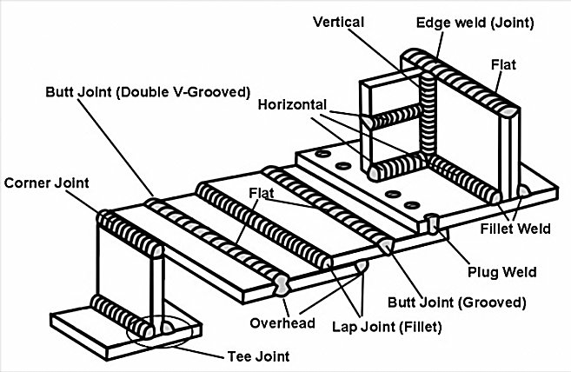
TIG on Stainless Steel (single run welding)
Workpiece Thickness  Gauge, in. (mm) | Joint Form | Tungsten Electrode Diameter in. (mm) | Welding Wire Diameter in. (mm) | Argon Gas Flow Rate SCFH  (L/min) | Welding Current (DCEP)  A | Welding Speed in./min  (cm/min)
22, 0.031 (0.8) | Butt joint | 0.040 (1) | 1/16 (1.6) | 10.6 (5) | 20-50 | 26 (66)
20, 0.037 (1.0) | Butt joint | 1/16 (1.6) | 1/16 (1.6) | 10.6(5) | 50-80 | 22 (56)
16, 0.063 (1.5) | Butt joint | 1/16 (1.6) | 1/16 (1.6) | 14.9(7) | 65-105 | 11.8 (30)
16, 0.063 (1.5) | Corner joint | 1/16 (1.6) (1.6)1/16 (1.6) (1.6) | 1/16 (1.6) | 14.9(7) | 75-125 | 9.8 (25)
14, 0.078 (2.0) | Butt joint | 1/16 (1.6) | 3/32 (2.4) | 14.9(7) | 85-125 | 11.8 (30)
14, 0.078 (2.0) | Corner joint | 1/16 (1.6) | 3/32 (2.4) | 14.9(7) | 95-135 | 9.8 (25)
11, 1/8 (3.2) | Butt joint | 1/16 (1.6) | 3/32 (2.4) | 14.9(7) | 100-135 | 11.8 (30)
11, 1/8 (3.2) | Corner joint | 1/16 (1.6) | 3/32 (2.4) | 14.9(7) | 115-145 | 9.8 (25)
7, 3/16 (4.8) | Butt joint | 3/32 (2.4) | 1/8 (3.2) | 17 (8) | 150-225 | 9.8 (25)
7, 3/16 (4.8) | Corner joint | 1/8 (3.2) | 1/8 (3.2) | 19.1 (9) | 175-250 | 7.9 (20)
Note: Welding with inverter welding machines often needed less heat input (lower amperage). The recommended parameters are all approximate and are only for manual welding, not automated welding. Test the welds to ensure they meet your requirements.
TIG Welding Setup
To begin TIG welding, carry out the following tasks (with the machine switched off):
- Install the TIG torch to the machine by connecting the Dinse connector to the negative output connection socket.
- Connect the control cable of torch switch to 9-pin socket on the front of the machine.
- Screw the argon gas regulator onto the gas cylinder and tighten it; connect the gas tube from the regulator to the gas inlet on the welding machine.(8, Fig. A) and then connect the TIG torch gas tube to machine’s gas outlet. (3, Fig. A)
- Set up the TIG torch. Loosen the back cap and remove the nozzle and copper collet pieces from your torch. Place the tungsten into the collet. Leave about 1/8 to 1/4 in. sticking out of the collet. Tighten the back cap. Ensure back cap and collet body are screwed in firmly.
- Fit the earth lead Dinse plug to the positive terminal and then connect earth clamp to the workpiece ensuring that the clamp makes good contact with bare metal.
- Connect the BLUE (COLD water supply) hose to the BLUE water inlet quick push-to-lock fitting connector and RED (HOT water return) hose to the RED water inlet quick push-to-lock fitting connector on the front panel of the water-cooled unit. (for more detail please refer to the section " Cooling unit connections ". Fill up the tank according to the recommended coolant type. (for more detail please refer to the section " Reservoir filling") Check for Leaks!
- Connect the input power cord's 3-pin circular male connection of the cooling unit to the 3-pin circular female outlet on the welding machine's back side panel.
- Connect the connecting cable of the cooling unit for control signal to the 5-pin circular female receptacle on the welding machine's back side panel using the 5-pin circular male connector.
- Power on the machine.
- Power on the cooling unit. The POWER SWITCH is located on the rear panel. When the rotary switch turns to either "l" or "O," the cooler will be "On" and "OFF," respectively. When the cooler is working, you can hear the pump working and feel airflow coming from the side panels of the device. It will run constantly and can be controlled by an automatic device inside the attached Canaweld’s welding machine.
- After turning on the cooling unit for the first time, you must eliminate the air bubbles in the system. For more detail please refer to the section " Eliminate the air bubbles in the system ".
- Remove the fill cap to check the coolant flow. The return flow can be heard directly via the fill opening. Make sure there are no water leaks in any of the coolant pipes before starting the welding process.
- Carefully open the valve of the gas cylinder. Set the required gas flow rate.
- Select “Lift TIG” or “HF TIG” on the front panel.
- Set torch operation 2T/4T and choose one of the No-Pulse/Pulse/ Cold/Stitch functions.
- When 2T operation is selected, press the torch switch, the gas starts to flow and after the pre gas time selected, the arc is ignited (in lift TIG, press the tip of the torch against the workpiece then press down the torch switch, lift the electrode away from the workpiece) and current rising to the principal welding current within the selected slope up duration. Release the torch switch and the welding current will drop in accordance with the selected slope down duration. After the arc is turned off the gas will continue for the post gas time.
- When 4T operation is selected, press the torch switch, the gas starts to flow. Release the torch switch, the arc is ignited (in lift TIG, press the tip of the torch against the workpiece then press down the torch switch, lift the electrode away from the workpiece) and current rising to the principal welding current within the selected slope up duration. press the torch switch down and the welding continuous. Release the torch switch, current will drop in accordance with the selected slope down duration. After the arc is turned off the gas will continue for the post gas time.
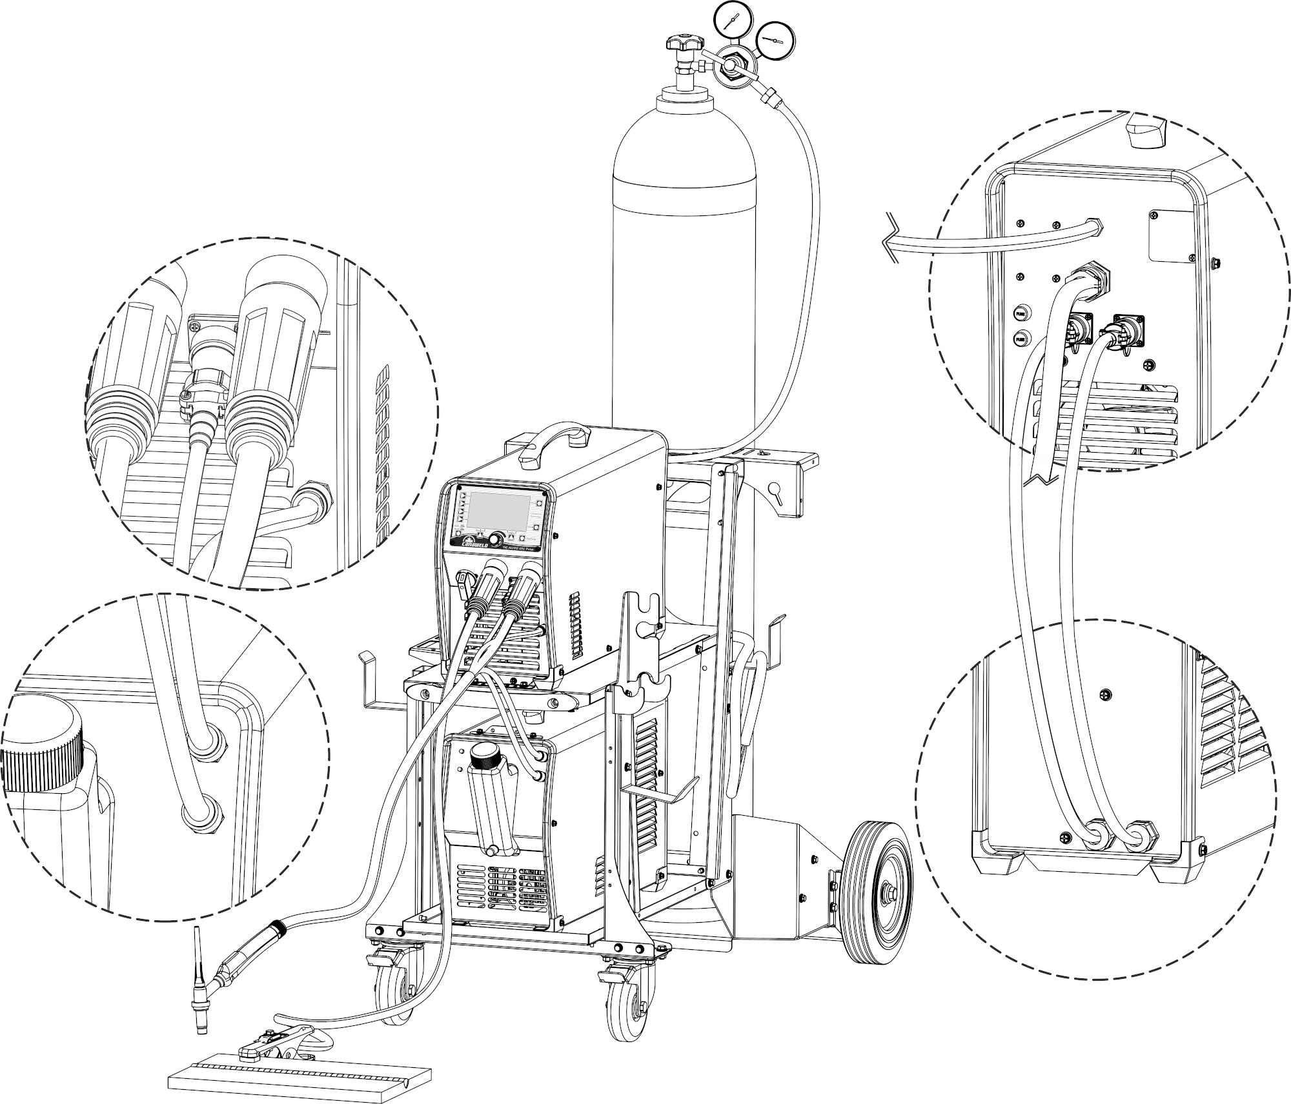
Fig. C
When a TIG AC/DC 231 Pulse welding machine is operated in the HF ignition method, the ignition spark can cause interferences in equipment near the welding machine. Be sure to take special safety precautions and shielding measures.
Short-circuit protect function:
- In TIG DC LIFT, If the tungsten electrode touches the workpiece when welding, the current will drop to 20A, which can effectively reduce tungsten spoilage and extend the tungsten electrode lifespan.
- In TIG DC HF, If the tungsten electrode touches the workpiece when welding, the current will drop to 0 within 1s, which can reduce the tungsten spoilage farthestly, prolong the using life of the tungsten electrode and prevent tungsten clipping.
Prevent arc-break function: if arc-break occurs the HF will keep the arc stable.
TIG Display Introduction

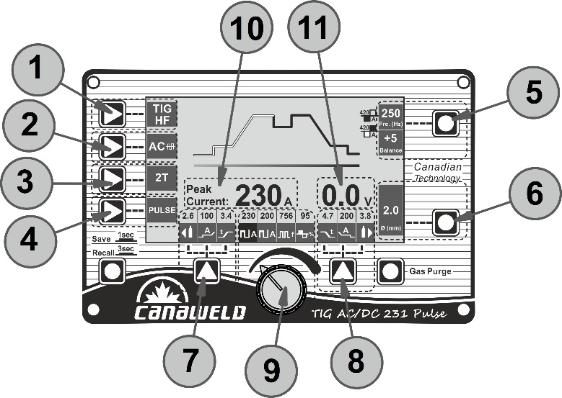
Fig. D
- Welding process key: Press it to enter HF TIG or Lift TIG welding process.
- Waveform key: Press it to select DC output or AC waveform output.
- Welding mode key: Press it to select 2T or 4T trigger mode.
- Welding function key: Press it to select No-Pulse, Pulse mode, Cold (Tack) and Stitch welding mode.
- Parameter A key: Press it to select AC Balance or Frequency. In AC welding the ratio between positive and negative half cycle is called Balance. The adjustment range of the balance is 30 to 90. The adjustment range of the frequency is 50 to 250 HZ.
- Parameter B key: Press it to select Electrode Diameter.
- Function A key: Press it to select pre-gas time, initial welding current and slope up time.
- Function B key: Press it to select slope down time, final welding current and post gas time.
- Parameters select/adjust knob: Press it to select welding current and other parameters. Rotate it to adjust parameters’ value.
- Current display: It displays welding amperage during welding operation, otherwise show amperage selected.
- Welding voltage display.
TIG PULSE Display Introduction
Important notice:
The actual welding amperage in the pulse and AC welding mode is the average value of the pulsed or AC waveform and may differ from the predetermined peak amperage (current). During the welding, the LCD display always shows the average value of the welding amperage not the preset value.
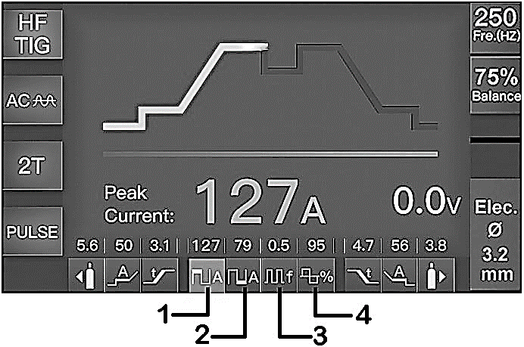
- Peak current: The peak current is adjustable from 5 to 230 A in DC mode, and from 10 to 230 A in AC mode.
- Base current: The base current is adjustable from 5 to 230 A in DC mode, and from 10 to 230 A in AC mode.
- Pulse frequency: 0.5 - 999Hz.
- Pulse width: 5 - 95%.
TIG Stitch/Cold (Tack) Welding Display Introduction
- Current display: 10 to 230A (20 to 200A for Stick Welding Mode).
- T_{on} display: 0.1 to 10s.
- T_{off} display: off to 25s.
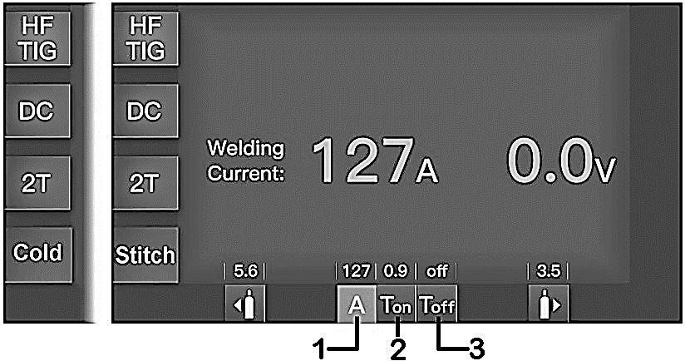
Reservoir Filling
Note: Before filling up the coolant reservoir, turn off and unplug the cooler.
The customer is responsible for filling the reservoir before using the machine.
Use only CANAWELD coolant and carefully read the MSDS for safe use and correct storage.
After 6 months the coolant must be completely changed, whatever the operating hours of the machine.
Place the cooling system on a completely flat (horizontal) level surface before adding the coolant to the reservoir. Avoid moving or replacing the cooling system when it is full of the coolant to prevent leaks and electrical shock risks. It is advised to place the cooler on Canaweld's industrial welding cart before filling it up to make it easier to move the cooler (and welding machine as well) without taking the risk of a leak during the movement. This industrial welding cart was created specifically for this type of cooling unit. The fill cap's aperture fits most coolant containers, but while filling the cooling unit, a funnel should be inserted into the reservoir hole to prevent coolant spills. Fill out with the suitable coolant until the level of the coolant reaches to the maximum level that is visible through the designated slot at the side panel of the cooling device. Be cautious, after connecting the water cool torch to the system for the first time, the coolant level will decrease because some of the coolant fills out the long water tubes of the torch. In such a situation, fill out the reservoir once again to reach the maximum level again. Use a funnel to carefully pour the proper amount of the coolant into the coolant reservoir fill aperture until the reservoir gets “FULL”. Avoid letting the coolant spill on the cooling unit panel and/or cover. When the coolant lies slightly below the maximum sign at the side panel opening slot of the cooler, the cooler is considered "FULL."
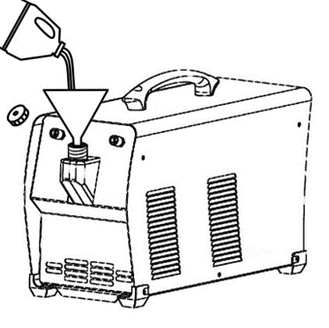
It is necessary to know that the pump has a coolant pressure switch connected that deactivates and opens the contact between pins 1 and 2 of the 5-pin control connection when there is insufficient coolant pressure. An open circuit between the two pins indicates that the cooling system is not working properly. The issue may be caused by a simple cooling system issue, such a shortage of coolant, or by a much more serious issue, like a pump issue. This open-circuit will stop the welding process of the related welding machine to prevent any damage to the water-cooled torch.
Note:
- Always be cautious of the water-cooled torches' adequate coolant flow. The heating raised from blocked or bent torch hoses, in such a situation will destroy the torch neck, and the damage is not covered by the warranty!
- The fluid level must not fall below the lower marker or rise above the higher marking
- Do not add more coolant to the reservoir than 2 gallons (7.6 liters).
- When the reservoir is filled, make sure to reinstall the fill cap. Employing the CU-H1 without the fill cap in place may result in coolant evaporation loss, ineffective cooling, and shortened product life.
- Before using the cooler, the reservoir volume should be checked every day. Check the coolant level by looking at the opening slot of the side cover. Keep the reservoir full, especially after switching the accessory being cooled or removing the water lines.
Cooling Unit Connections
The front panel of the CU-H1 cooling unit has two female Push-to-Lock fitting inlets. In the welding industry, these kinds of water hose couplings are often utilized. Most of the water-cooled torches made by Canaweld are equipped with the proper male fitting connections.
Push the supplementary Inlet hose into the coolant "OUT" fitting on the cooler's right side, which is colored or marked BLUE on most hoses. Then, using the supplementary inlet hose which is usually colored or marked RED, push it into the coolant red inlet fitting, which is situated on the left side of the cooler's front panel. Once more, push firmly both the connectors of the hoses into the cooler fitting in order to prevent leaks.
NOTE: Immediately after turning on the cooling units, make sure that there are no leaks, because leaking will reduce the coolant level in the reservoir, impair the cooling performance, and reduce the torch/gun lifespan significantly.
Eliminate the Air Bubbles in the System
After turning on the cooling unit for the first time, you must eliminate the air bubbles in the system. Use the special pipe provided with the equipment and the following directions to get rid of air bubbles in the hydraulic circuit.
As shown in the following image, insert the specific pipe connection into the cooling unit's BLUE fitting outlet and place the other end of the pipe on top of the reservoir's filling aperture. Power on both the relevant welding machine and the cooling unit. Be careful not to let the coolant liquid spill when pouring it into the reservoir. Always protect yourself against splashed coolant droplets by putting on the proper mask, gloves, and safety goggles. Wait until the output coolant flow at the pipe's end becomes clear and bubble-free, and the related welding machine shows no cooling unit-related errors. Then turn off the machine and the cooling unit. Take out the special pipe and install the water-cooled torch blue pipe connector into the BLUE fitting outlet, then install the water-cooled torch red pipe into the RED fitting inlet. After all, turn on the related welding machine and the cooling unit as well. If there is no error on the related welding machine, the system is ready to start the welding process.
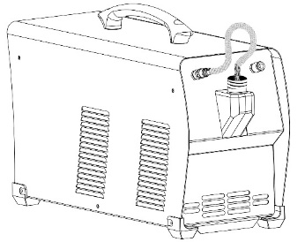
Checking the Coolant Level
Before using the cooler, the coolant tank should be checked every day. Check the coolant level by looking at the opening slot of the side cover. Keep the tank full, especially after switching the accessory being cooled or removing the water hoses.
TIG Welding with Air-Cooled Torch
- When the machine is set to air cooling, you must use an air cooled torch that matches the duty cycle shown on the machine’s nameplate.
- Connection of a water cooled torch to an air cooled machine is strictly prohibited, as this may cause overheating and torch failure.
JOB Program Introduction
The JOB function makes it possible to save up to 10 welding programs.
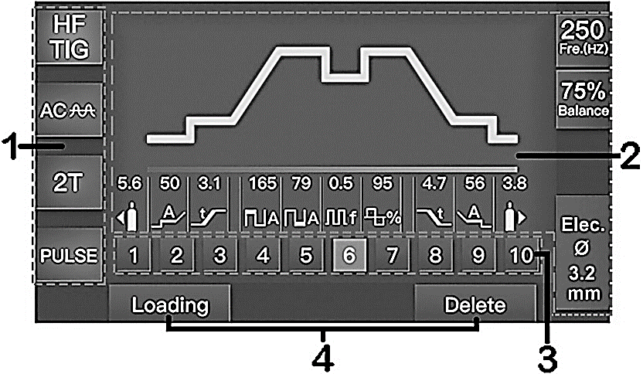
- Welding mode display: Here are selected welding states.
- Parameters display: Here are all selected parameters values.
- JOB number: A total 1~10 JOB numbers can store or call the selected parameters by JOB key.
- Load/ Delete display: Press Function A/B key to call/delete parameters setting for the selected JOB number.
Stick Welding Procedure
Manual metal arc welding, often known as stick welding, is one of the most used kinds of arc welding. A disposable electrode rod or "stick" and the base material are brought together by an electric current to form an arc. The electrode rod is constructed from a material that is compatible with the base material being joined, and it is coated with a flux that emits gaseous vapors that act as a shielding gas and as a coating of slag, as well, to protect the weld region from ambient contamination. The slag that accumulates over the weld metal after welding must be chipped away, and the electrode core itself serves as filler material.
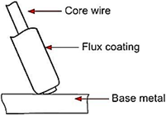
By quickly contacting the electrode to the base metal, the arc is started. At the electrode's end, a molten pool is created as the heat from the arc melts the base metal's surface. The molten pool is where the melted electrode metal is moved across the arc to create the deposited weld metal. A slag that results from the electrode coating covers and shields the deposit. There is a protective gas surrounding the arc and the surrounding areas.
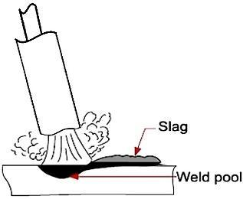
Solid metal wire is the core of manual metal arc (stick) electrodes, which also include a flux covering. The wire diameter and a string of letters and numbers are used to identify these electrodes. The metal alloy and the electrode's intended purpose are identified by the letters and numbers. The metal wire core works as a conductor of the current that maintains the arc. The core wire melts and is deposited into the welding pool. The term "Flux" refers to the coating on a shielded metal arc welding electrode. Numerous distinct tasks are accomplished by the flux on the electrode. Creating a protective slag covering over the weld as it cools, establishing arc characteristics, introducing alloying components, and forming a protective gas surrounding the weld region are some of these. In addition to adding filler metal to the molten pool, covered electrodes have several other uses. The electrode's coating performs most of these extra activities.
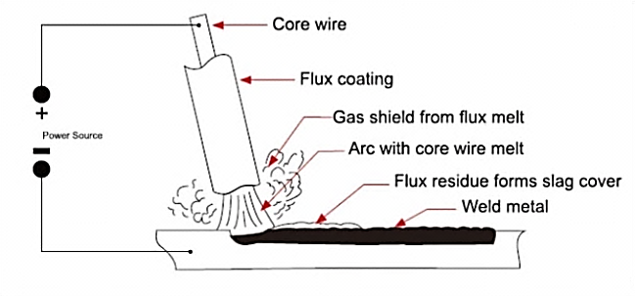
Electrode Selection
Choosing an electrode is typically simple because all that is required is to choose one with a composition that is comparable to the parent metal. However, there are a variety of electrodes available for various metals, each of which has unique characteristics to fit a particular sort of activity. It is advised that you speak with your welding provider to choose the ideal electrode choice.
Arc Length
The electrode should be carefully scraped on the work to strike the arc until the arc is formed. The smallest arc that provides a satisfactory surface for the weld should be used as the correct arc length, according to a straightforward rule. A too-long arc impairs penetration, causes spatter, and provides the weld a rough surface finish. A too-short arc will cause the electrode to stick and produce poor quality welds. The arc length for down hand welding should generally not be longer than the core wire's diameter.
Electrode Size
The thickness of the workpiece being welded often determines the size of the electrode, with a thicker section requiring a bigger electrode. The next chart lists the largest electrodes that may be used for different thicknesses based on the usage of a type 6013 all-purpose electrode.
Welding Current (Amperage)
Arc welding depends on selecting the appropriate current for the task at hand. When the current is regulated too low, it is challenging to initiate and maintain a constant arc. Beads with a noticeably rounded shape will be deposited due to the electrode's inclination to stick to the work and its poor penetration. A hot electrode undercuts and burns through the base metal while also producing a lot of splatters when there is too much current flowing through it. The maximum current that may be used for a certain operation without destroying the output, overheating the electrode, or producing a rough, spattered surface may be considered as the normal current. The allowable current ranges for a type 6013 general-purpose electrode are listed in the table.
Steel Sheet Thickness  in. (mm) | Stick Electrode Rod Diameter  in. (mm) | Current Range  (Amps)
1/16 - 1/8 (1.6 – 3.17) | 3/32 ( 2.4 ) | 45 - 95
1/8 - 1/4 (3.17 – 6.35) | 1/8 ( 3.2 ) | 75 -130
1/4 - 3/8 (6.35 – 9.5) | 5/32 ( 4.0 ) | 105 -185
3/8 - 1/2 (9.5 -12.5) | 3/16 ( 4.8 ) | 150 - 225
Electrode Angle
To enable a seamless, equal transfer of metal, the electrode's angle with the work is crucial. The electrode is typically angled between 5 and 15 degrees toward the direction of motion when welding in a horizontal, above, horizontal fillet, or down hand position. The electrode should be at an angle of between 80 and 90 degrees to the workpiece while welding vertically up.
Travel Speed
The electrode should be moved at a pace that will provide the desired length of run in the direction of the joint being welded. To maintain the proper arc length at all times, the electrode is fed downward at the same time. While excessive travel speeds typically result in arc instability, slag inclusions, and poor mechanical characteristics, excessive travel speeds frequently result in poor fusion, lack of penetration, etc.
Material and Joint Preparation
The weldable material must be free of any pollutants that might contaminate the weld material and interfere with the arc, such as moisture, paint, oil, grease, mill scale, and rust. Joints may need to be prepared using sawing, punching, shearing, machining, flame cutting, and other techniques depending on the technology used. Edges should always be clean and free of debris. The type of joint will be determined by the application selected.
Stick (SMAW) Welding Setup
To begin Stick welding, carry out the following tasks (with the machine switched off):
- Assemble Arc and Earth leads into the welding terminals depending on requirements of electrodes. Refer to your electrode packet for polarity and current requirements. (please see the Fig. E )
- DCEP (most common application): Earth clamp connector into the negative terminal and electrode holder connector into the positive terminal.
- DCEN (straight polarity): Earth clamp connector into the positive terminal and electrode holder connector into the negative terminal.
- AC stick welding: No requirements for polarity connection.
- Connect Earth clamp firmly to workpiece ensuring that the clamp makes good contact with bare metal.
- Take electrode holder and insert bare metal rod end of electrode and twist handle to clamp electrode.
- Ensure the electrode and electrode holder is not near the workpiece, turn the machine on using the mains power switch.
- Select Stick mode on welding machine control panel.
- Set the welding current relevant to the electrode type and size being used as recommended by the electrode manufacturer.
- Set the Hot Start and Arc Force as required using the keys 3,4 in Fig. F.
- Start welding.
- Pull out electric arc.
- After completion of welding the power source should be left turned ON for 2 to 3 minutes. This allows the fan to run and cool the internal components.
Note: If the electrode touches the workpiece over two seconds, the automatic short circuit current protection reduces the current to zero to protect the electrode.
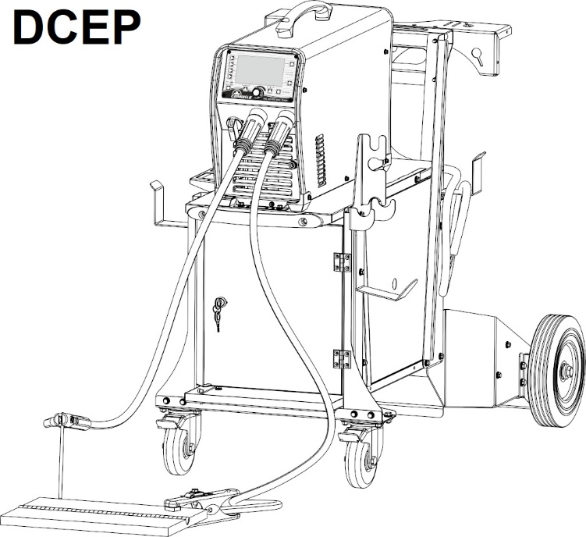
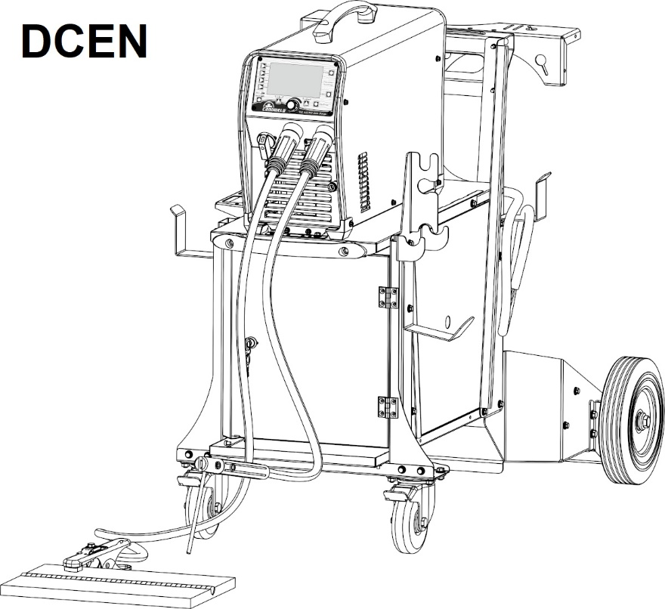
Fig. E
Stick Welding Display Introduction
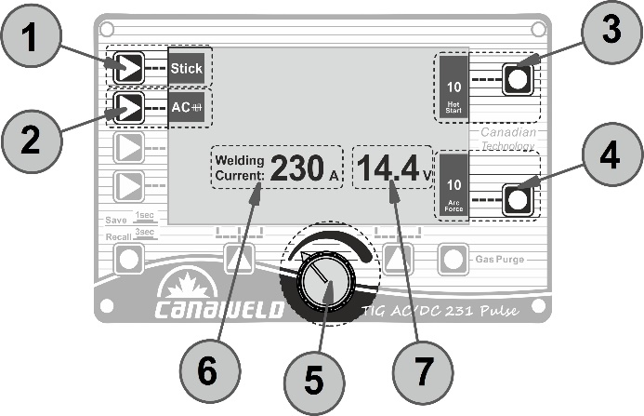
Fig. F
- Welding process key: Press it to enter Stick welding process.
- Waveform key: Press it to select DC output or AC Square wave output.
- Parameter A key: Press it to select Hot start. This increase the welding current for a time interval at the start of the welding process. Thereby reducing the risk of poor fusion at the start of the joint. The setting range is 0 to 10.
- Parameter B key: Press it to select Arc force. It's the dynamic characteristic of the arc. The setting range is 0 to10.
- Parameters adjust knob: Rotate it to adjust the welding current and the value of Hot start and Arc force.
- Current display: During the welding process the display shows the real current (Amps) at which the operator is actually welding, otherwise show the current selected.
- Welding voltage display: It displays welding voltage.
Maintenance
WARNING:
Always disconnect the machine power source before doing any maintenance to avoid personal injury accidents such as electric shock and burns.
By following proper maintenance procedures, the welding machine can operate safely and reliably for a long time.
Cooling Unit Maintenance
Disconnect the mains lead before any internal inspection of the unit. Periodically remove dust and extraneous materials from inside the unit and especially from the radiator. Make sure all of the hose tightening clips are closed, all fittings are intact and in perfect condition. Check the coolant is at the correct level.
Grounding Maintenance
Why test ground systems?
Over time, corrosive soils with high moisture content, high salt content, and high temperatures can degrade ground rods and their connections. Despite low ground resistance values upon initial installation, these values can increase if the ground rods are eaten away.
If there are intermittent electrical problems, the problem may be related to poor grounding or poor power quality. All grounds and ground connections must be checked annually as a part of normal proactive maintenance plan. Once identified, the problem can be solved by replacing or adding ground rods to the grounding system.
Earth Clamp Maintenance
Do not Use if the Earth clamp is damaged or in bad condition.
If the Earth clamp is not in good condition, this will cause welding current leakage or a drop voltage in the machine output, which looks like someone changing the settings on your welding machine, Often the first reaction of the operator is to change the machine settings to compensate, rather than fix the real cause of the problem.
There are typically 3 areas of “connection” on an earth clamp that can cause a current leakage or blockage.
- Cable to the cable lug: Lugs are probably the worst offender here! They can be hard to fit properly, sometimes the cable can be removed from the lug, the lug bolt/terminal may come loose, etc., Use a high-quality, copper tin plated cable lug and a professional crimping tool.
- Within the clamp itself: Be careful of broken clamp jaws or worn parts. Use a high-quality Earth clamp, Strong spring and other mechanical parts, Current conductive parts made from copper or brass and not Steel alloys at all.
- Clamp to workpiece connection: A weak clamp spring or improper connection to the workpiece, corroded clamping jaws or low electrical conductivity, particularly if the workpiece is rusty, causes poor electrical conduction with it and increase in heat.
Once a “connection” problem in an Earth clamp develops, the affected component will then begin to heat up. The heat will then accelerate the original problem, causing the connection to fail further, which will then cause more heat and the cycle to continue.
Conclusion:
- Do Check your earth clamp regularly. Make sure the cable lug is firmly fitted and bolted. Replace the clamp in case of weak spring, broken parts, overheating, etc.
- Do not just give your clamp a shake and reattach it. This won’t solve the problem.
- Use only high-quality, well-designed Earth clamps.
Regular Maintenance Planning:
Date | Maintenance item
Daily Inspection | - Check if all panel buttons, potentiometers, switches, electrical and gas connections on the front and rear sides of the machine are working properly. If not, repair or replace them.  - After turning on the power source, observe / listen whether the machine has any abnormal noise or smell. If yes, try to find the reason and if you cannot find the reason, please contact the local agent or branch.  - Turn on the power source to make sure the fan is working properly. Check if the fan blades move a little or starts spinning. If not, observe whether there is anything stuck in the blade, and if so, remove it. If the fan is damaged, replace it immediately. Make sure the machine is unplugged.  - Observe if the connectors are loose or overheated. Observe whether the current output cable and the input power cable are damaged. If a cable is damaged, it must be wrapped, insulated, or changed.  - Check gas/air connections and circuit for any probable leaks.  - Check the water-cooling unit connections, fittings, tubes, hoses for any probable leaks.  - Fill out the liquid coolant reservoir up to the maximum level.
Monthly Inspection | Use dry compressed air (with low pressure settings) to clean the inside of the machine and water-cooling unit, especially clean the dust on the heat sinks, main voltage transformer, inductor, IGBT modules, diodes, capacitors, and all PCBs, etc. Check the bolts and screws of the machine, if any bolt or screw is loose, tighten it. If it is stripped, replace it. If it is rusty, wipe the rust off the bolt and make sure it works well. Check the liquid coolant filter inside the water-cooling system and replace it if it is necessary.
Annual Inspection | Compare the actual value of parameters with the display value installed on the machine. If the difference is significant, the machine must be calibrated. The value of the parameters can be measured by a calibrated instrument. Check the liquid coolant filter inside the water-cooling system and replace it if it is necessary.  Check the liquid coolant strainer/filter inside the water-cooling system and clean/replace it if it is necessary.  Replace damaged hoses and connections with the genuine parts  Replace the coolant totally.
Note: Only professional service personnel authorized by Canaweld may service the machine!
Troubleshooting Table
Power Supply Troubleshooting
Note: Only professional service personnel authorized by Canaweld may service the machine!
If there is a problem and you can’t find the authorized professional maintenance personnel, please contact the local agent or the company branch. If there are some simple machine troubles, you can use the following information from the below table:
PROBLEM | POSSIBLE REASON | SOLUTION
When the machine is turned on, the fan turns on, but the display does not illuminate. | Faulty components in the front panel PCB | Contact Canaweld Service Center.
When the machine is turned on, the display turns on, but the fan does not work. | Something is blocked the fan blades physically | Remove the blockade.
 | The fan motor damaged | Change fan
The fan blades are not running. | Power supply voltage is not sufficient or is disconnected | Check power supply fuses and replace if necessary or reset the circuit breakers.  Turn on the machine.
The fan blades are not running. | Improper input power connections | Check for the correct input power connections
The fan blades are not running. | Faulty components in power supply. | Contact Canaweld Service Center.
During operation, the arc goes out and can’t be restarted by pressing the torch trigger and the Fault Overheat appears. | Power Supply is overheated. | Allow the device to cool down for at least 6 minutes. Make sure the device is not operating beyond the duty cycle limit.
 | Fan blades blocked. | Check the fan and the blades.
 | Faulty components in unit | Contact Canaweld Service Center.
Arc cannot be ignited (TIG-HF Mode) and there is no spark on the HF igniting board inside the machine. | The torch trigger switch or control cable or connection has been damaged. | Check the torch trigger switch, control cable and 9-pin socket.
 | HF is OFF | Press HF button to set the weld mode into HF Mode
 | The HF igniting board does not work. | Contact Canaweld Service Center.
Arc cannot be ignited (TIG-HF Mode) but there is spark on the HF igniting board inside the machine. | The welding cable is not connected to the output terminal of the welder. | Connect the welding cable to the welder’s output.
 | The welding cable is damaged. | Repair or change it.
 | The earth clamp is not connected properly. | Ensure the earth clamp is properly connected to the clean and dry workpiece area. Inspect the earth clamp for damage, repair or replace as needed.
 | The welding cable is too long. | Use an appropriate welding cable.
 | There is oil or dust on the workpiece. | Remove rust, paint, and other residues to ensure good contact between the earth clamp and the workpiece.
No gas flow (TIG) | Gas cylinder is empty or closed or the gas pressure is low. | Open or change the gas cylinder
No gas flow (TIG) | Something is blocked the valve | Remove the obstacle/blockade.
No gas flow (TIG) | Electromagnetic valve is damaged | Contact Canaweld Service Center.
Gas always flows | Something in the valve | Remove the obstacle/blockade.
Gas always flows | Electromagnetic valve is damaged | Contact Canaweld Service Center.
The welding current cannot be adjusted | The control PCB or the current transducer is damaged. | Contact Canaweld Service Center.
The welding current displayed isn’t accordant with the actual value. | The control PCB or the current transducer is damaged. | Contact Canaweld Service Center.
The penetration of the molten metal pool is not enough. | The welding current is adjusted too low | Increase the welding current
Weld output is erratic or incorrect | Improper weld cable | Use proper size and type of weld cable
Weld output is erratic or incorrect | Loose connection | Clean and tighten all weld connections
Weld output is erratic or incorrect | The control PCB or the current transducer is damaged. | Contact Canaweld Service Center.
Weld arc wanders and/or flutters during TIG welding. | Improper tungsten size | Use proper tungsten size
Weld arc wanders and/or flutters during TIG welding. | Unprepared tungsten electrode tip | Use appropriately prepared tungsten.
Weld arc wanders and/or flutters during TIG welding. | High rate of gas flow | Reduce the rate of gas flow.
Weld arc wanders and/or flutters during TIG welding. | In correct polarity in DC welding | Check the welder's output polarity and choose Direct Current Electrode Negative (DCEN).
Weld arc wanders and/or flutters during TIG welding. | Too long arc length | Decrease the arc length to 0.1in. (2-3mm)
Weld arc wanders and/or flutters during TIG welding. | Contaminated base metal | Clean up the base metal to remove any paint, grease, oil, or dirt, including rust, oxide, and mill scale.
Weld arc wanders and/or flutters during TIG welding. | Contaminated tungsten | Repoint the tungsten after cutting 1/2 inch of contaminated tungsten.
Weld arc wanders and/or flutters during TIG welding. | Incorrect shielding gas or mixture | Inspect the gas type; it must be argon
Weld arc wanders and/or flutters during TIG welding. | Too long arc length | Decrease the arc length to 0.1in. (2-3mm)
After welding is completed, the tungsten electrode becomes oxidized and loses its brightness. | Shielding gas is leaking | Check for any gas leakage and tighten all gas fittings.
 | Post flow time is too short | Increase the post flow time.
 | Wind or drafts around the welding area | Protect the weld zone from the wind and drafts.
Locked “Err” message on display | Faulty components in power supply. | Contact Canaweld Service Center.
When the torch trigger is released, the welding output continues. | The trigger mode is set to 4T | Change the trigger mode to 2T mode
 | Torch trigger switch contacts have been shortened. | Replace the torch trigger switch
When the torch trigger switch is depressed, welding output voltage is present, but an arc cannot be established. | Poor or no earth cable (work lead) contact. | Remove rust, paint, and other residues to ensure good contact between the earth clamp and the workpiece.
 | Faulty components in power supply. | Contact Canaweld Service Center.
When the torch trigger is pressed, no welding output voltage is present. | Faulty trigger switch | Replace the torch trigger switch
When an arc is struck, the TIG electrode melts down. | TIG torch is connected to the positive (+) terminal. | Connect the TIG torch the negative (-) terminal.
Tungsten electrode is quickly consumed | Incorrect tungsten size for the current application | Change tungsten size.
Tungsten electrode is quickly consumed | Oxidation of tungsten after welding | Increase post flow time
Tungsten electrode is quickly consumed | Utilization of gases containing CO2 or oxygen | Change gas to pure argon
Tungsten electrode is quickly consumed | Improper balance setting | Adjust the balance setting
Tungsten has contaminated the weld pool | Tungsten melting into weld puddle | Decrease welding current
Tungsten has contaminated the weld pool | Tungsten melting into weld puddle | Change electrode to thoriated (DC), Ceriated (AC, DC), or Lanthanated tungsten
Tungsten has contaminated the weld pool | Tungsten melting into weld puddle | Increase tungsten diameter
Tungsten has contaminated the weld pool | Tungsten in contact with the weld puddle | Prevent tungsten from coming into touch with the weld puddle. Raise the torch so that the tungsten is no longer touching the work piece.
There is a high frequency present but no arc power | No or wrong shielding gas | Check for gas flow at the torch's tip.
There is a high frequency present but no arc power | No or wrong shielding gas | A Adjust the argon gas flow rate between 10 to 25 CFH
There is a high frequency present but no arc power | Incomplete weld circuit | Check all cable connections, especially the earth (work) connection.
Porosity in the weld pool and/or improper weld bead color | Improper gas flow rate | Adjust the argon gas flow rate between 10 to 25 CFH
Porosity in the weld pool and/or improper weld bead color | Torch or hose fittings that are loose | Tighten all torch and hose fittings.
Porosity in the weld pool and/or improper weld bead color | A faulty gas hose or a loose connection | Replace the faulty gas hose and inspect the connections for leaks, cuts, or pin holes.
Porosity in the weld pool and/or improper weld bead color | Base metal condensation | Warm up the workpiece with hot air or just Argon gas for a few minutes. Remove any moisture from the base metal before welding. Metals that have been stored in cold temperatures condense when exposed to warm and humid temperatures.
Porosity in the weld pool and/or improper weld bead color | Not matching or contaminated filler metal | Inspect the filler metal type. Clean the filler metal of any grease, oil, or moisture.
Porosity in the weld pool and/or improper weld bead color | Contaminated base metal | Clean up the base metal to remove any paint, grease, oil, or dirt, including rust, oxide, and mill scale.
Smoke and/or yellow powder on the gas cup or tungsten discolor | Insufficient gas flow rate | Increase the gas flow rate and adjust it between 10 to 25 CFH
 | Incorrect shielding gas or mixture | Inspect the gas type; it must be argon
 | Tungsten in contact with the weld puddle | Prevent tungsten from coming into touch with the weld puddle. Raise the torch so that the tungsten is no longer touching the work piece.
 | Incorrect tungsten or cup size. | Use tungsten and cup sizes that are appropriate in accordance with the joint being welded.
 | Insufficient post flow | Extend the post-flow period to at least 10–15 seconds.
Unstable AC Welding Arc | Incorrect shielding gas or mixture | Inspect the gas type; it must be argon
Unstable AC Welding Arc | Contaminated base metal | Clean up the base metal to remove any paint, grease, oil, or dirt, including rust, oxide, and mill scale.
Unstable AC Welding Arc | Contaminated tungsten | Repoint the tungsten after cutting 1/2 inch of contaminated tungsten.
Unstable AC Welding Arc | Too low frequency setting | Increase frequency to recommended 100 Hz to provide optimum arc stability and directional control.
Unstable AC Welding Arc | Improper arc length | Modify the arc length to 0.1in. (2-3mm)
Unstable AC Welding Arc | Unprepared tungsten electrode tip | Use appropriately prepared tungsten.
Unstable AC Welding Arc | Excessive arc rectification or balance control setting. | Insert filler metal. Speed up the welding process. Increase balance control to approach maximal penetration.
Unstable AC Welding Arc | Frosted light grey look of the tungsten electrode end. | Repoint the tungsten after cutting 1/2 inch of contaminated tungsten.
Unstable AC Welding Arc | Insufficient gas flow rate | Increase the gas flow rate and adjust it between 10 to 25 CFH
In TIG AC mode, the maximum amperage is limiter to 200A. | Machine is set to the Air-Cooled Mode | Turn OFF the machine and set up the water-cooling unit properly. Fill out the liquid coolant reservoir up to maximum level.  Turn ON the machine and water-cooling unit again.
In TIG DC mode, the maximum amperage is limiter to 250A. | Machine is set to the Air-Cooled Mode

Cooling Unit Troubleshooting
Note: Only professional service personnel authorized by Canaweld may service the machine!
If there is a problem and you can’t find the authorized professional maintenance personnel, please contact the local agent or the company branch. If there are some simple machine troubles, you can use the following information from the below table:
PROBLEM | POSSIBLE REASON | SOLUTION
The coolant system is not working. | Input power cord is not connected | Connect the power cord to the special receptacle at the rear panel of the Canaweld’s welding machine
The coolant system is not working. | The welding machine is turned off. | Turn on the welding machine.
The coolant system is not working. | Fuse or circuit breaker is deactivated. | If required, replace or reset any circuit breakers or line fuses. Check and replace 3A fuses on the rear panel of the welding machine.
The coolant system is not working. | The pump is overheated | Wait until the pump has cooled before using the device.
The coolant system is not working. | After the welding operation was complete, the related welding machine shuts off the cooling unit after around 8 minutes. | Press the torch/gun trigger to power up the cooling unit again
The coolant system is not working. | Faulty components in the cooling unit | Contact Canaweld Service Center.
Reduced or absent of the coolant flow. | Coolant is lower than the minimum level | Add coolant to the maximum level.
Reduced or absent of the coolant flow. | Hoses is clogged | Clean/replace hoses
Reduced or absent of the coolant flow. | Strainer/filter is clogged | Clean/replace strainer/filter
Reduced or absent of the coolant flow. | Faulty components in the cooling unit | Contact Canaweld Service Center.
Leaking coolant | Hose fitting are loose. | Push to lock the hose fittings
Leaking coolant | Internal hoses are broken or punctured. | Replace the broken hoses.
Leaking coolant | Pump seal is leaking | Contact Canaweld Service Center.
Leaking coolant | Heat exchanger is leaking. | Contact Canaweld Service Center.
Inadequate cooling performance (gun or torch is too hot) | Low or no flow of the coolant. | Check the coolant path for any probable clogs. Remove the blockade
Inadequate cooling performance (gun or torch is too hot) | Heat exchanger is clogged. | Try to unclog the heat exchanger by compressed air.
Inadequate cooling performance (gun or torch is too hot) | Pump is not working | Check the solution for “The coolant system is not working.” problem
Inadequate cooling performance (gun or torch is too hot) | Pump is not working | Contact Canaweld Service Center.
Circuit breaker is tripped by the cooler. | Pump motor failure | Contact Canaweld Service Center.
Error Codes
The machine is protected against problems and if any error occurred the display shows messages depending to the type of error. The below table provides a summary of all the error conditions that may arise on the machine.
Please Note: if the fault persists look for the cause of the fault and contact our technical department if necessary.
Error Code | POSSIBLE REASON | SOLUTION
E01  E02  E09 | Power Supply is overheated. | Allow the device to cool down for at least 6 minutes. Make sure the device is not operating beyond the duty cycle limit.
E01  E02  E09 | Fan blades blocked. | Check the fan and the blades.
E11 | Water-Cool unit is OFF | Turn ON the water-cooling unit
E11 | Water-Cool unit is disconnected | Connect the control cables of the water-cooling unit to the corresponding connectors on the rear panel of the machine
E11 | Liquid coolant pressure is low | Fill out the liquid coolant reservoir up to the maximum level.
E11 | 3A protection fuses are burnt | Replace 3A protection fuses.
E11 | Liquid coolant is frosted | Move the cooling unit and torch to a warm place.  Wait until the coolant completely defrosts.  Check for any leakages.  If there is any leakage, contact Canaweld Service Center.  Otherwise, use Canaweld’s recommended anti-freezing liquid coolant.
E11 | Water pump is not working | Contact Canaweld Service Center.
Meaning of Graphic Symbols on Machine
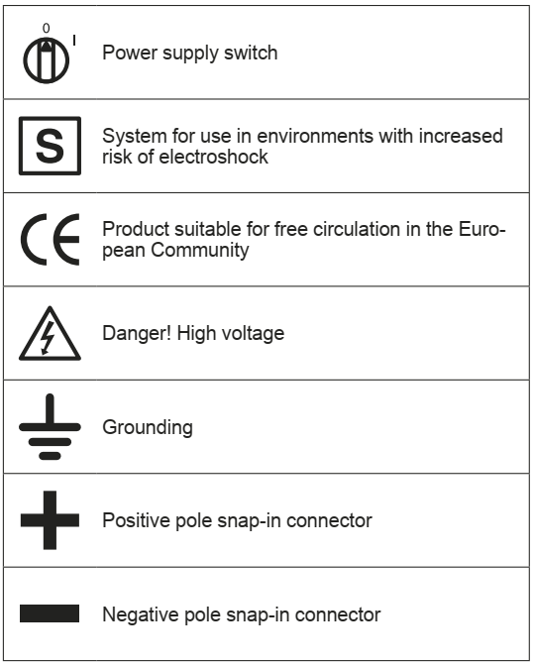
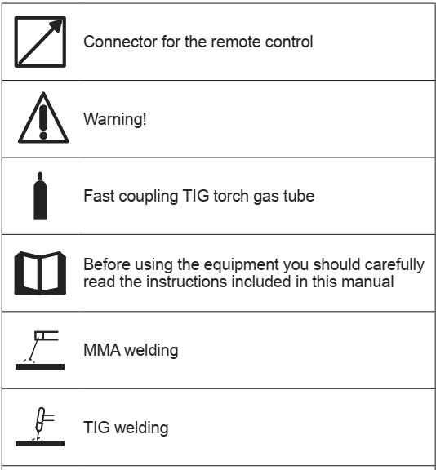

TIG AC/DC 231 Pulse Wiring Diagram

Cooling Unit Wiring Diagram
